**Assignment-2**

**Name :-** Yash Ashokkumar Patel

**ID :-** N01537676

**Subject :-** Web Programming and Framework 1

**Step-1 :-**

Create new folder named “Asn2-yash”.

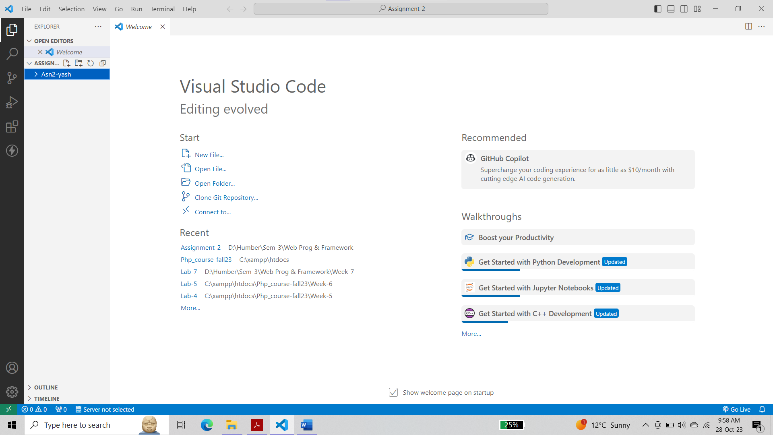

Change directory to “Asn2-yash”:

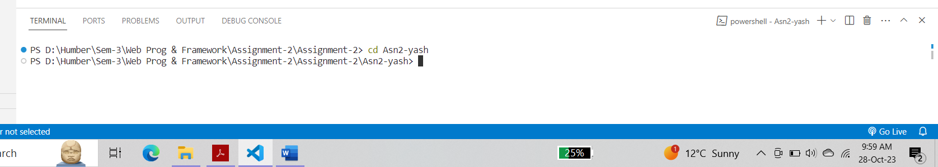

Open terminal and run npm init

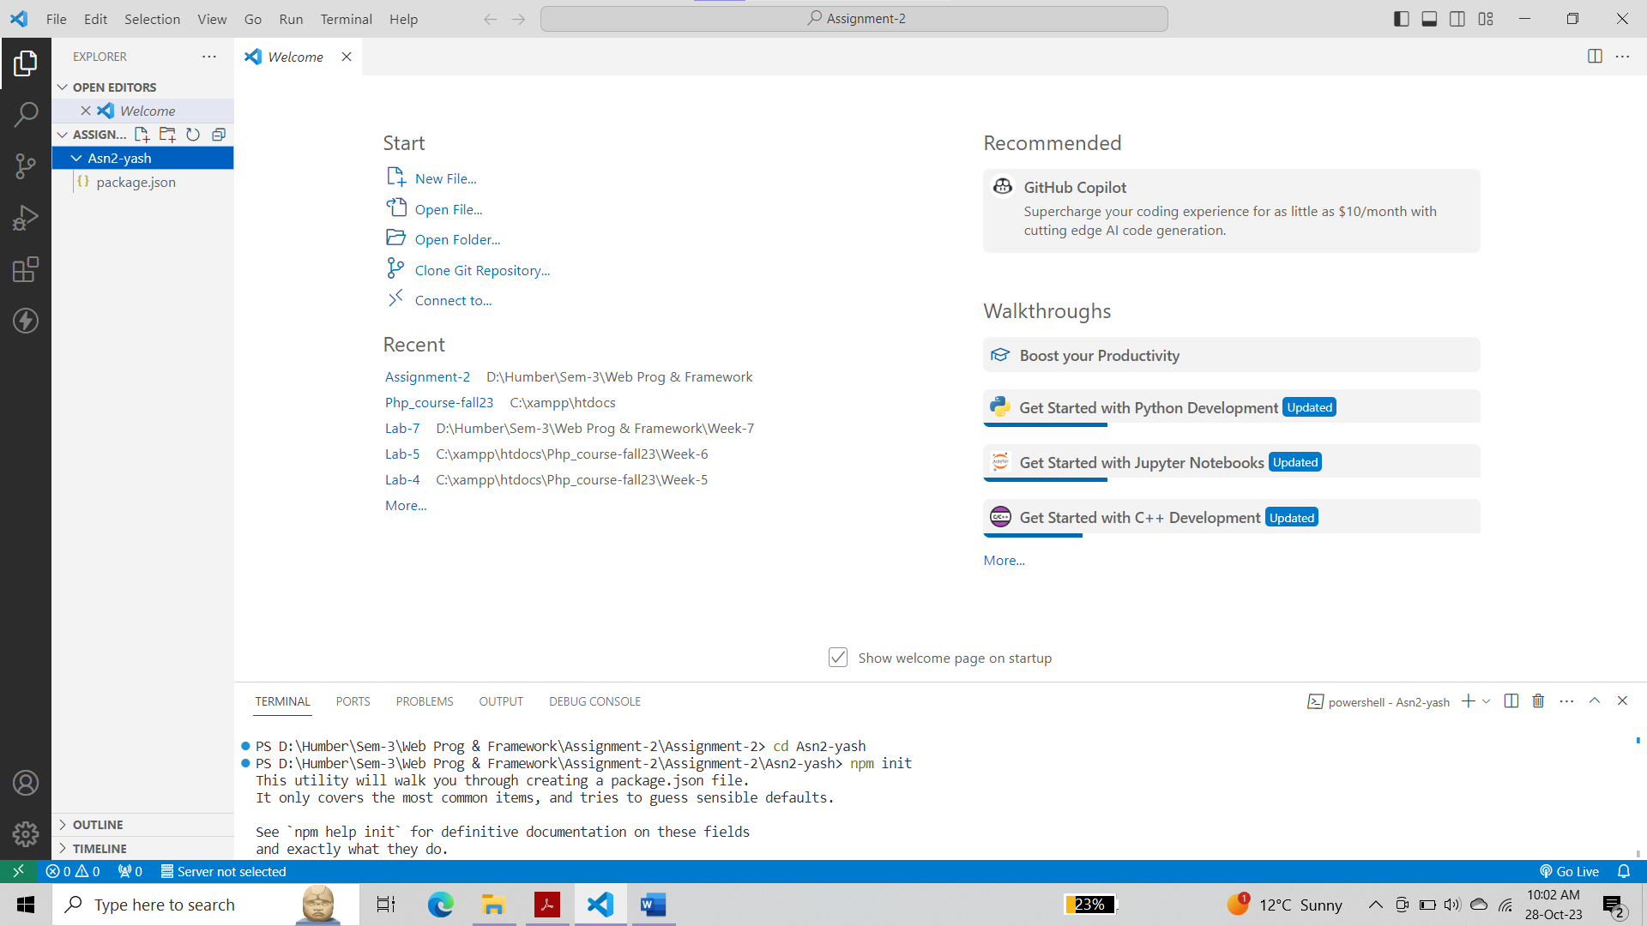

In the terminal run: npm install express --save

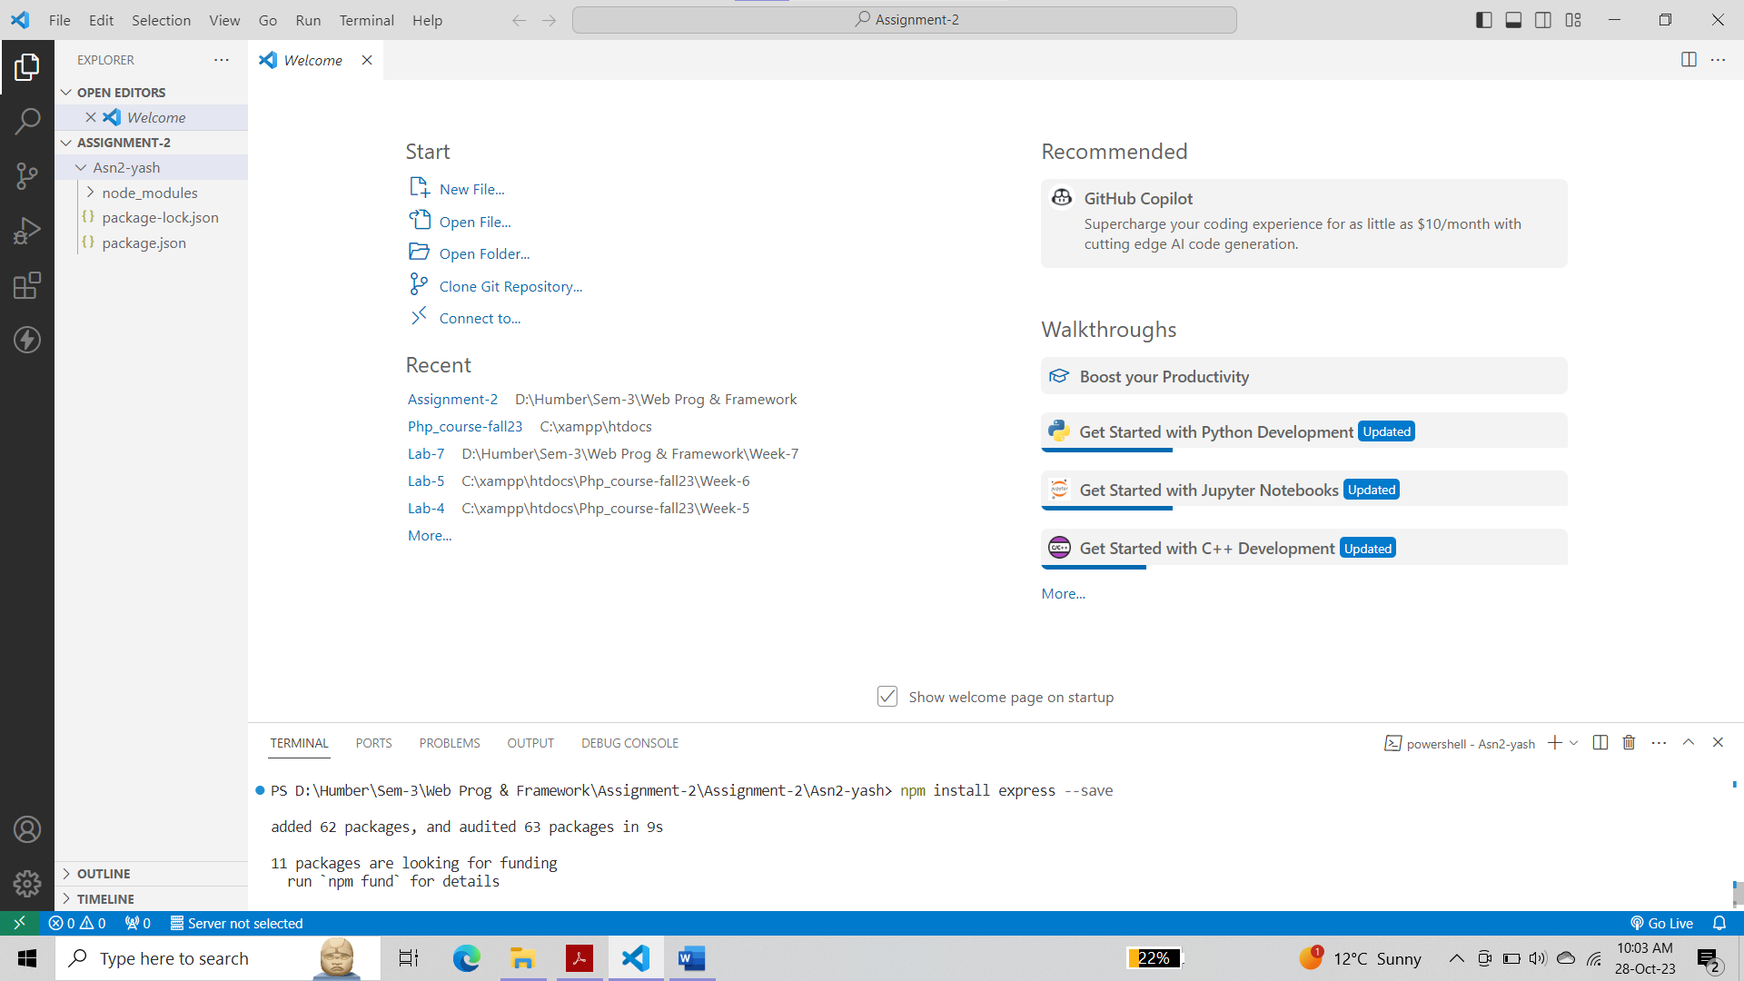

In the terminal run: npm install express-handlebars --save

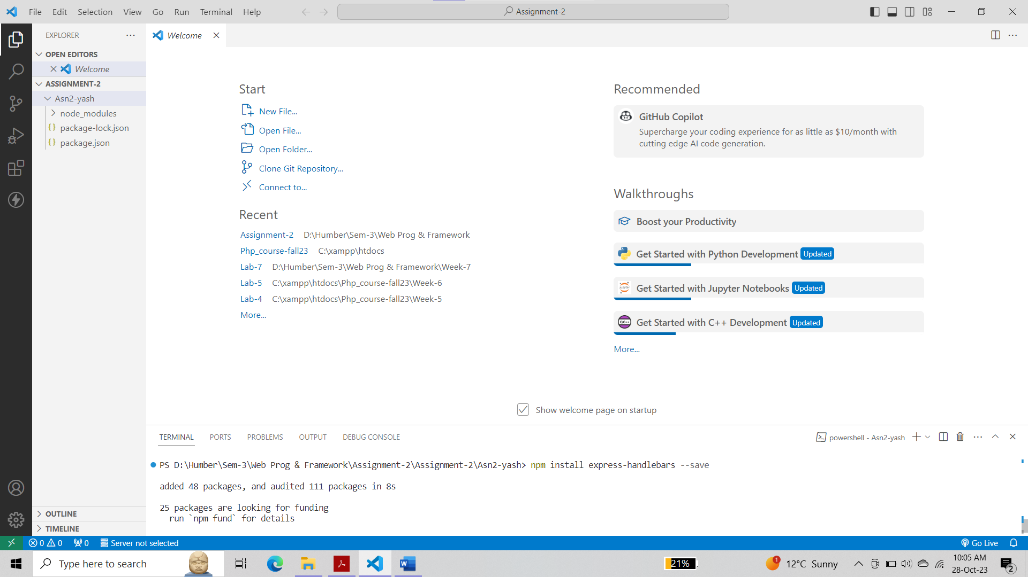

Make sure to have the following project structure:

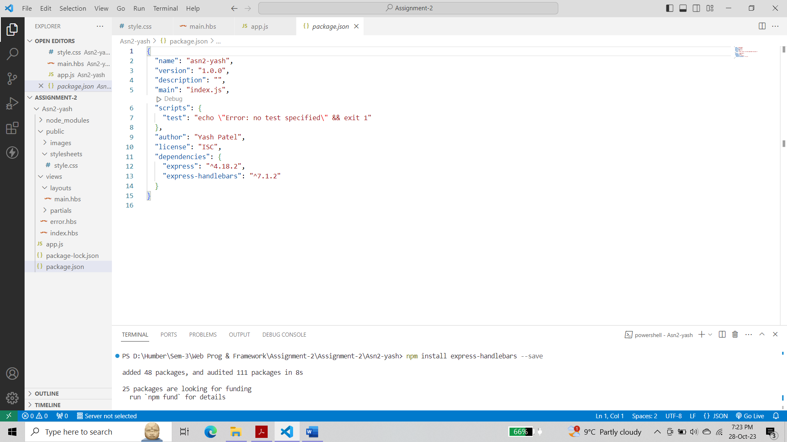

**Step 2 :-**

Using the attach file (codenippet.txt), copy/paste the related code to “style.css”, “main.hbs”, “index.hbs”, “error.hbs” and “app.js”.

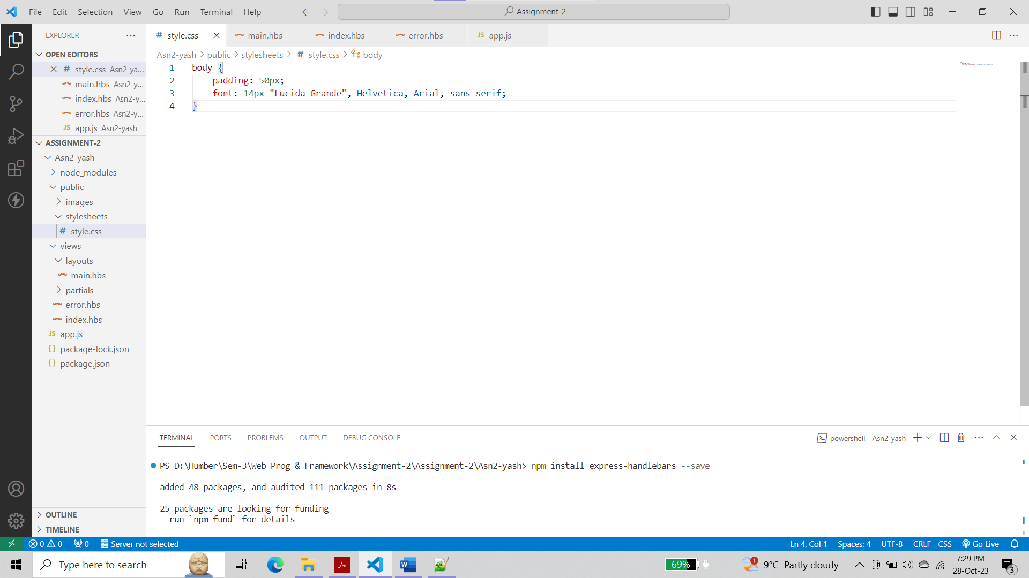

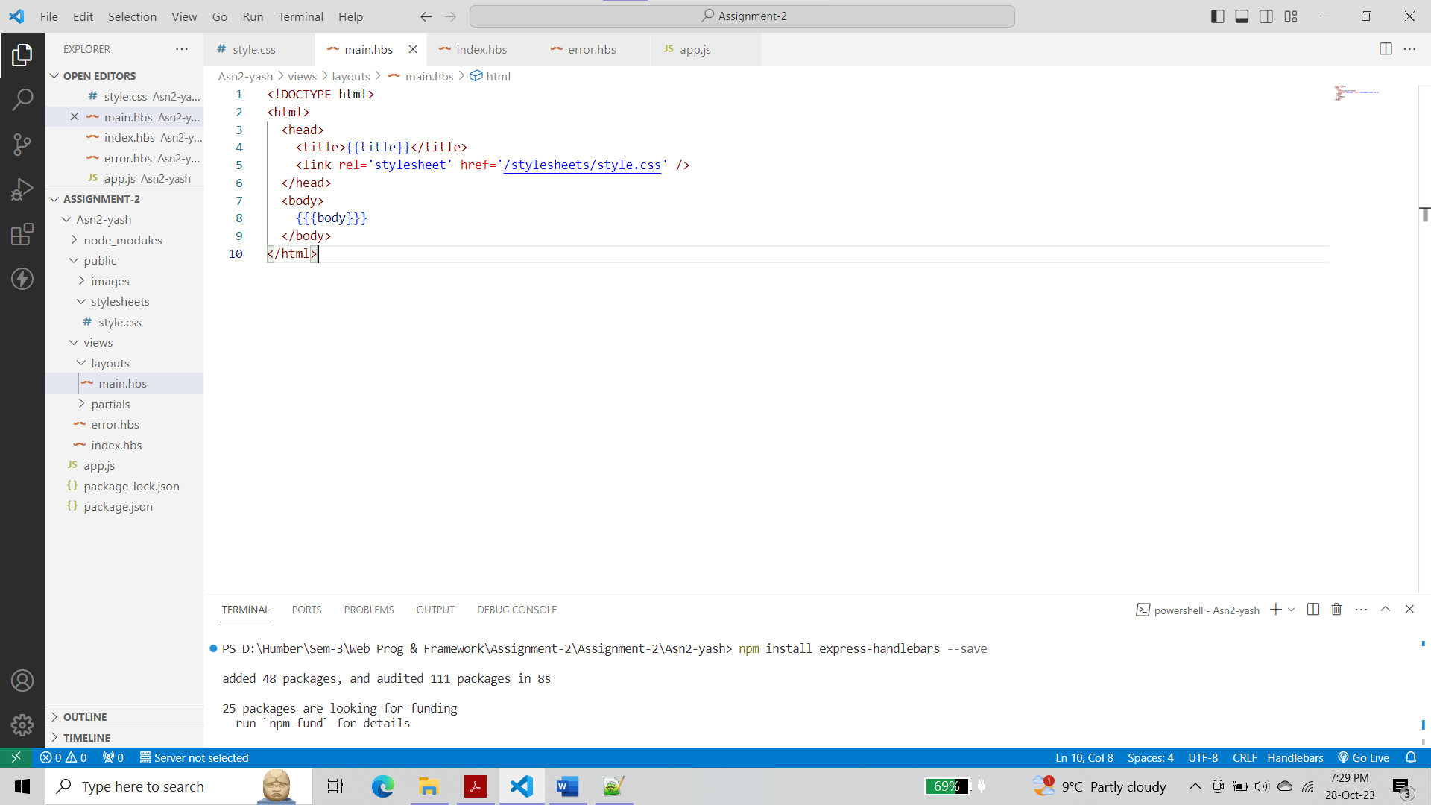

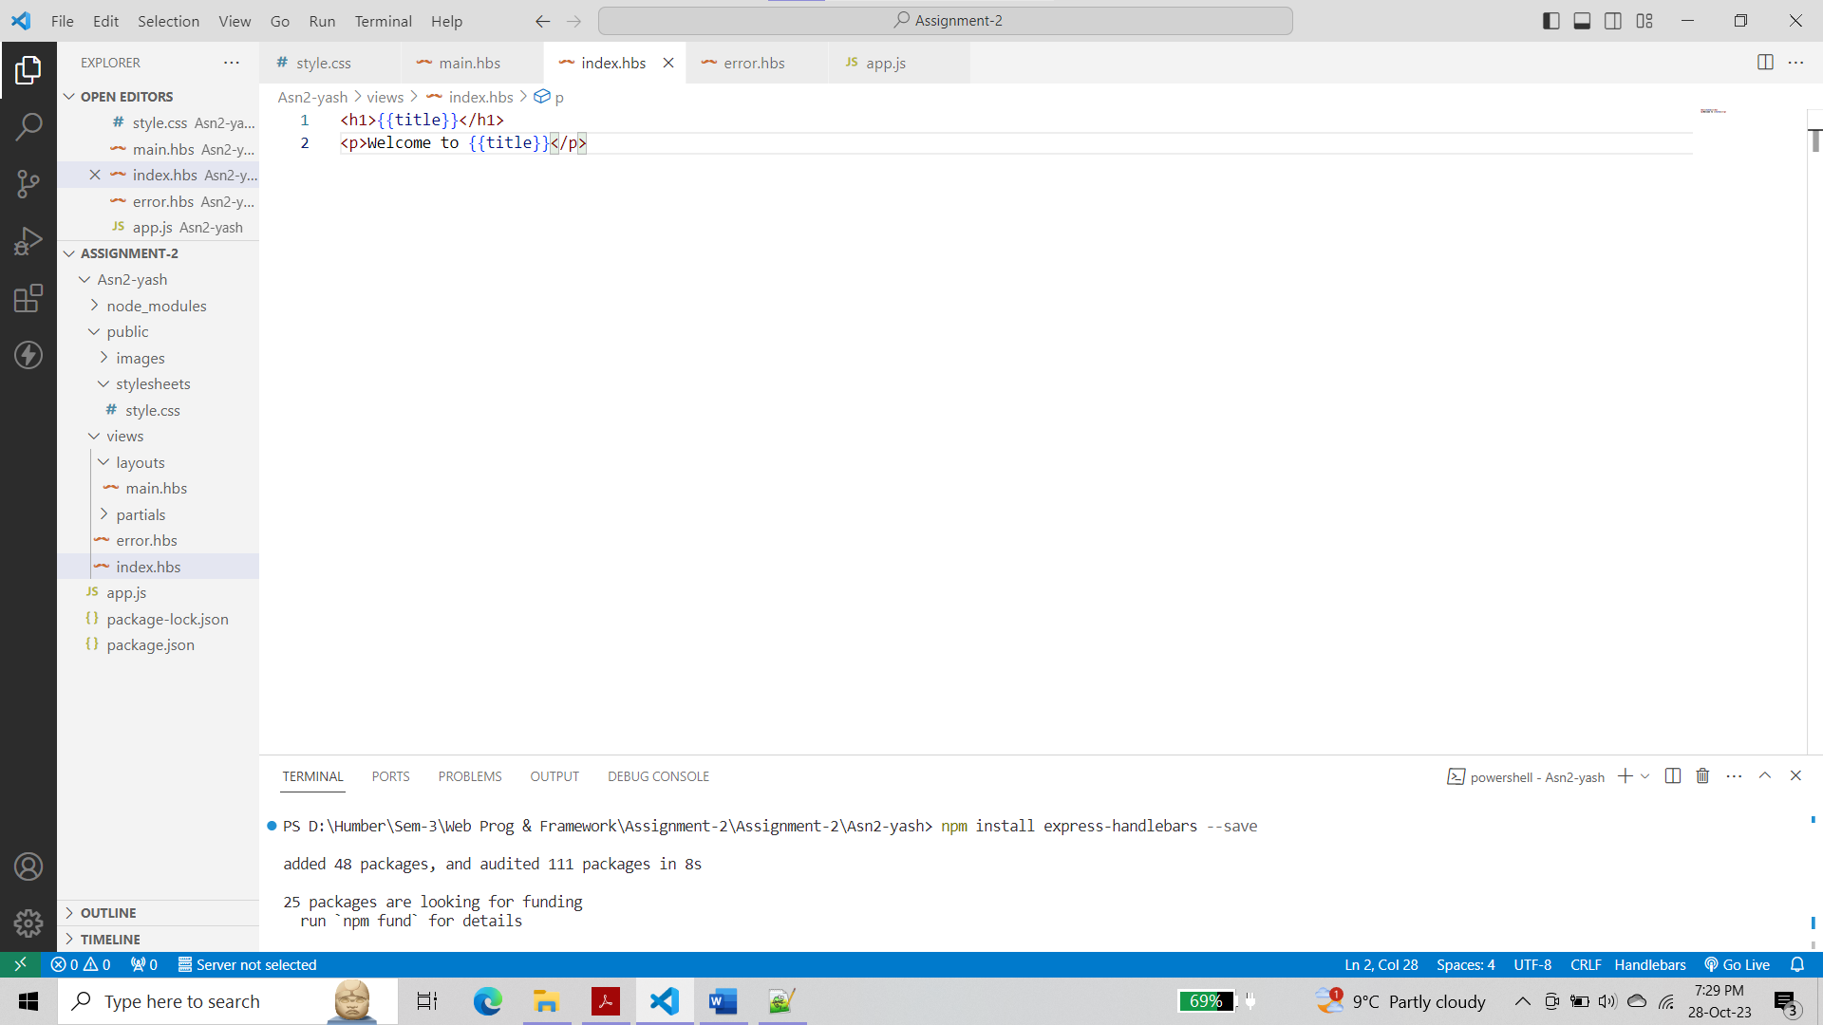

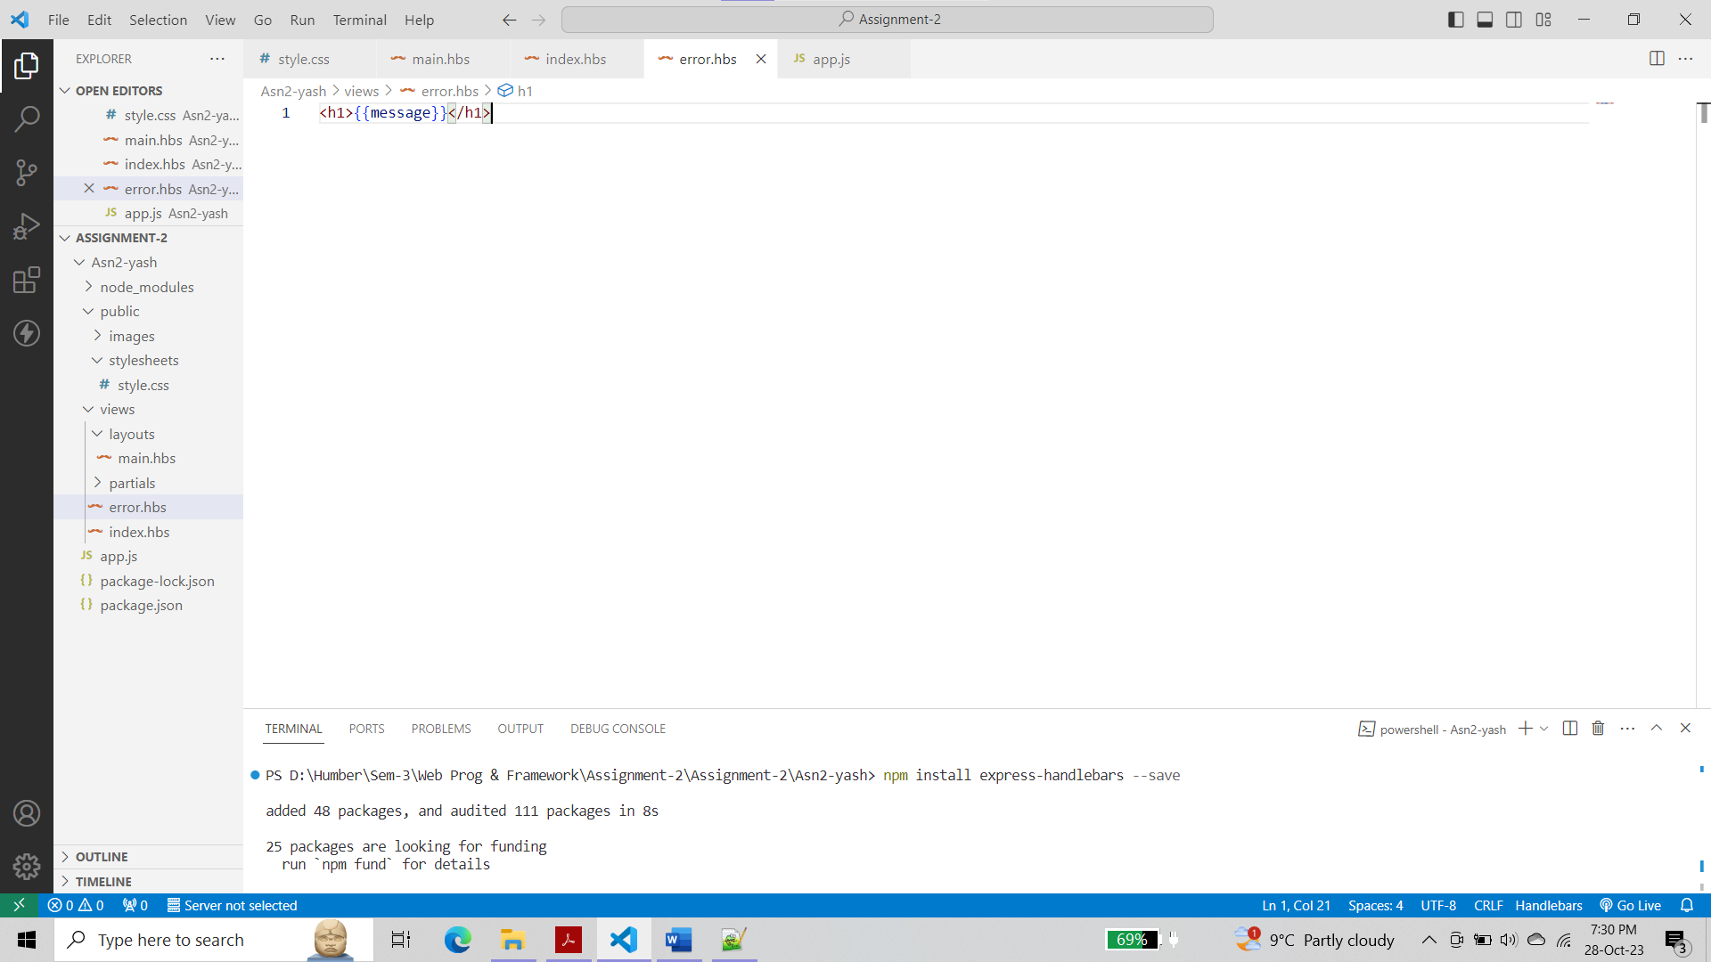

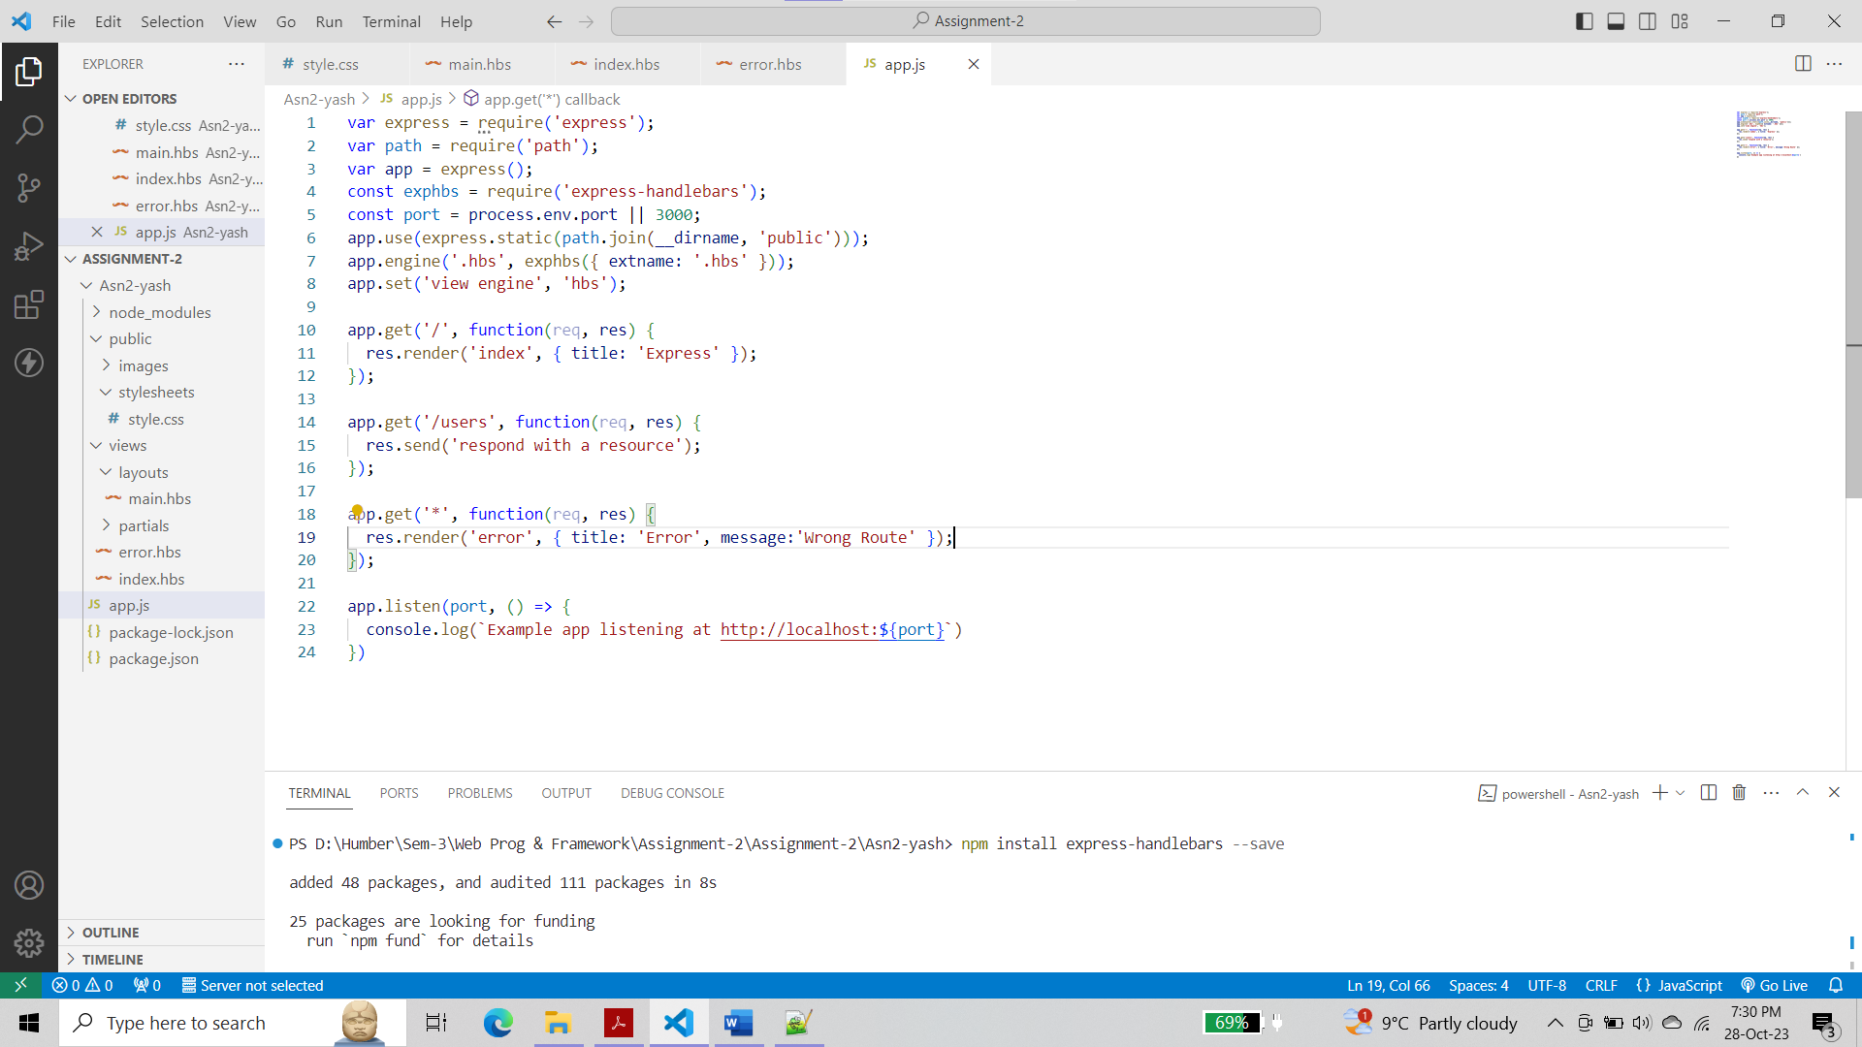

**Step 3 :-**

Run the application and test it using the following routes:

• <http://localhost:3000/>

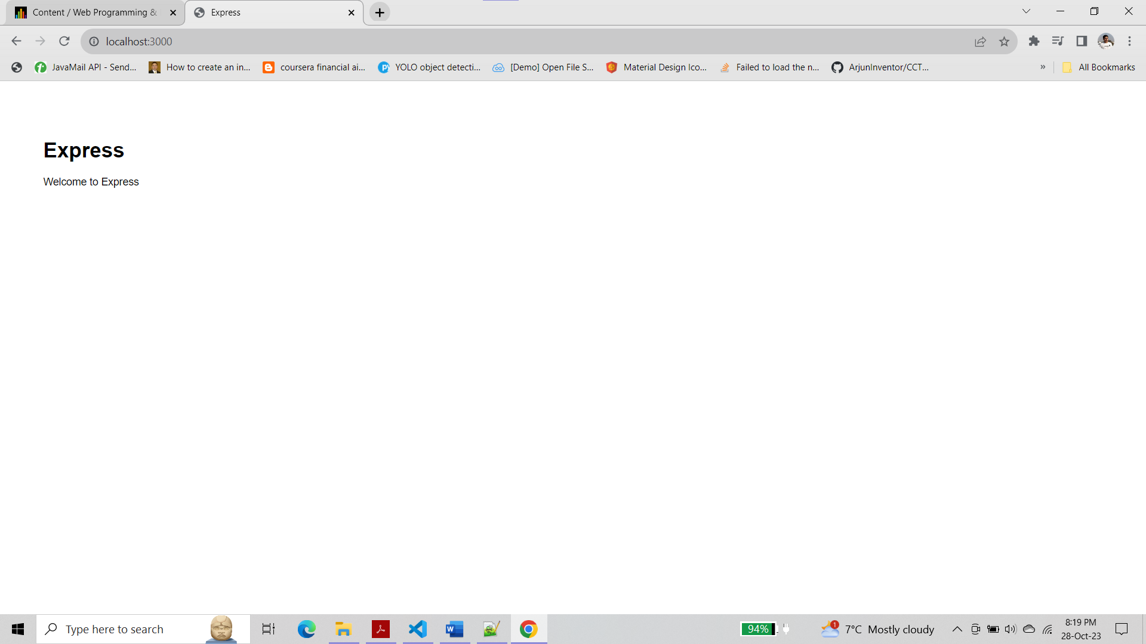

• <http://localhost:3000/users>

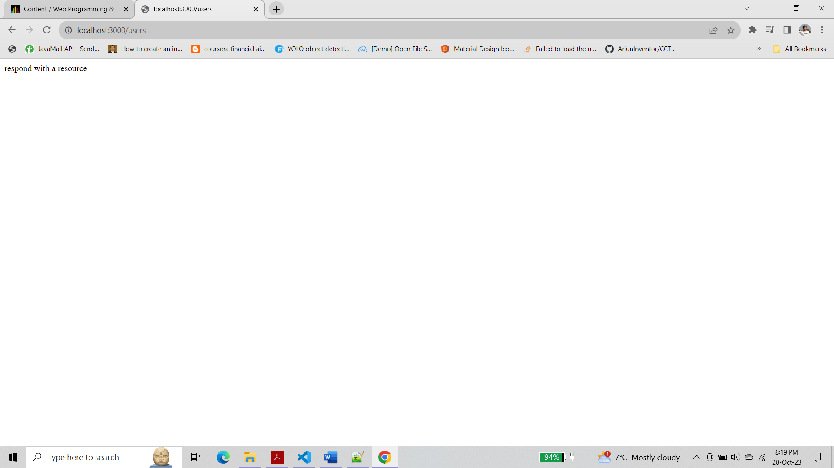

• <http://localhost:3000/notExist>

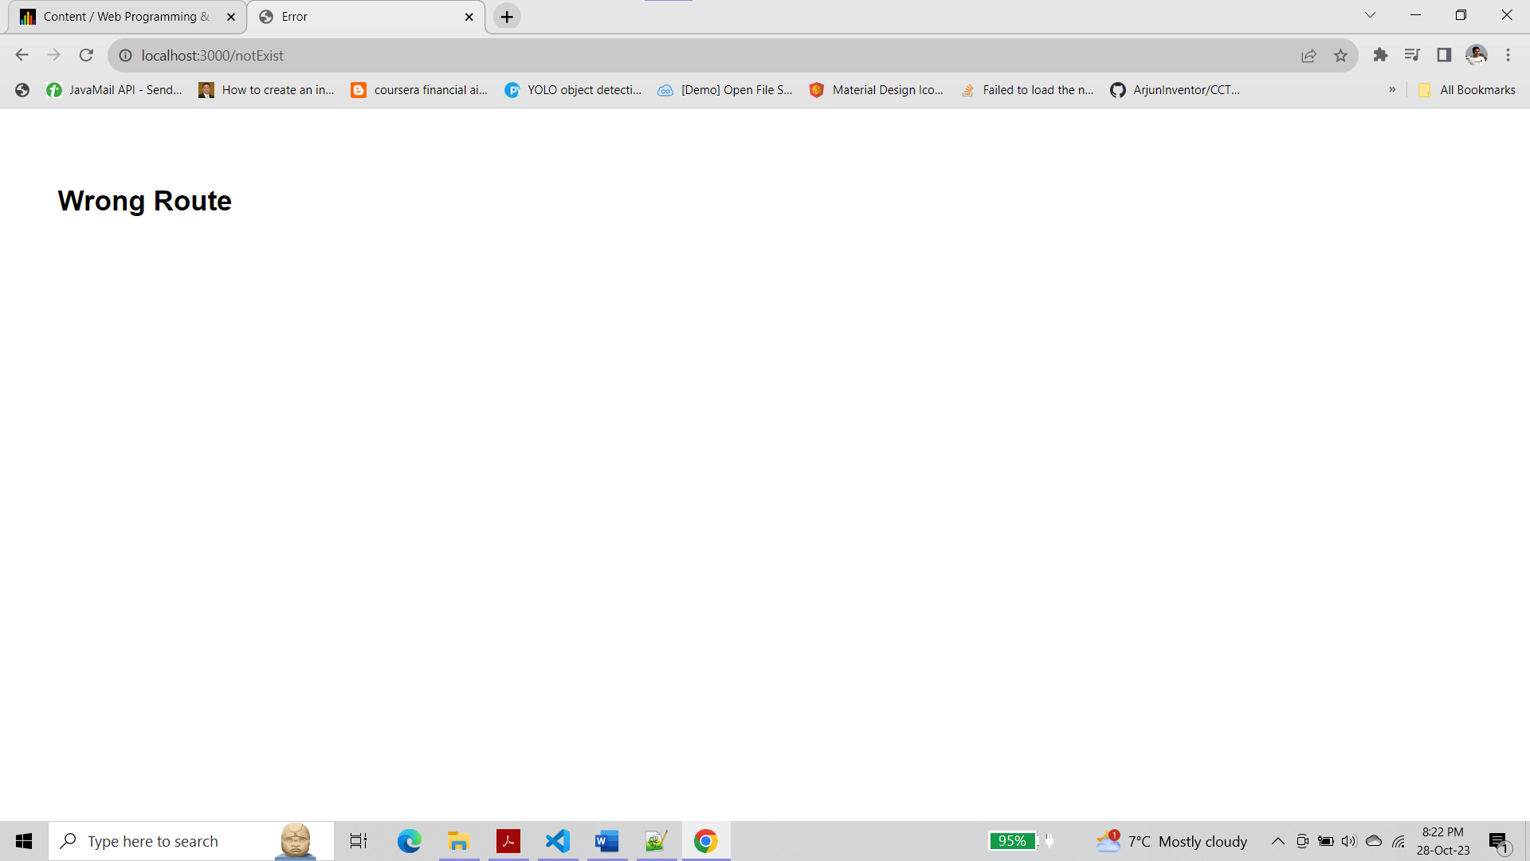

**Step 4 :-**

Base on your observation, answer the following questions:

1. **What is the role of “main.hbs”? How does it being used/called in the app?**

* The "main.hbs" file serves as the main template for the HTML structure of our application. It provides the basic HTML structure that is shared across multiple views. In our app, it is used as a layout template that includes a title and a link to a stylesheet. It is used to render the main layout structure of the application and is called automatically when other templates are rendered.

1. **What is the role of “index.hbs” and “error.hbs”? How do these files being used/called in the app?**

* The "index.hbs" and "error.hbs" files are used as view templates for specific routes in the application. The "index.hbs" file is used to render the content for the '/' route, displaying a title and a welcome message. The "error.hbs" file is used to render an error message when a route that doesn't exist is requested. These files are called when their corresponding routes are accessed in the application.

1. **In “app.js”, what is the role of the following line? What happen if you commend it out?**

* The line app.use(express.static(path.join(__dirname, 'public'))); is used to serve static files such as images, CSS files, and JavaScript files. It specifies a directory from which to serve static assets, in this case, the 'public' directory. If we comment it out, the application will not be able to serve static files, and any references to static files in the application will not be resolved, resulting in errors when trying to access those files.

1. **Try to add proper comments to each line/block in app.js**

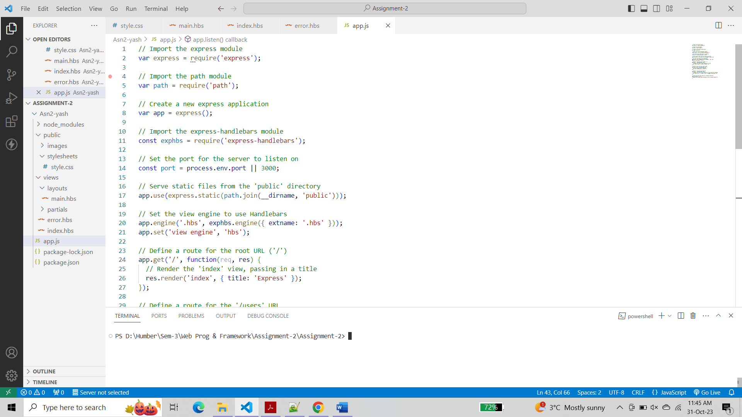

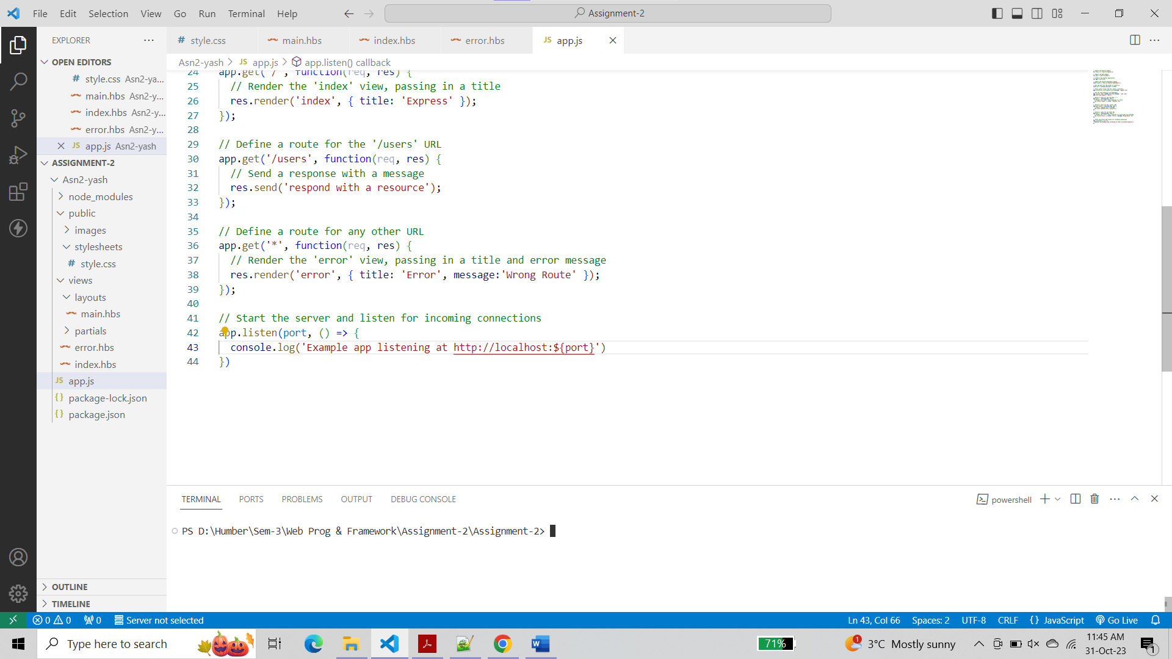

**Step 5 :-**

Modify the layout of the page and add “header”, “content” and “footer”

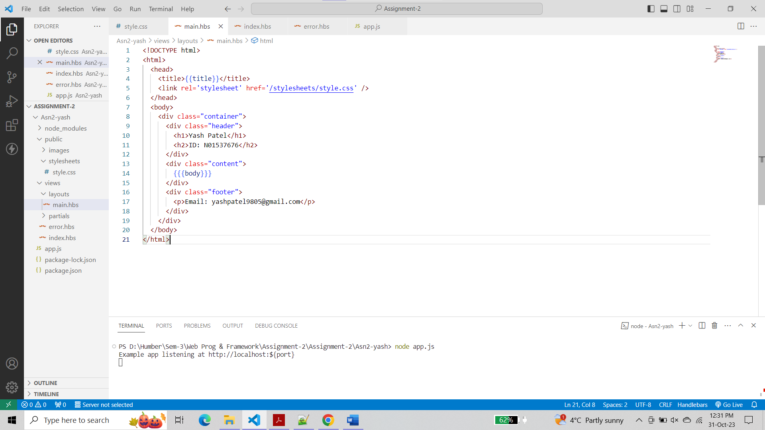

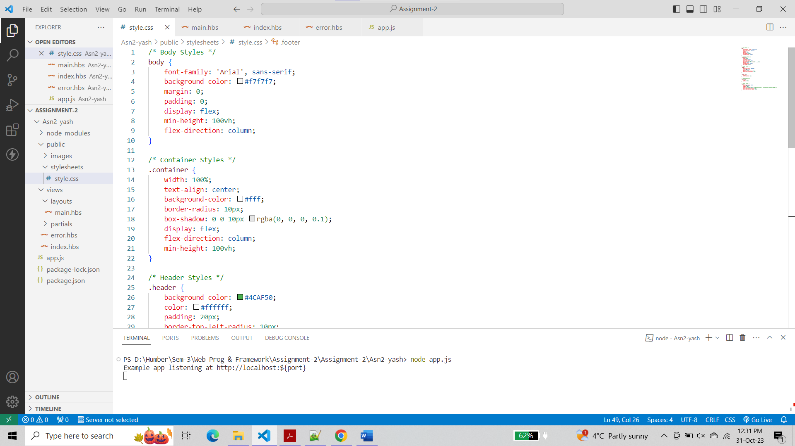

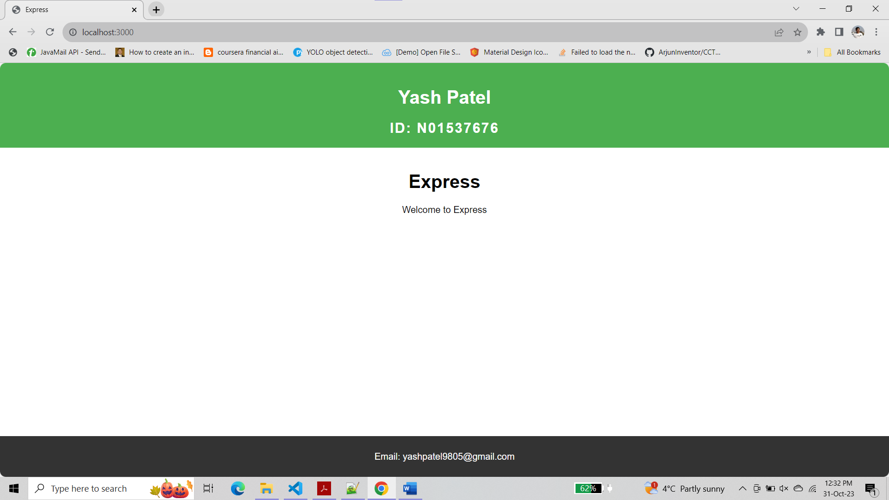

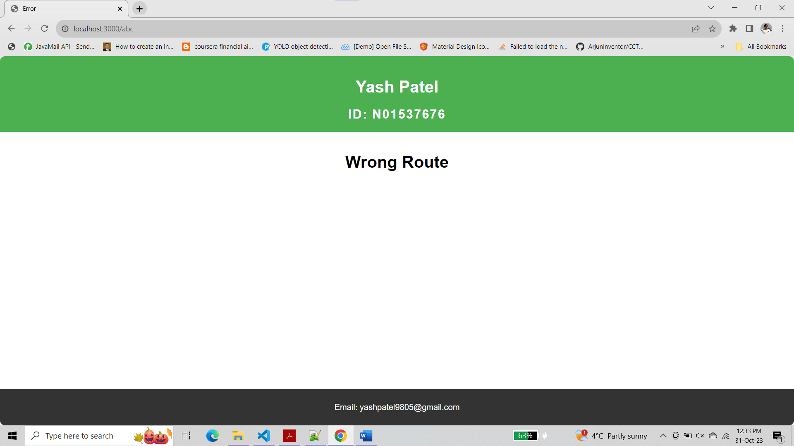

**Step 6 :-**

Displayed Assignment-1 code’s output using handlebars

**For route ‘/cv’ :-**

**app.js**

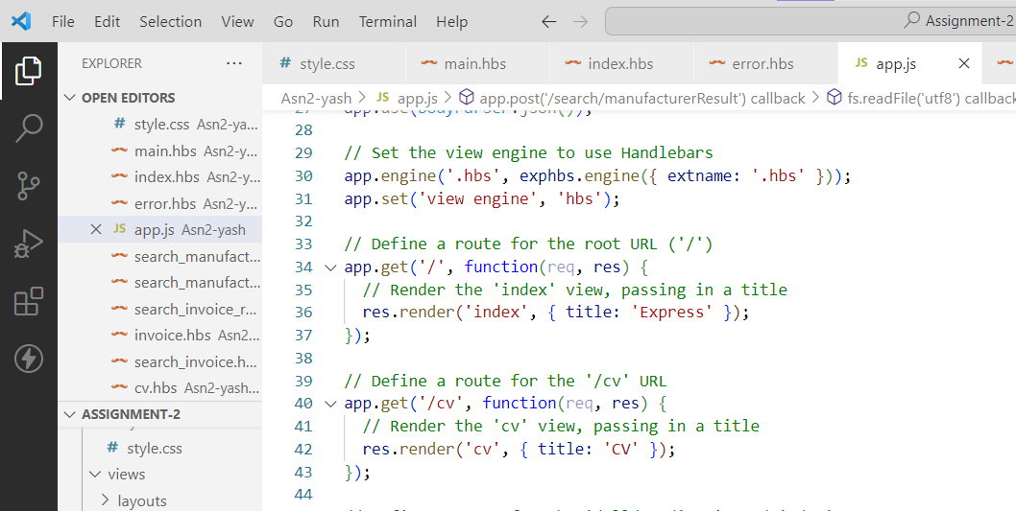

**cv.hbs**

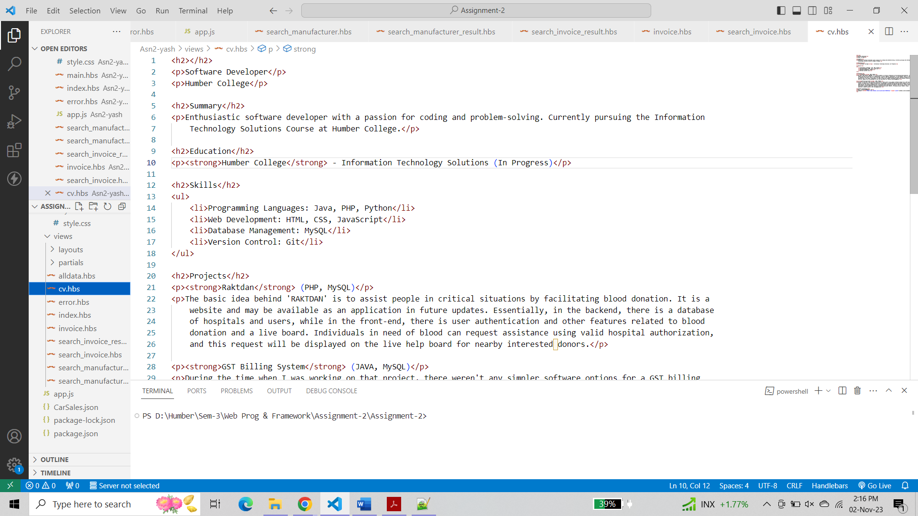

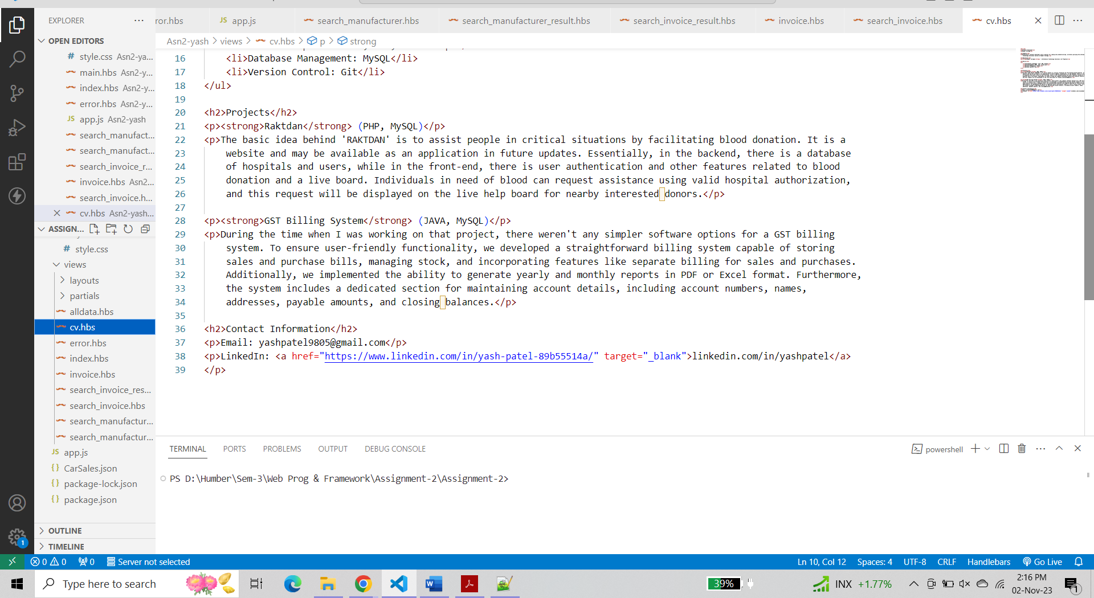

**Output**

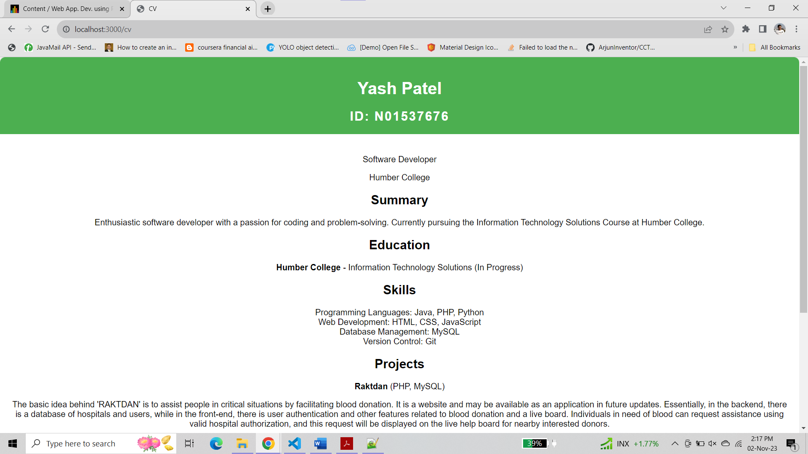

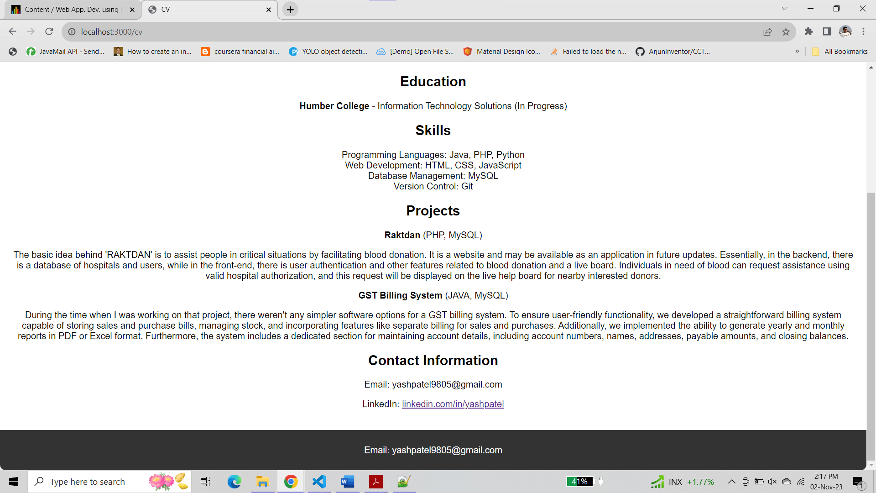

**For route '/alldata/invoiceNo/:index'**

**app.js**

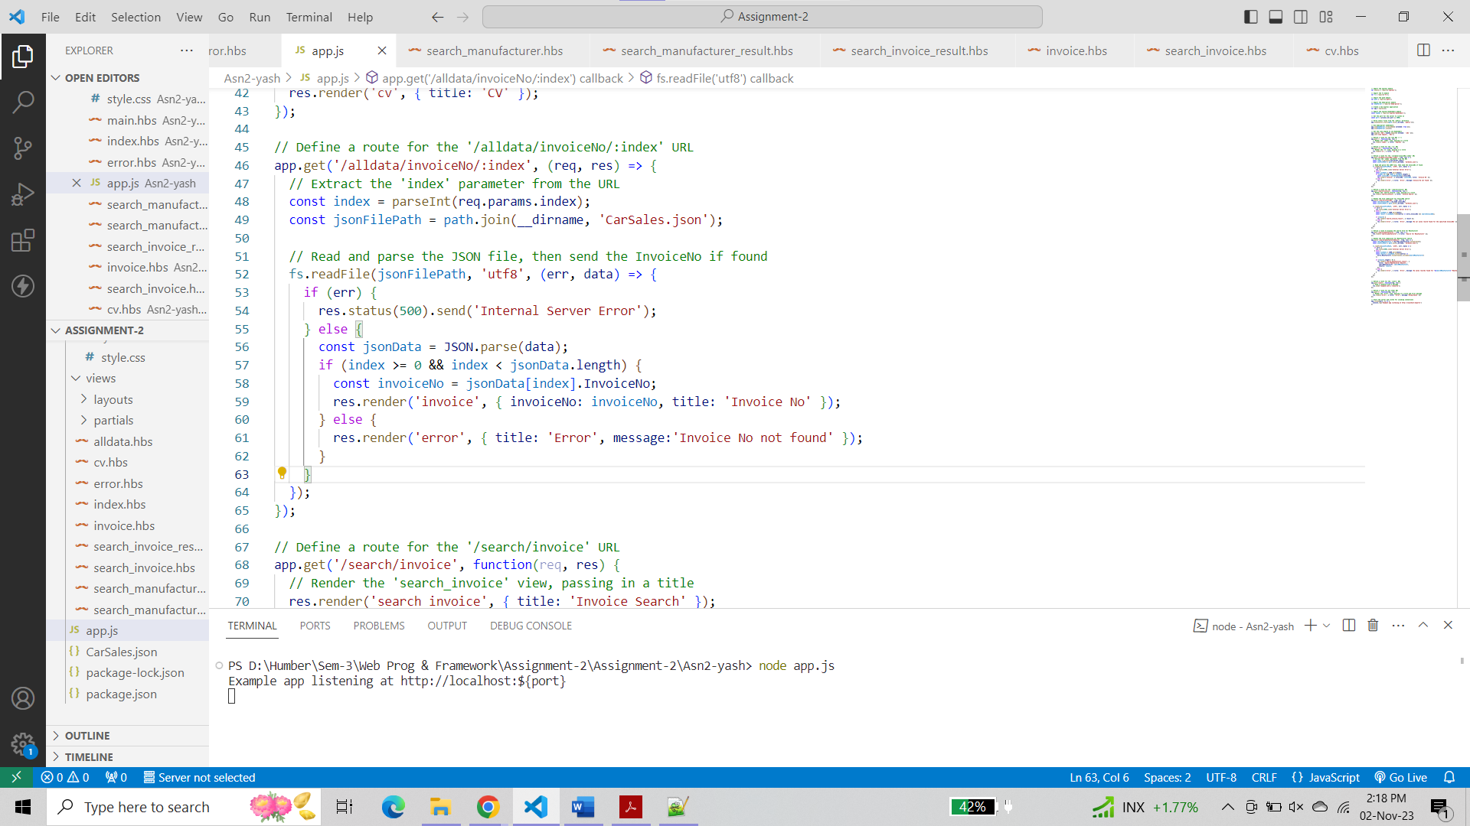

**invoice.hbs**

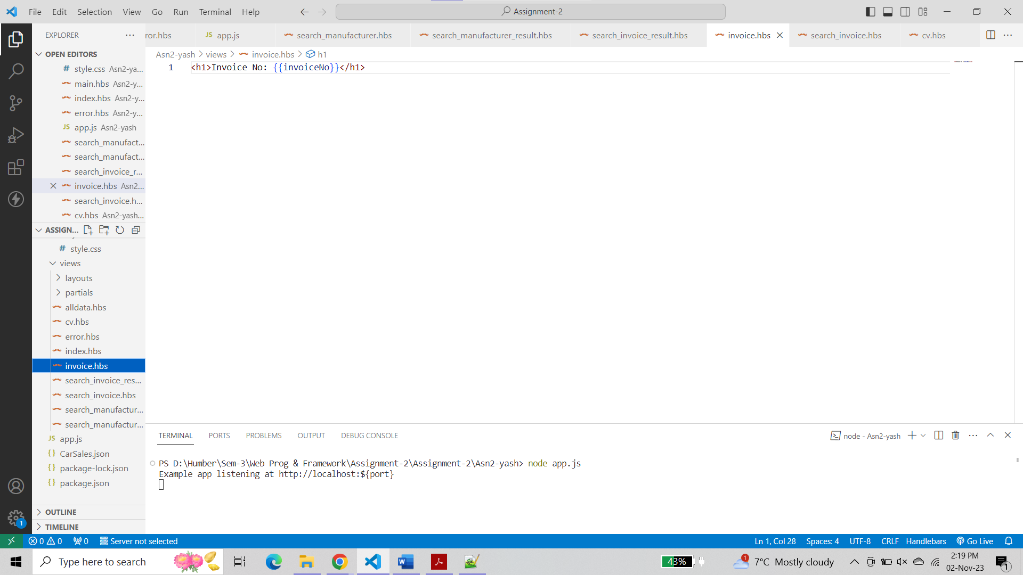

**Output**

For index ‘0’

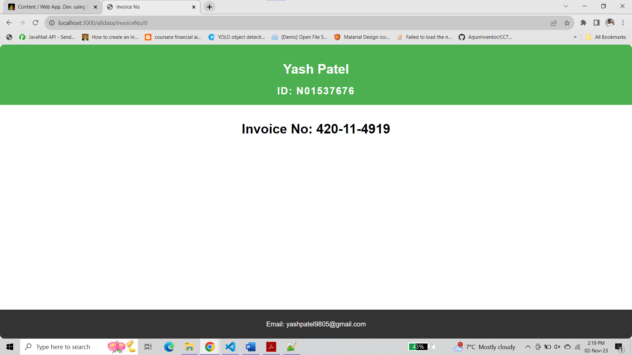

For index ‘a’

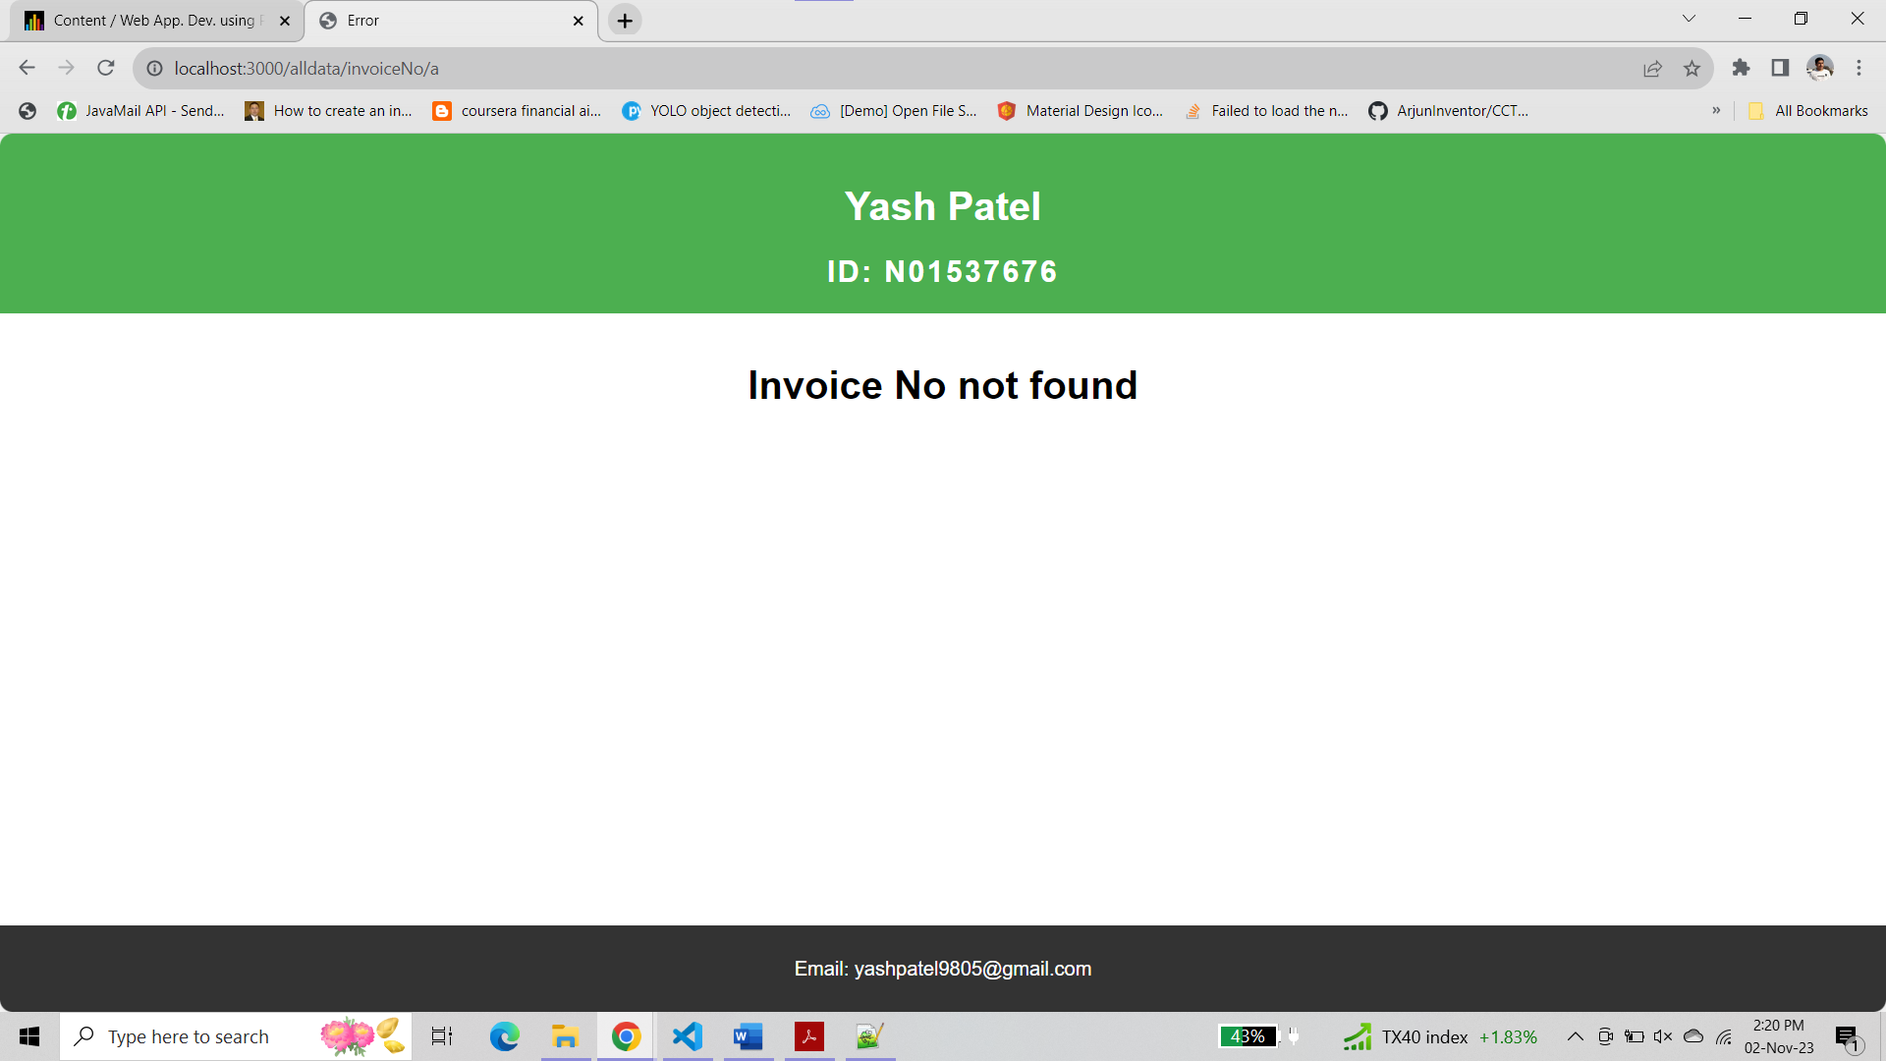

**For route '/search/invoice'**

**app.js**

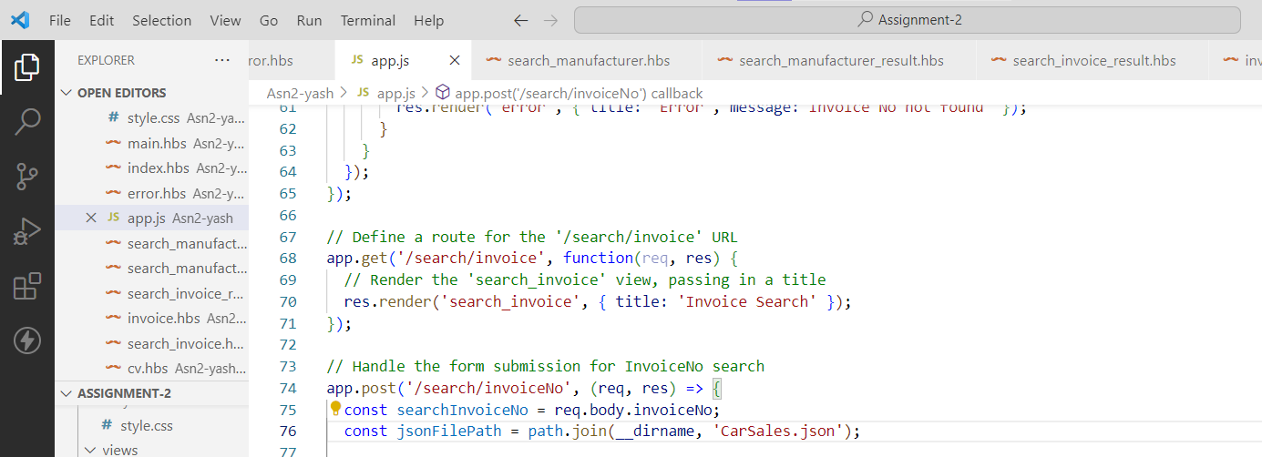

**search_invoice.hbs**

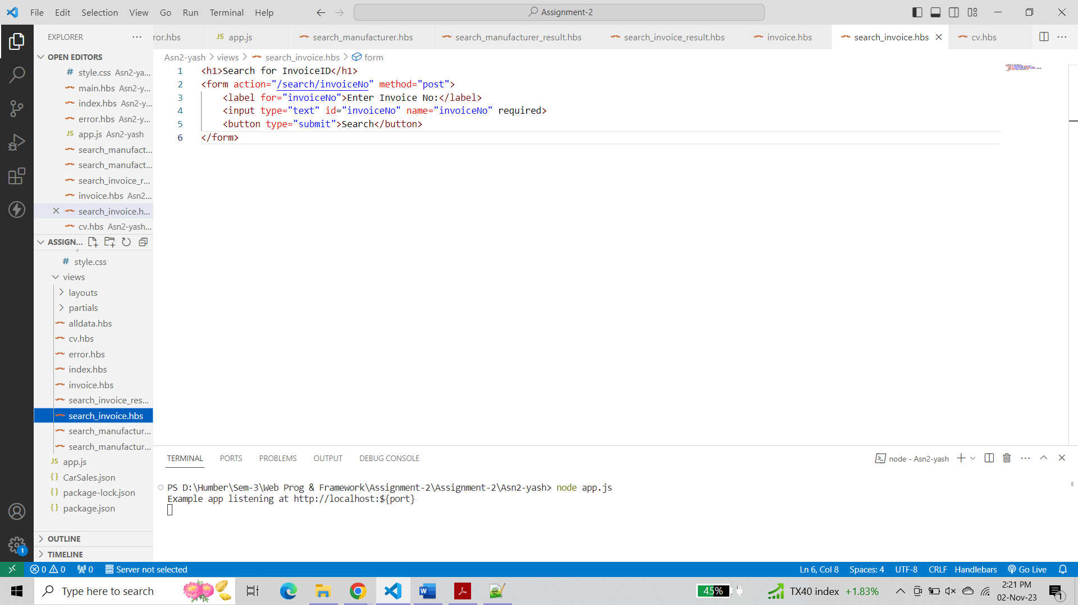

**For route '/search/invoiceNo' which will handle the form submission for InvoiceNo search**

**app.js**

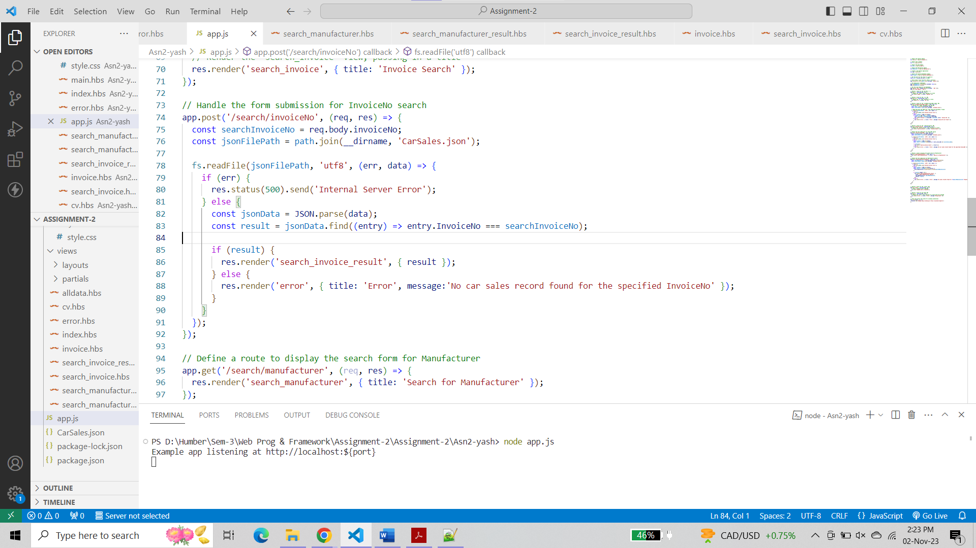

**search_invoice_result.hbs**

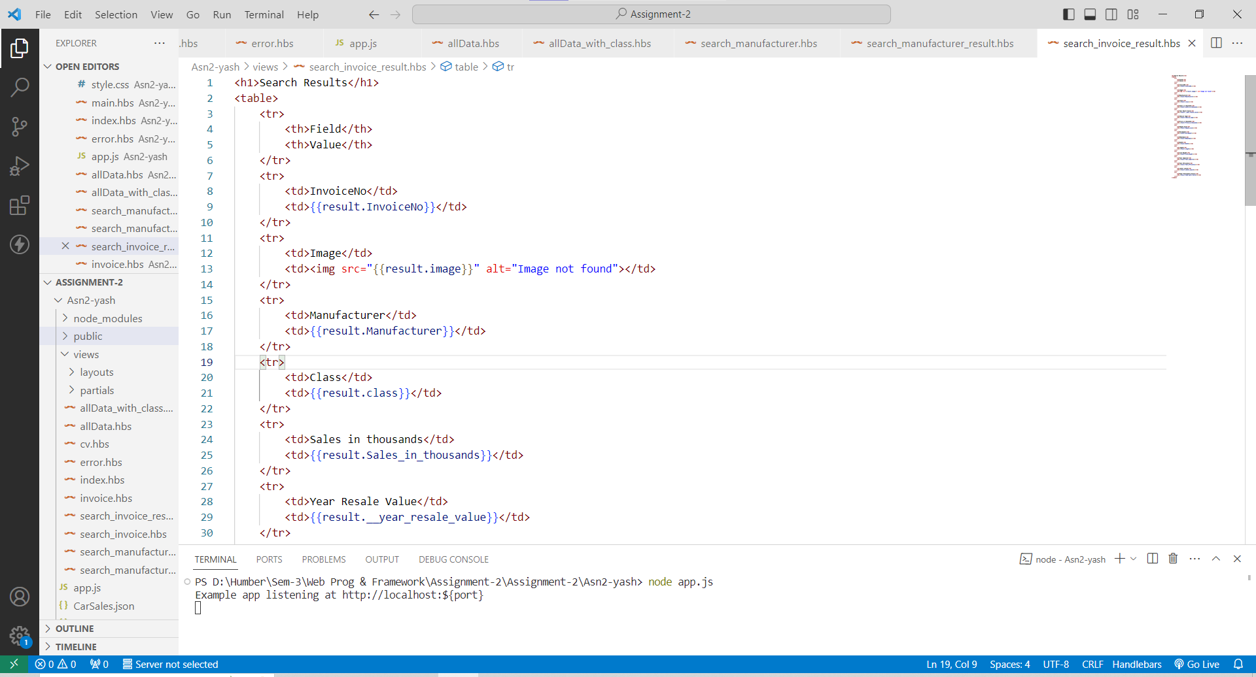

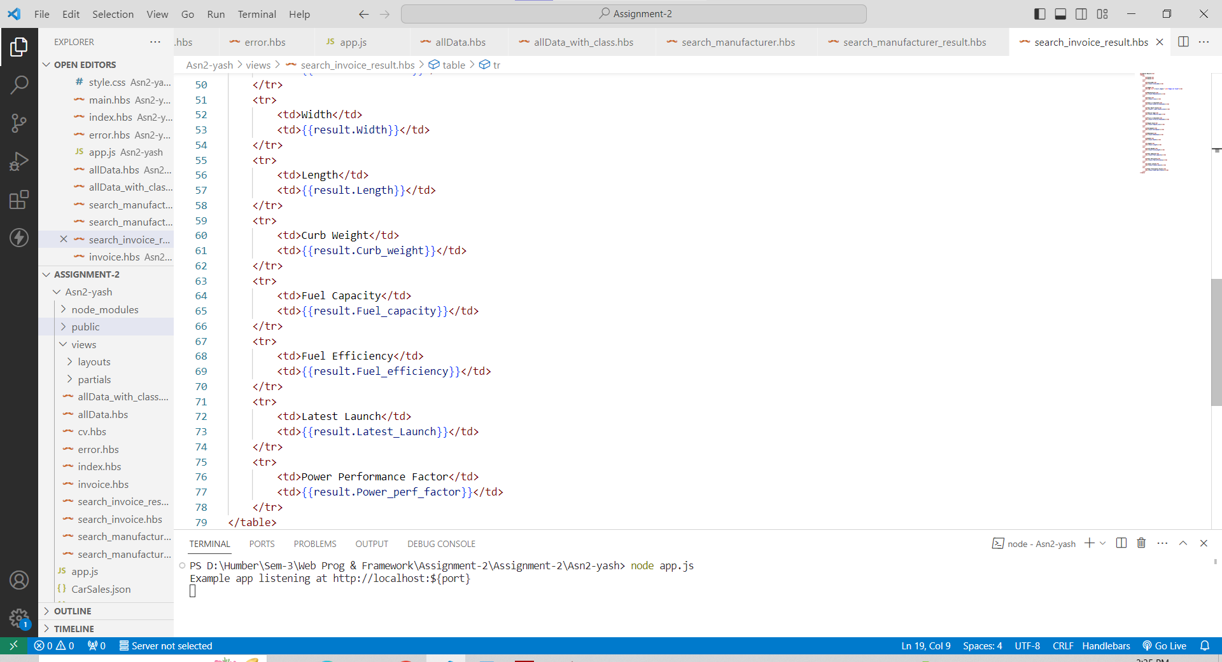

**Output**

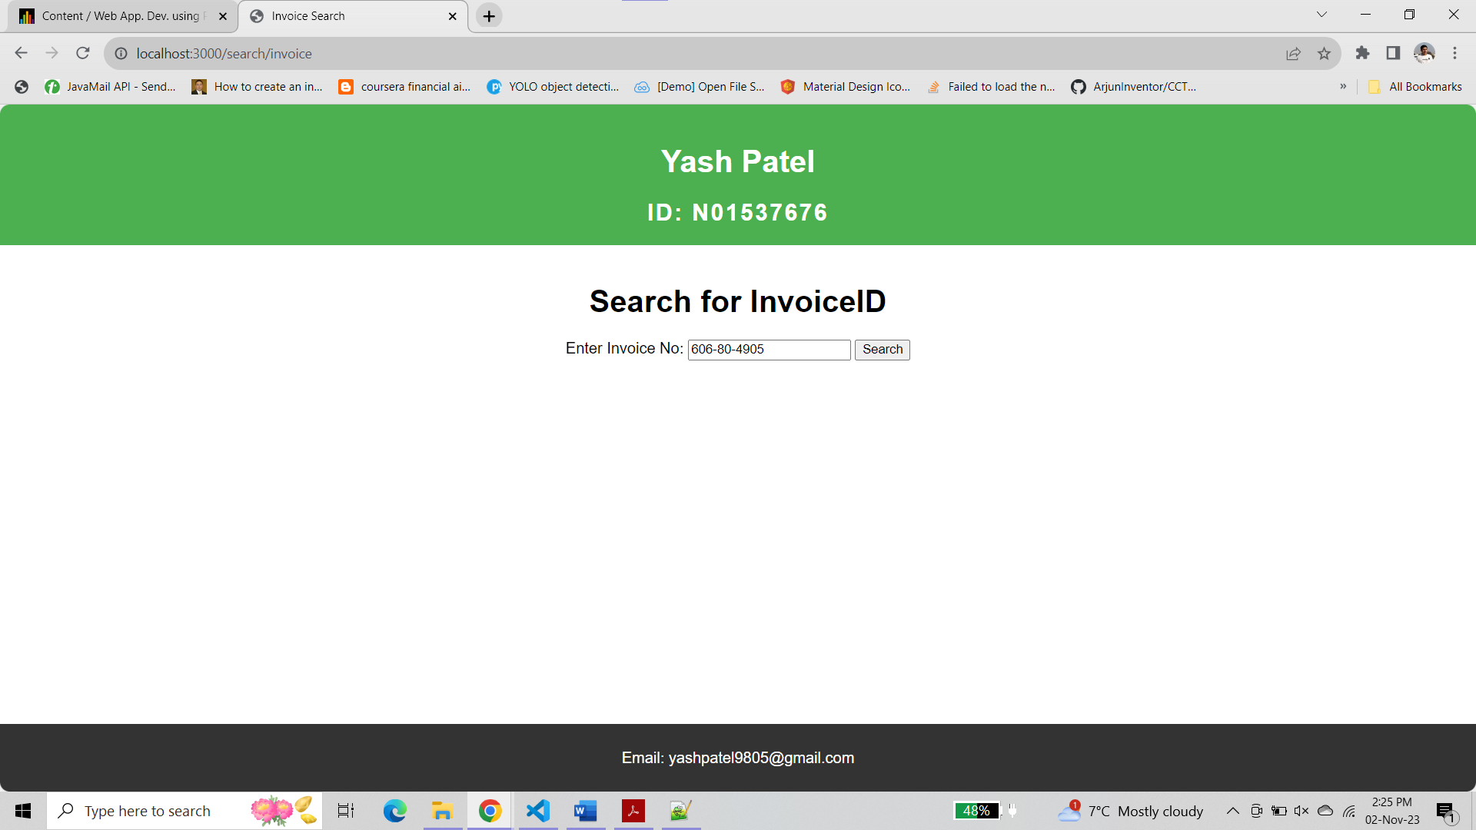

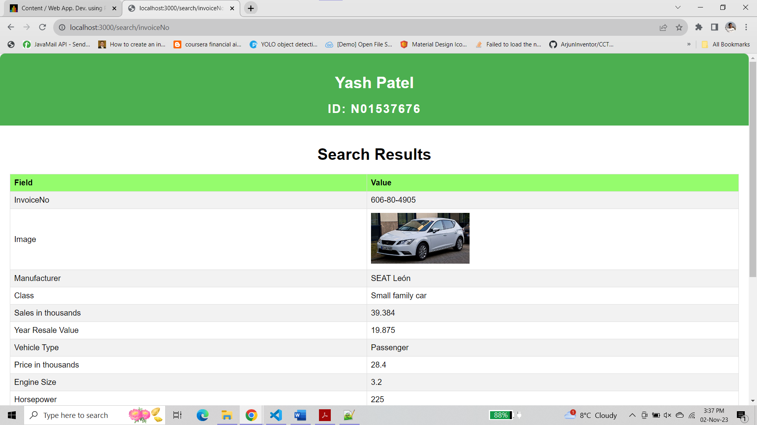

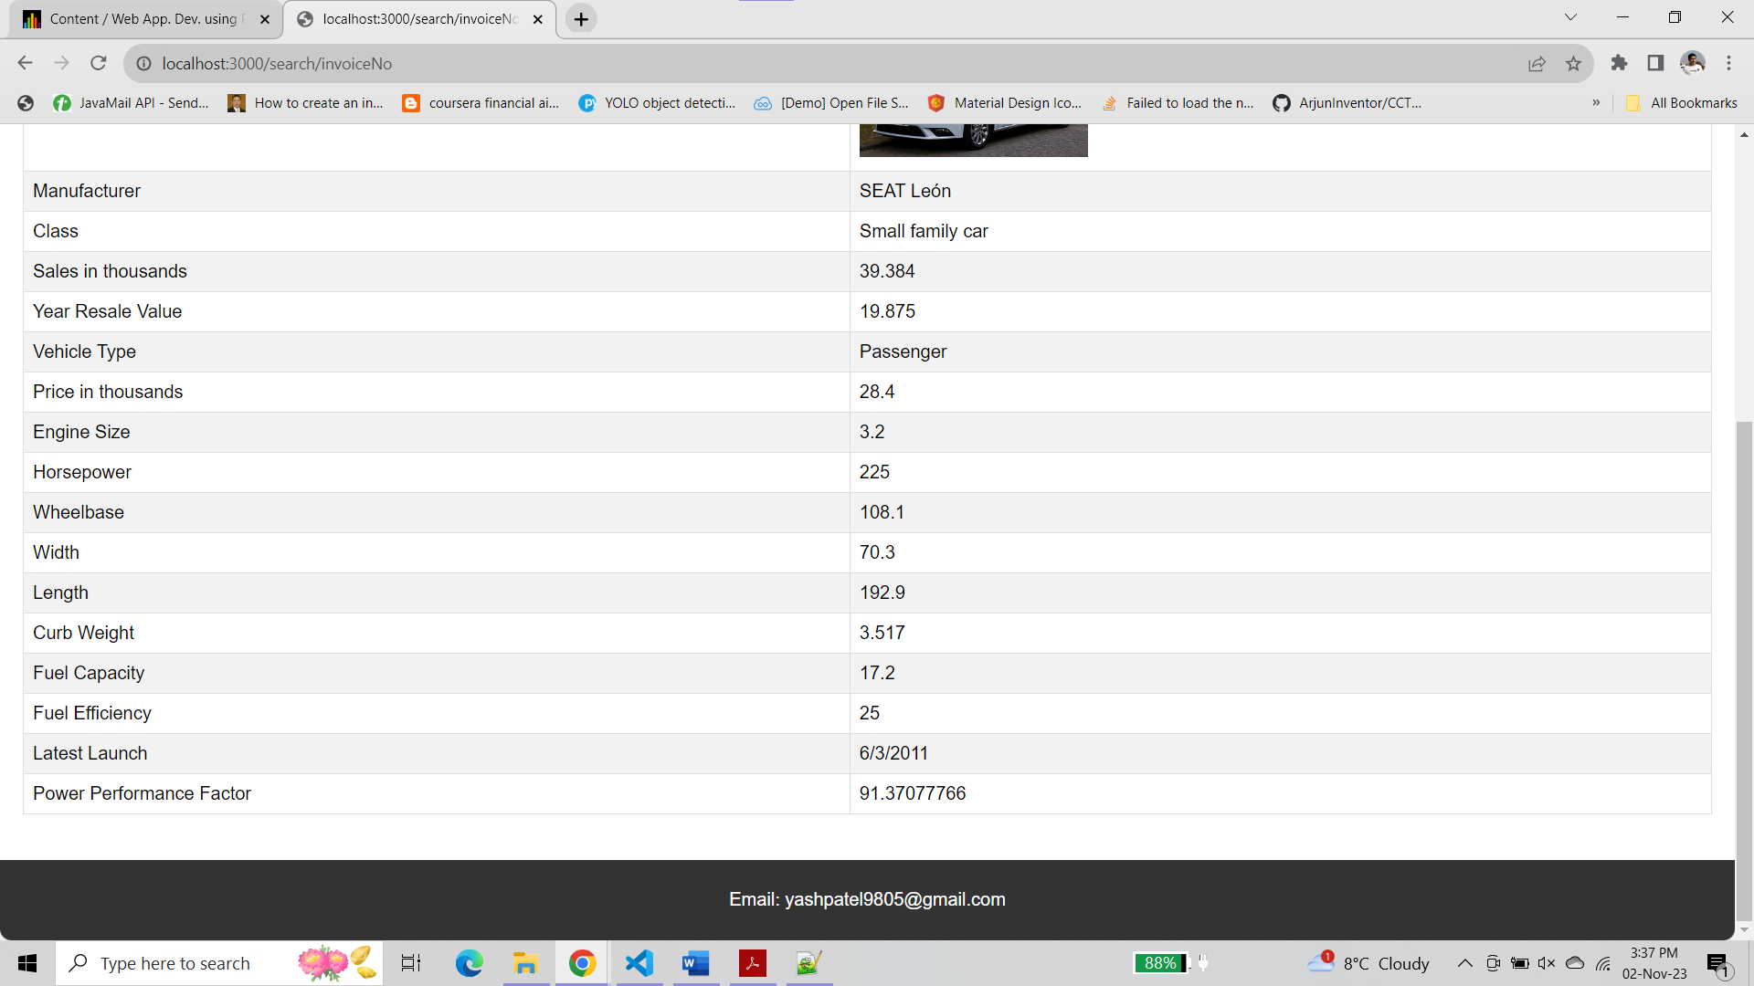

**For incorrect invoice no**

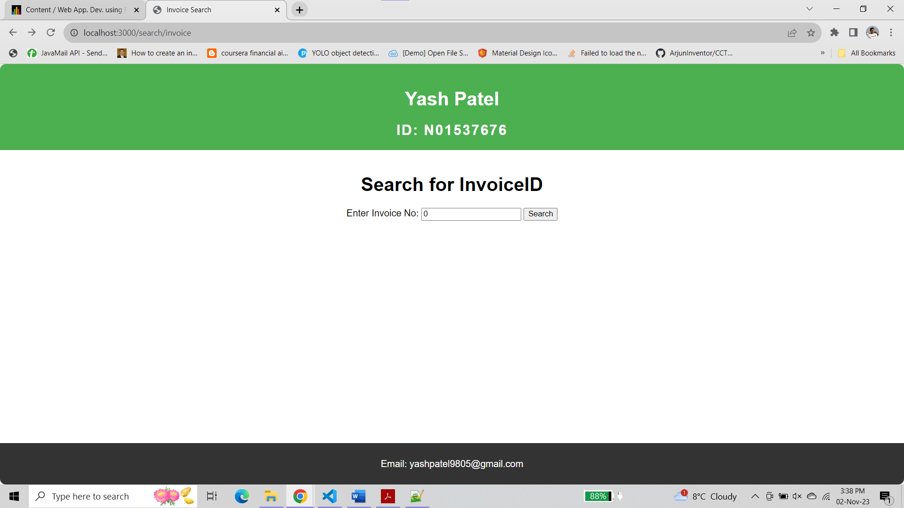

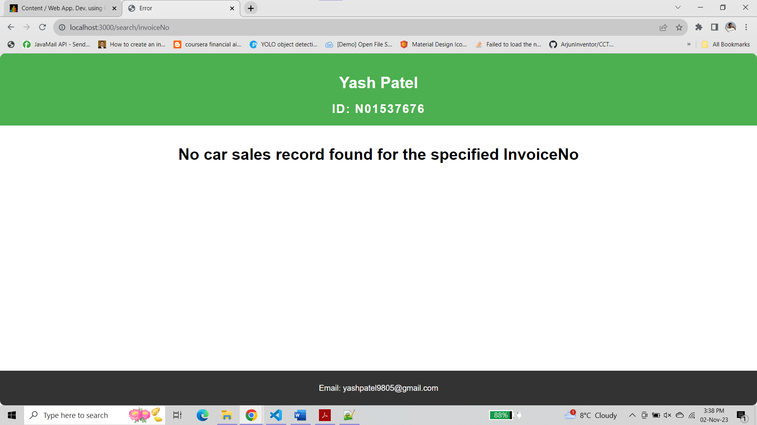

**Route ‘search/manufacturer’ to display the search form for manufacturer**

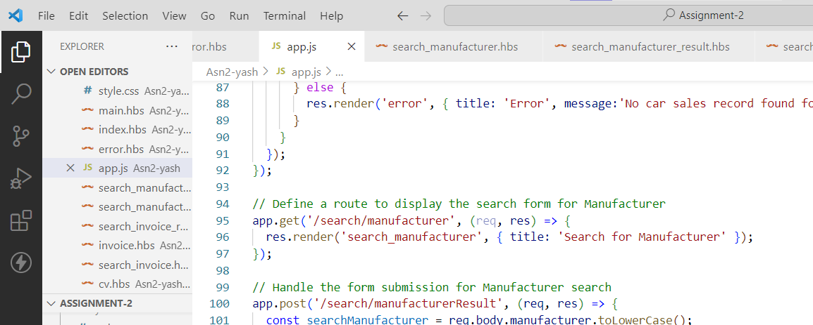

**search_manufacturer.hbs**

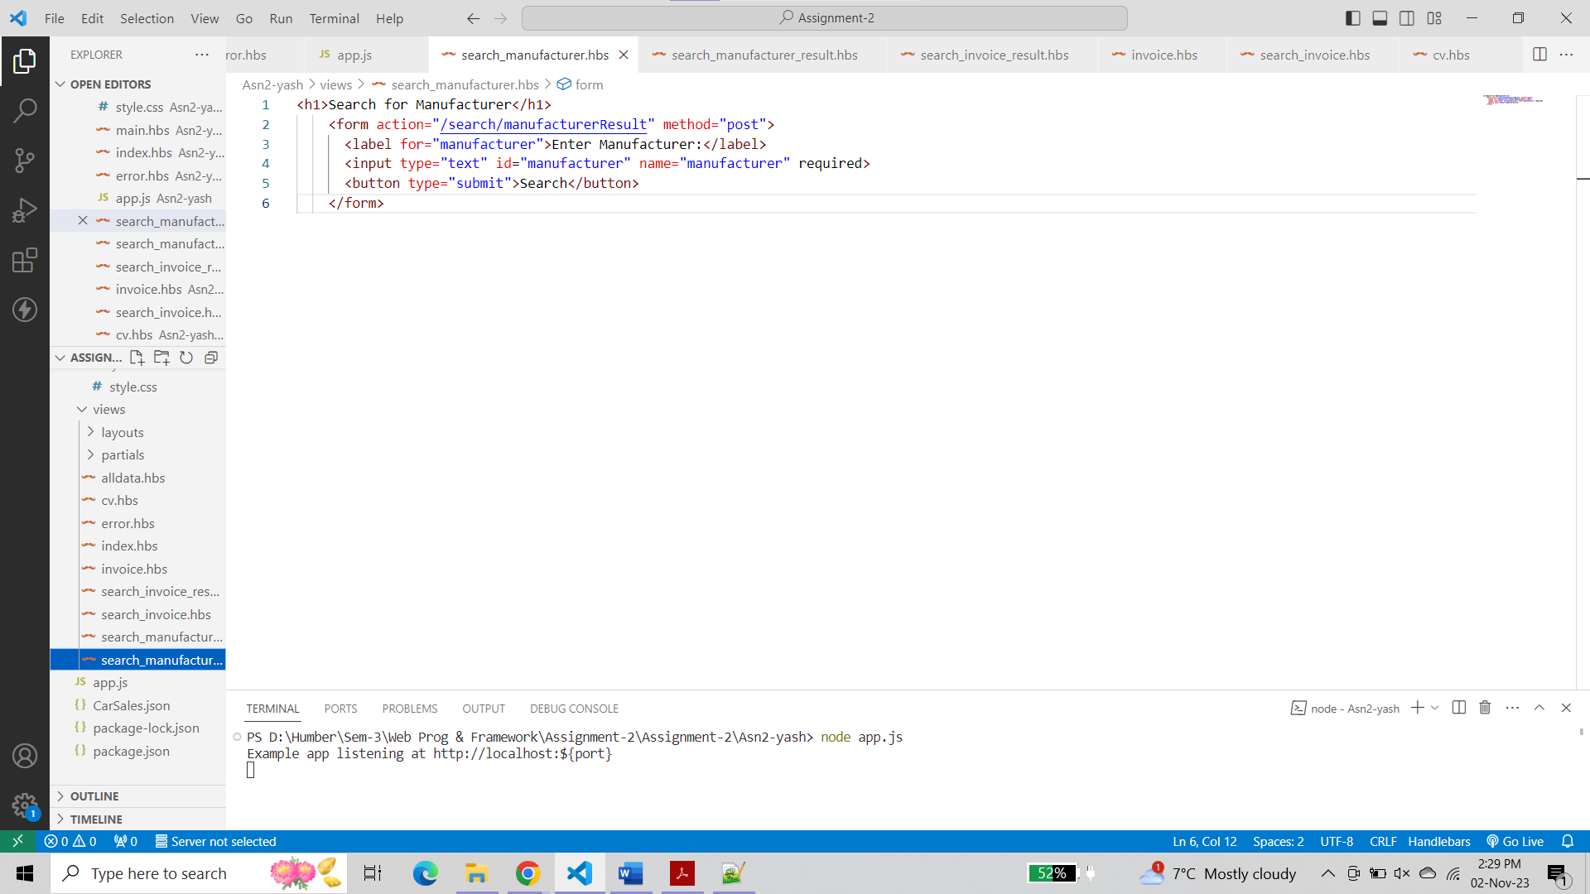

**Route '/search/manufacturerResult' to handle the form submission for Manufacturer search**

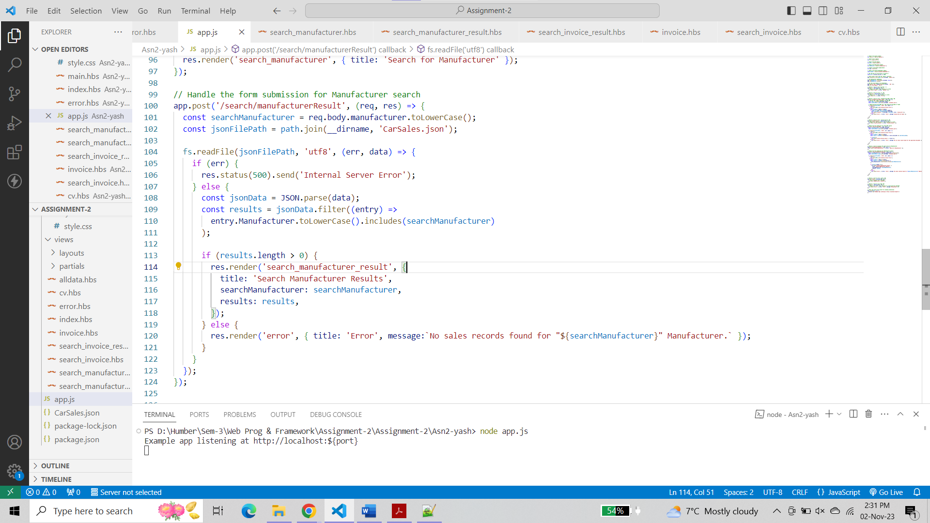

**search_manufacturerResult.hbs**

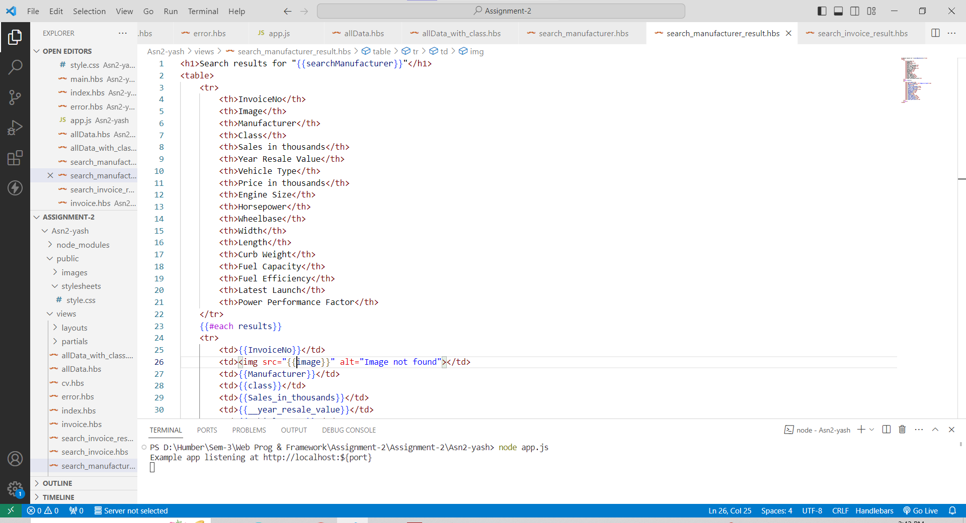

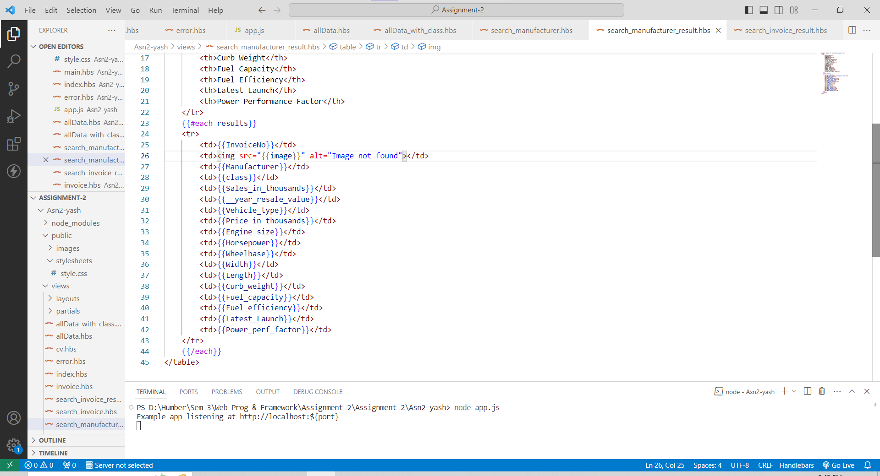

**Output**

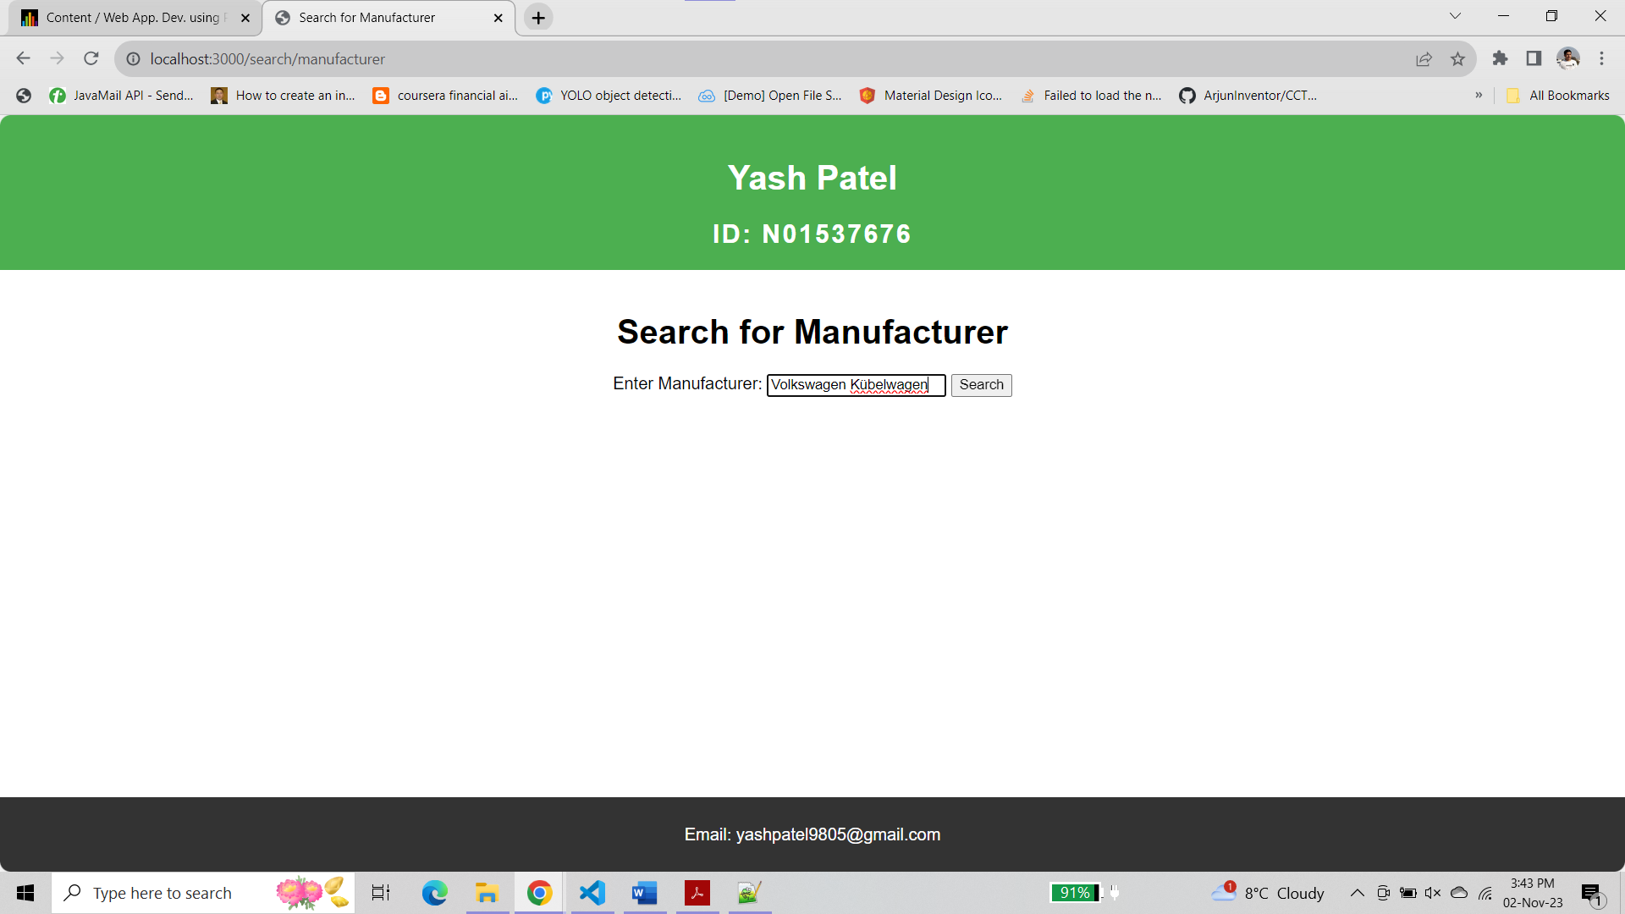

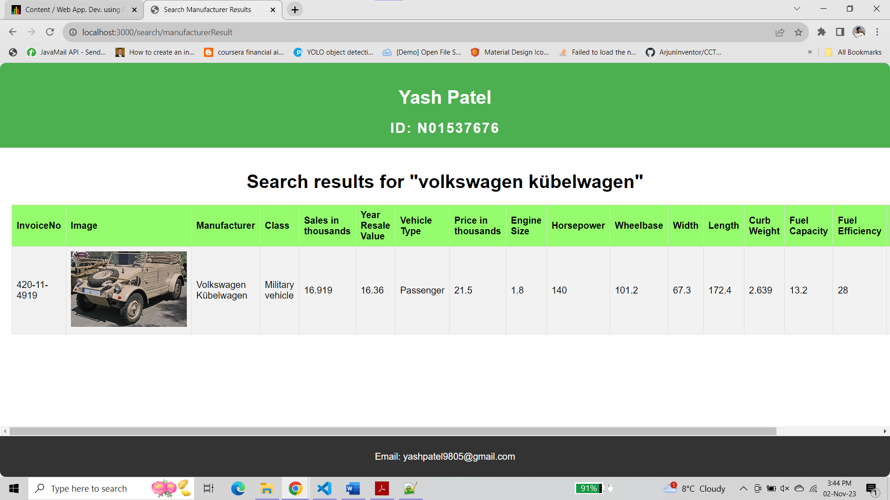

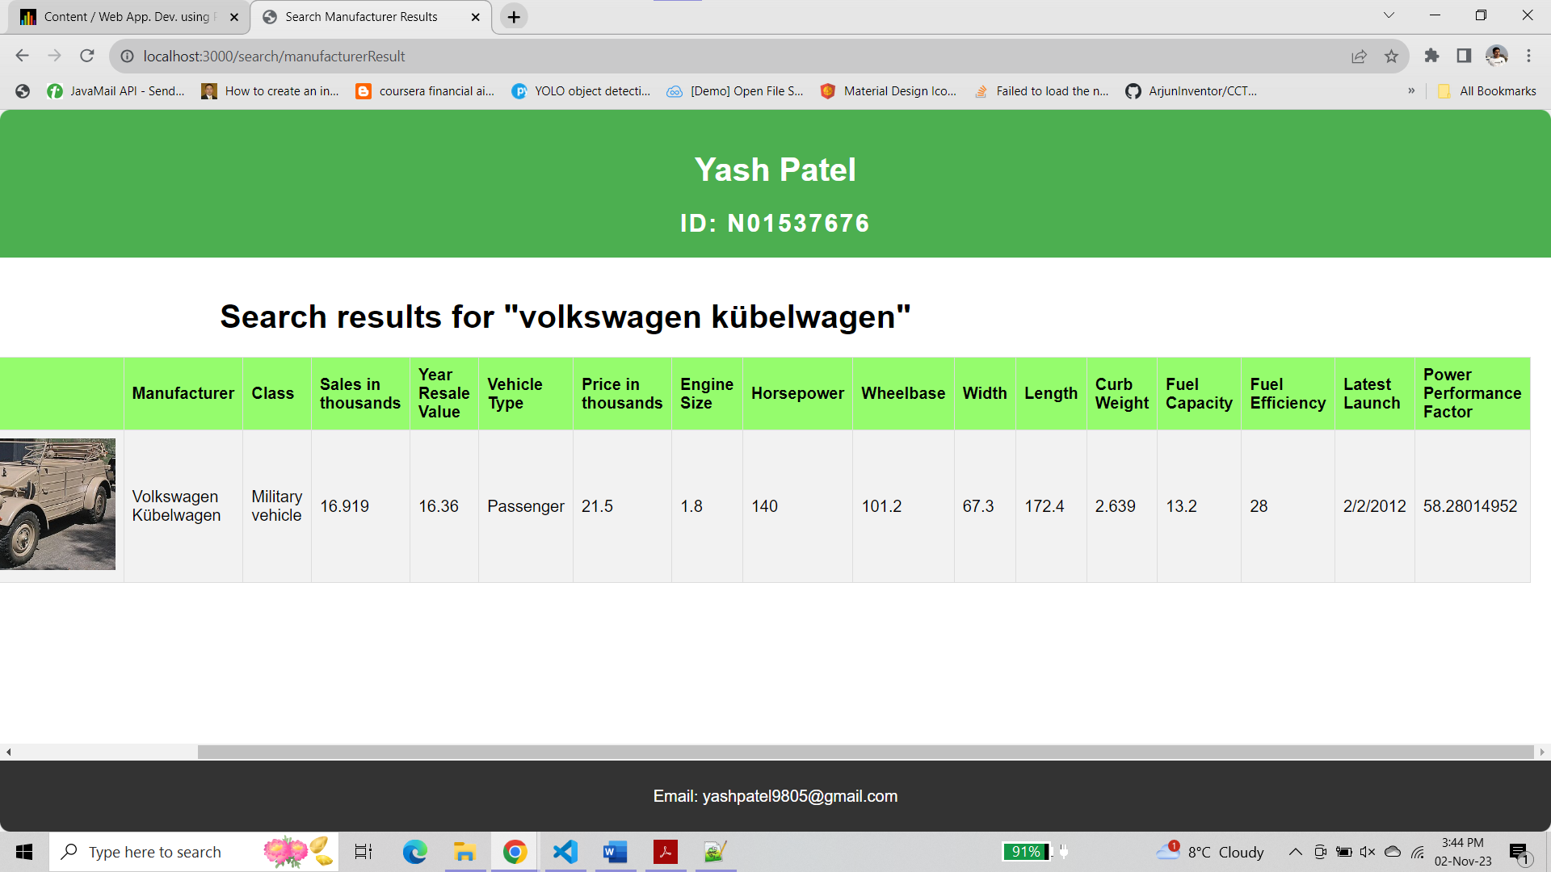

**For partial search ‘Volks’**

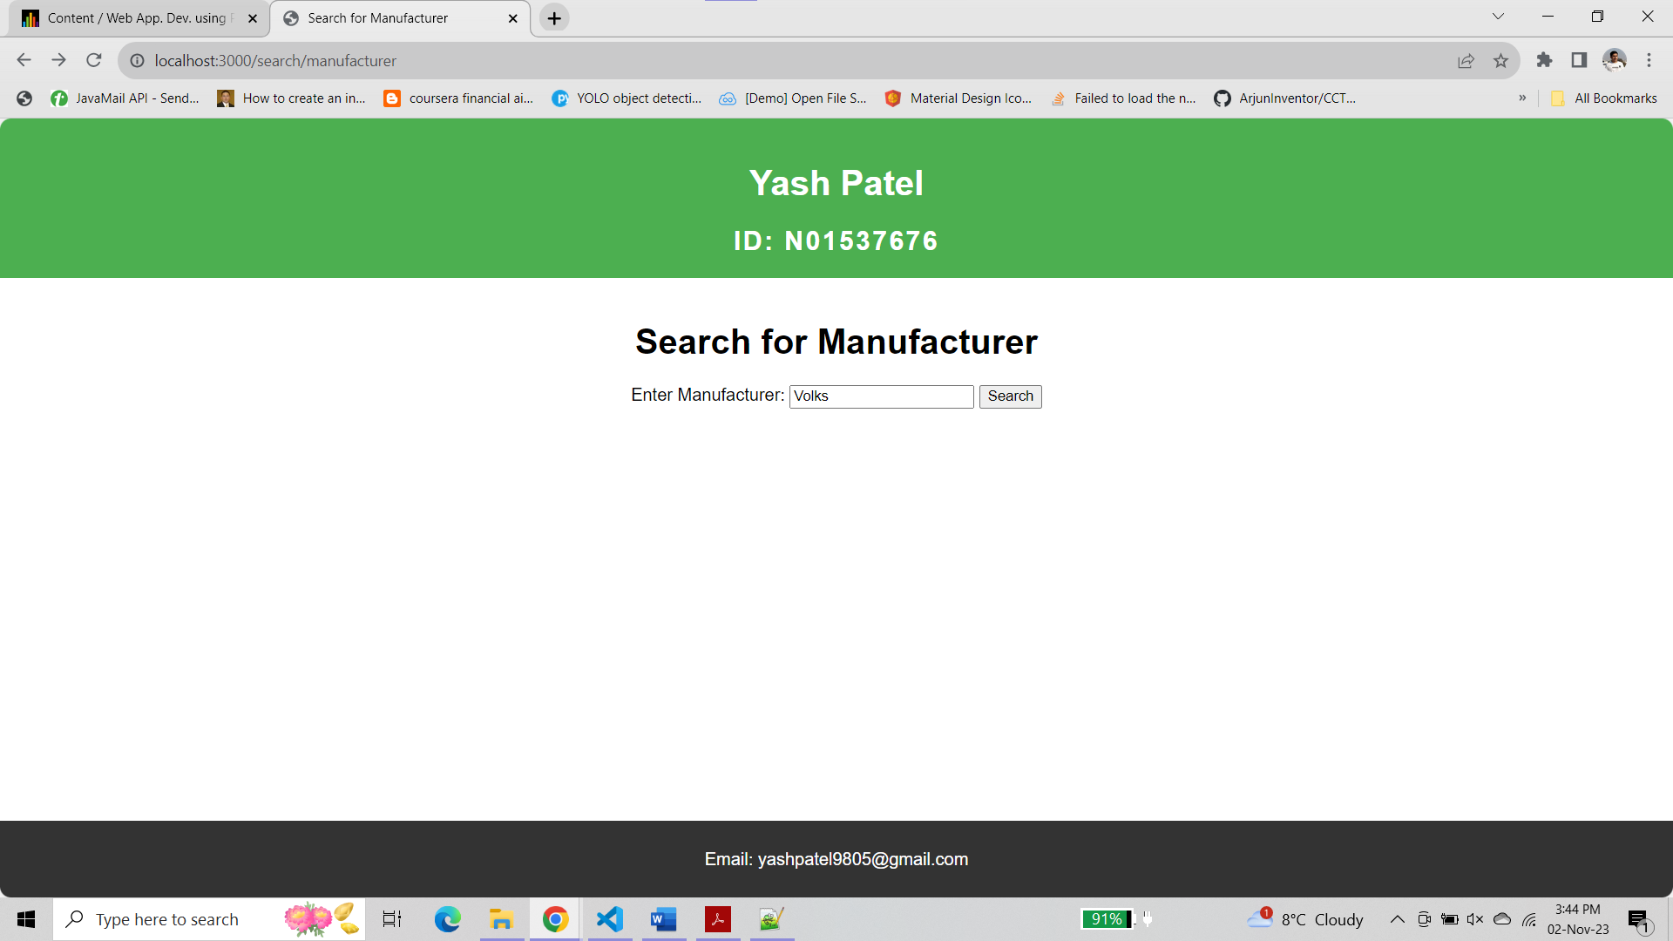

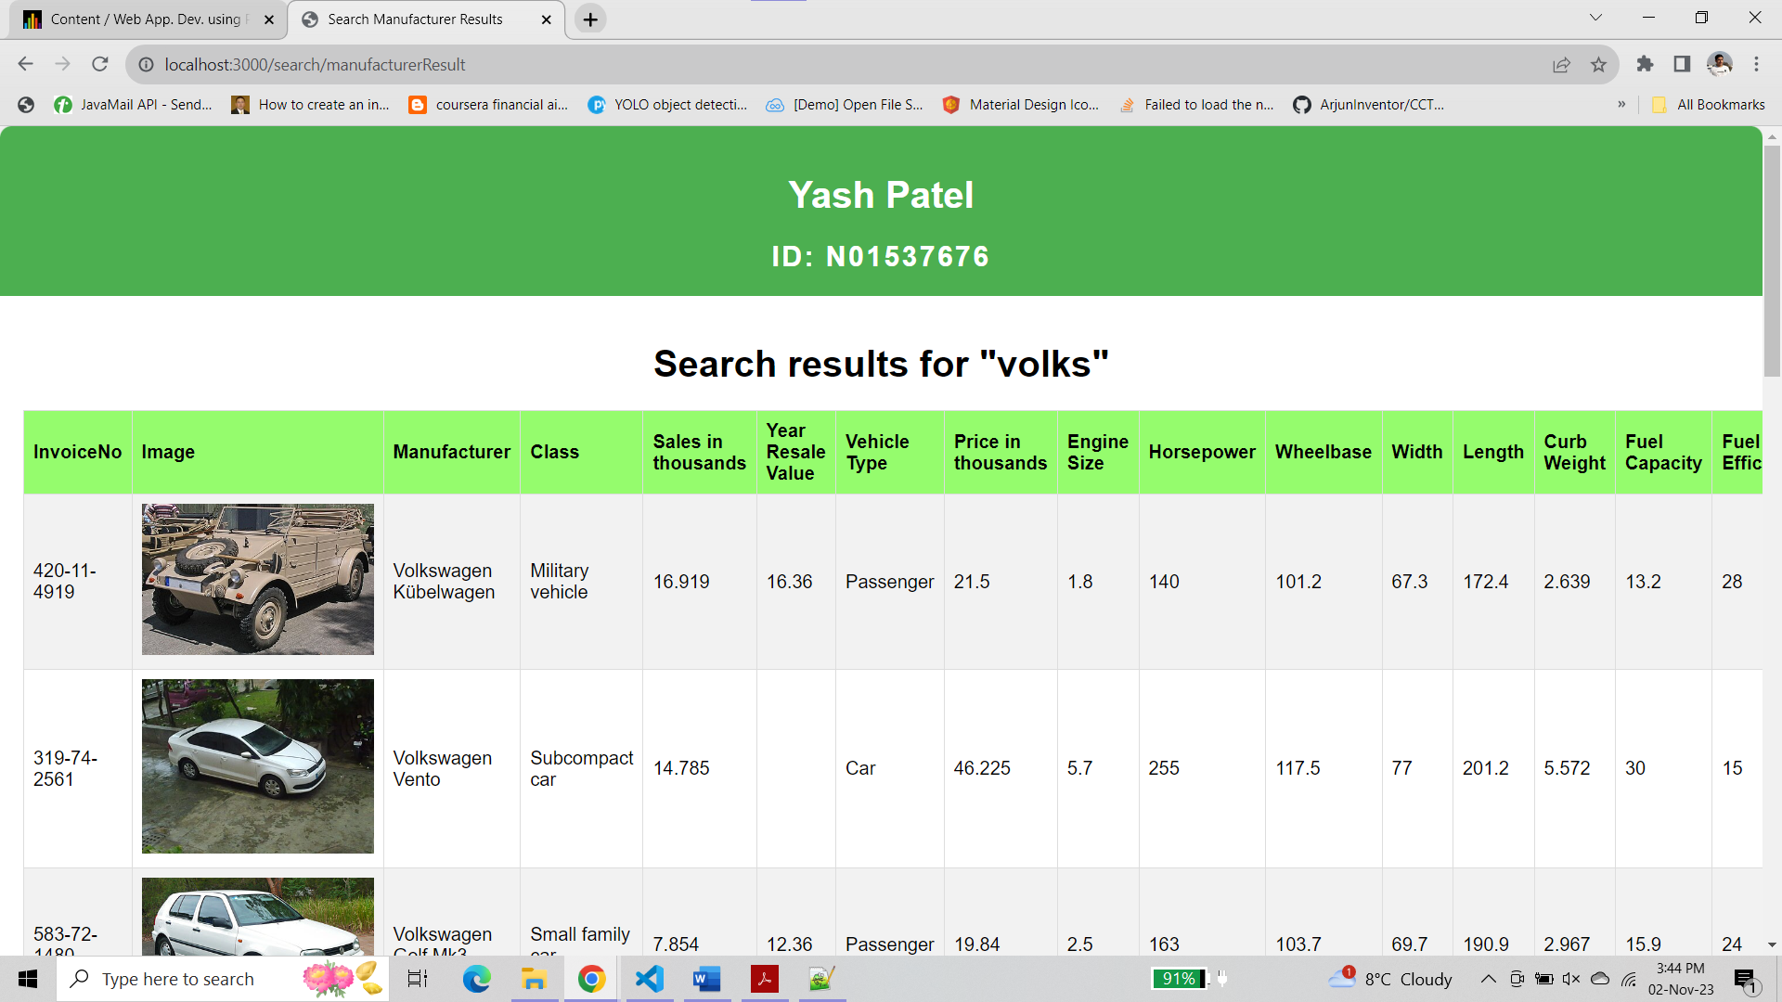

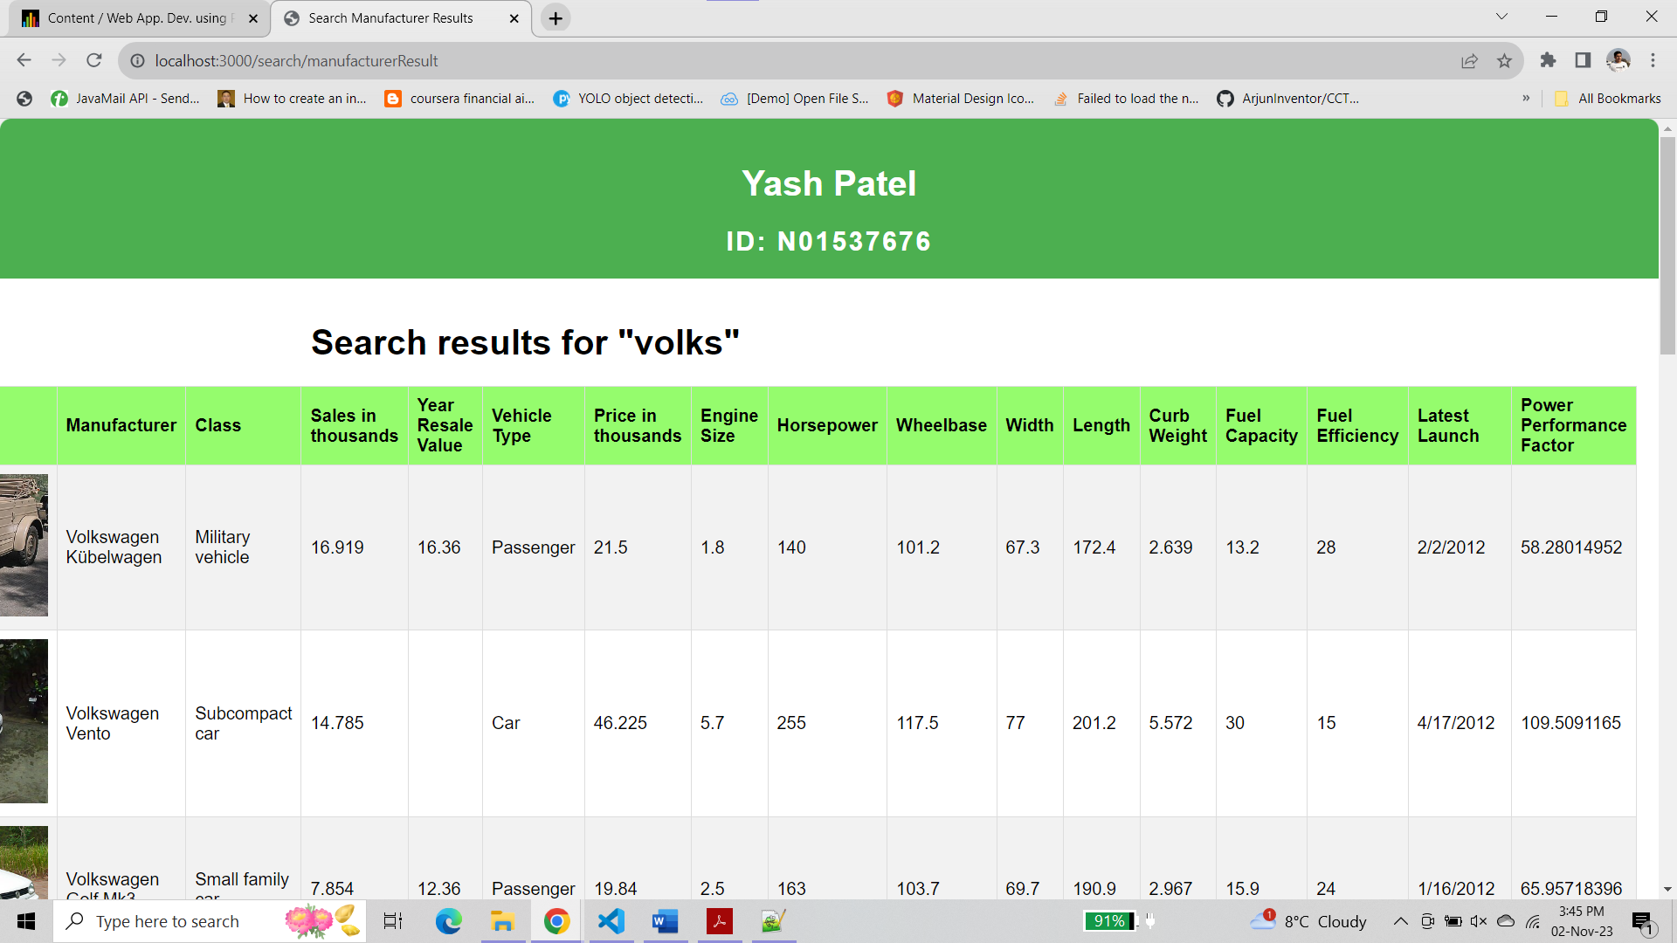

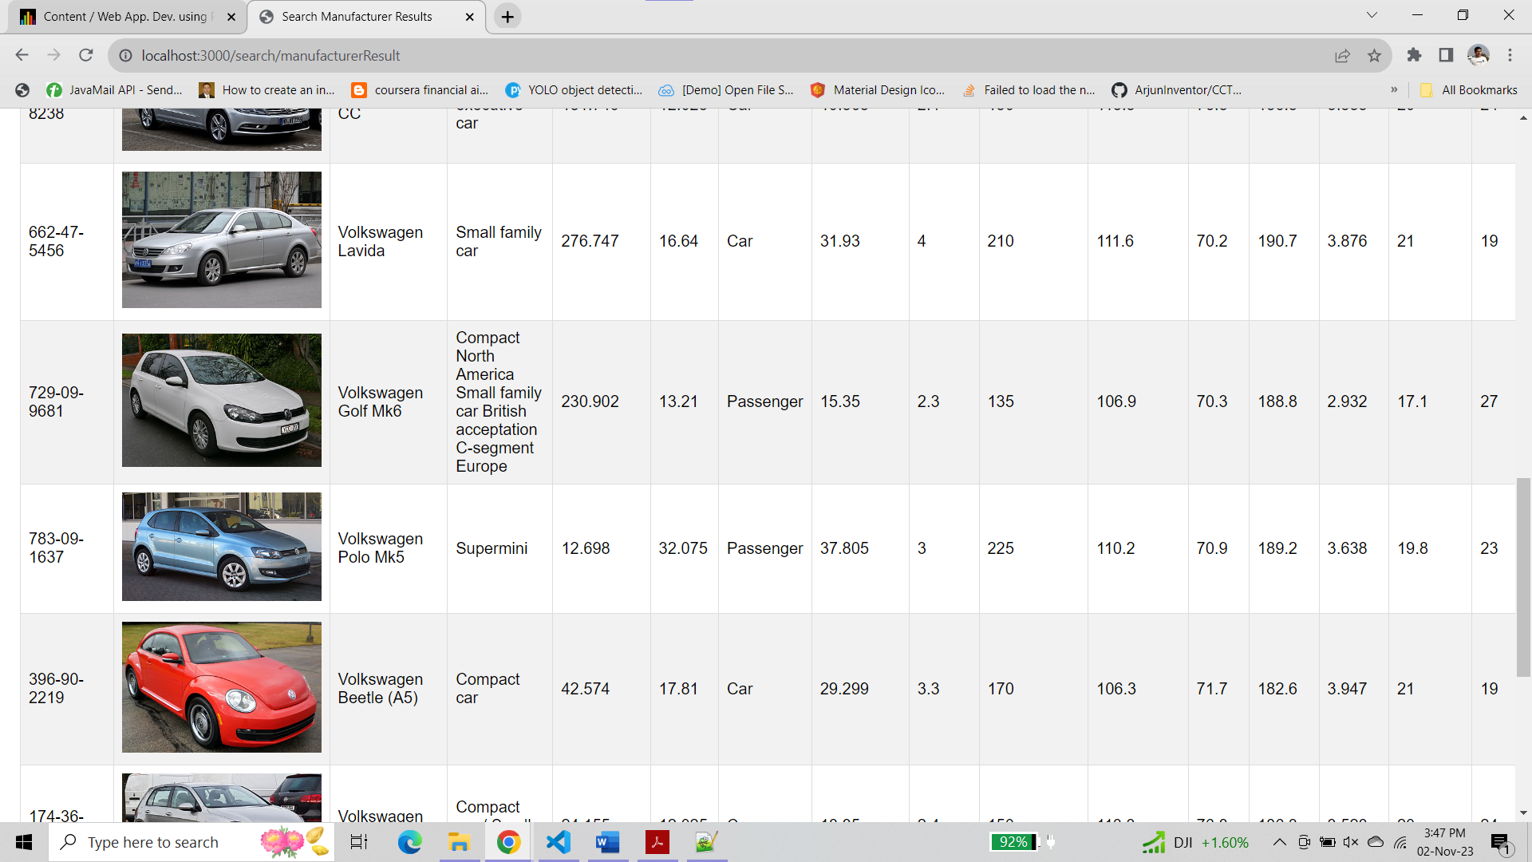

**For incorrect manufacturer**

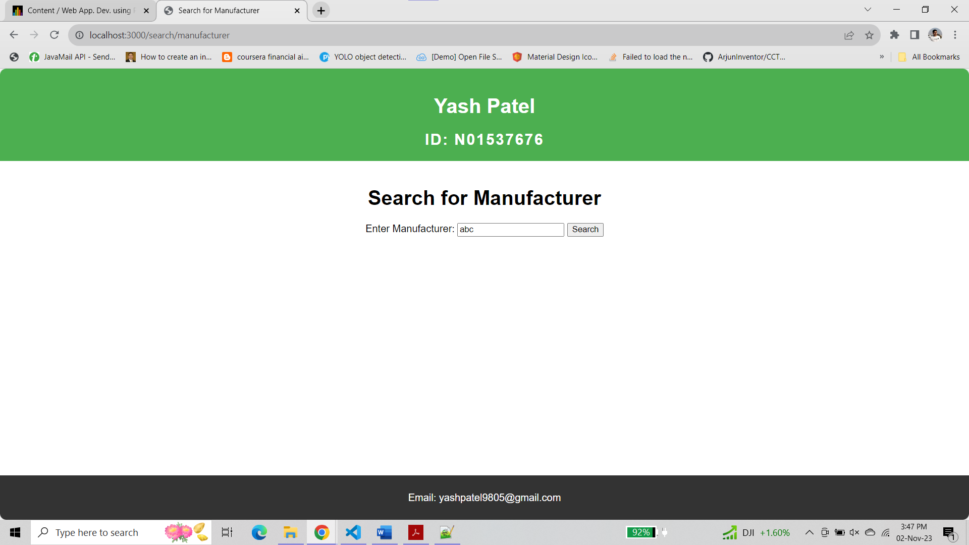

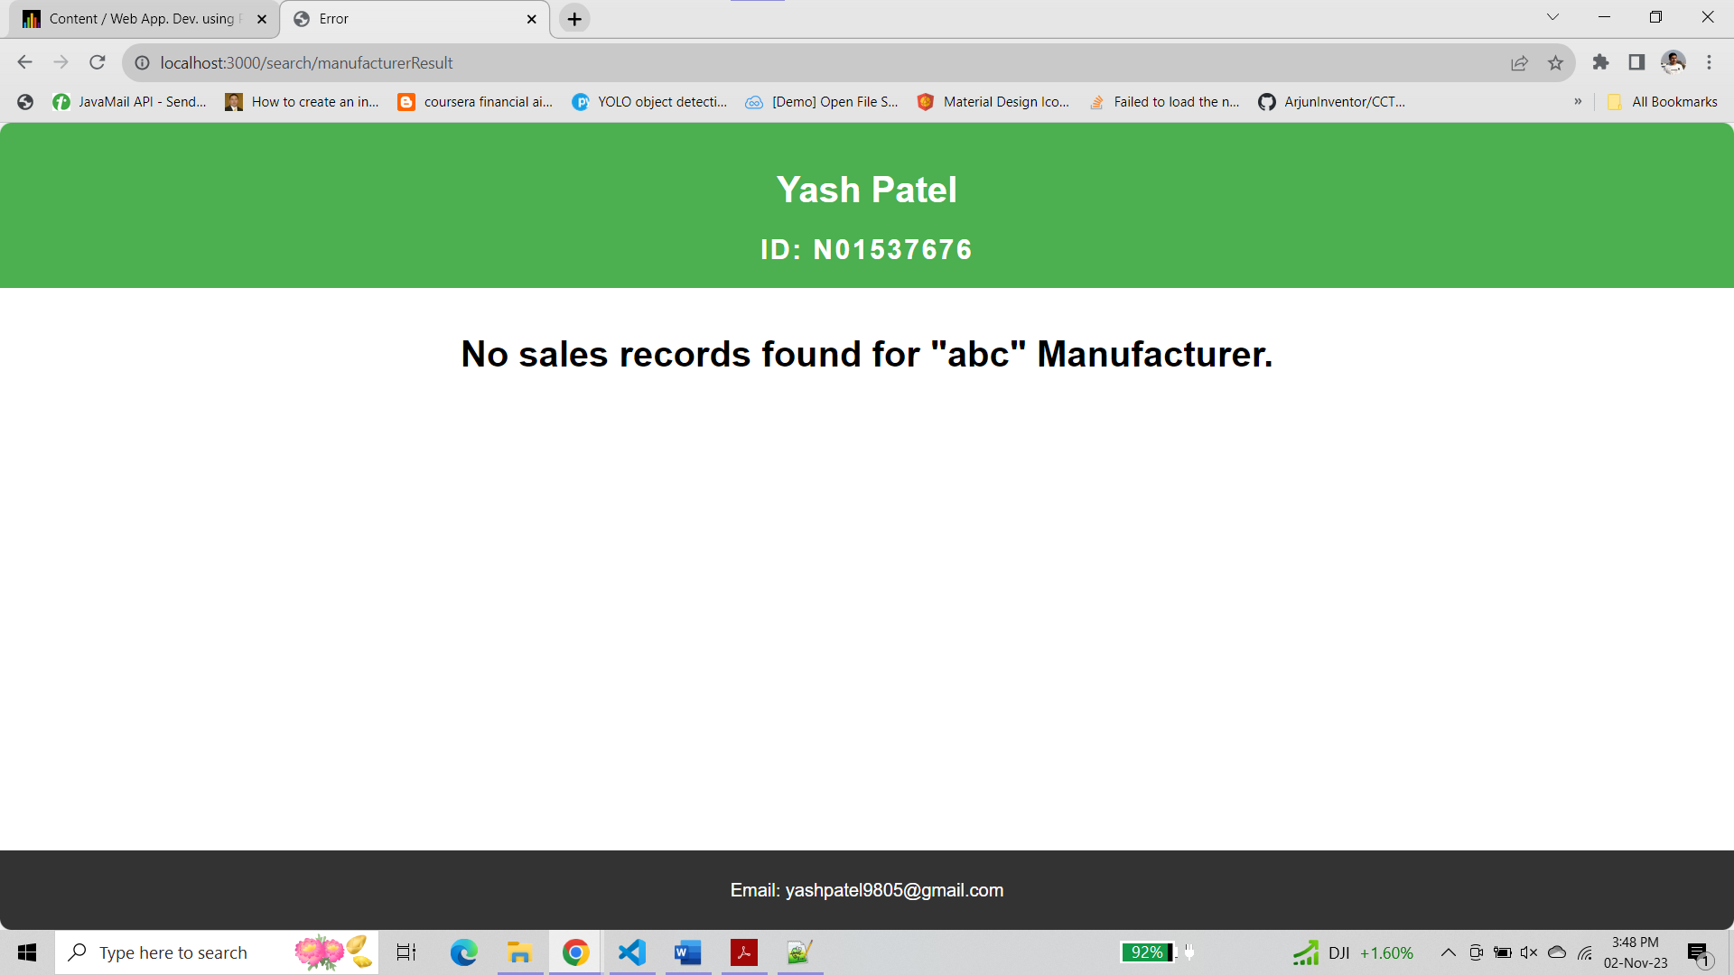

**Step 7 :-**

**Design a new route “/allData” to display all sales info in html table**

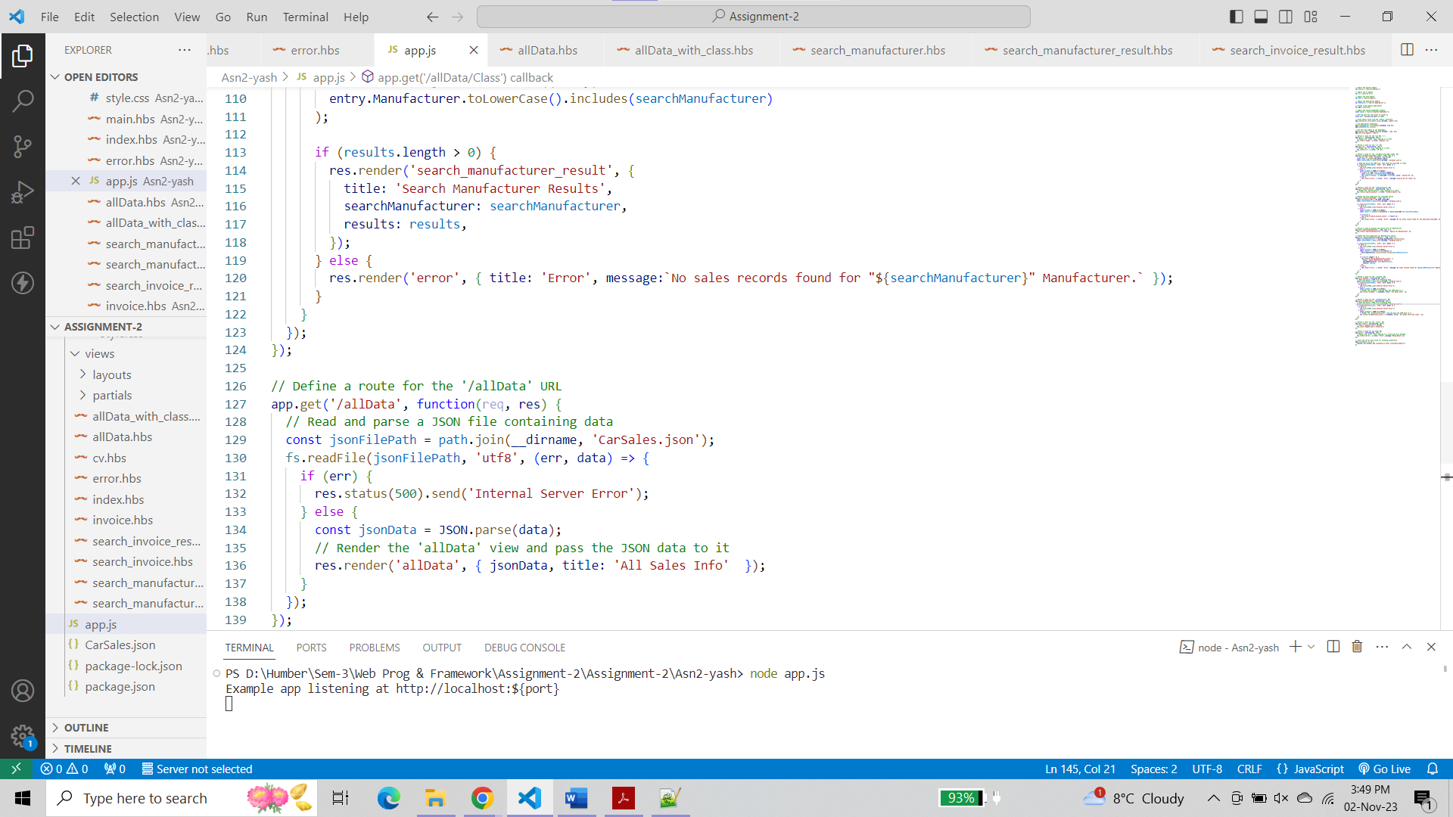

**allData.hbs**

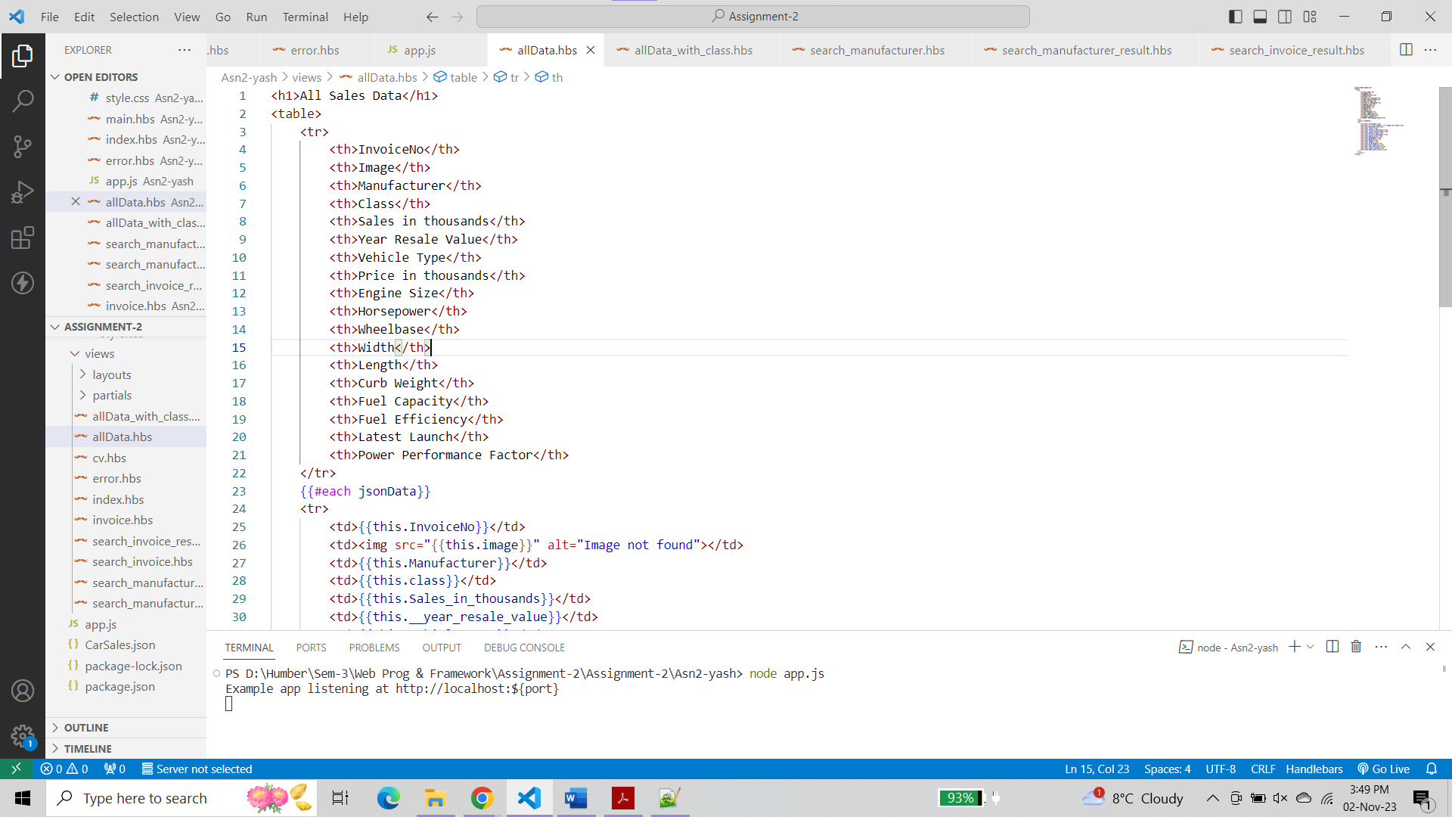

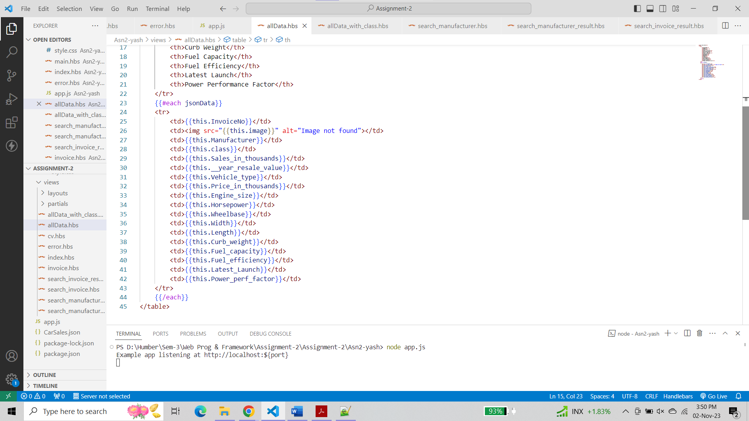

**Output**

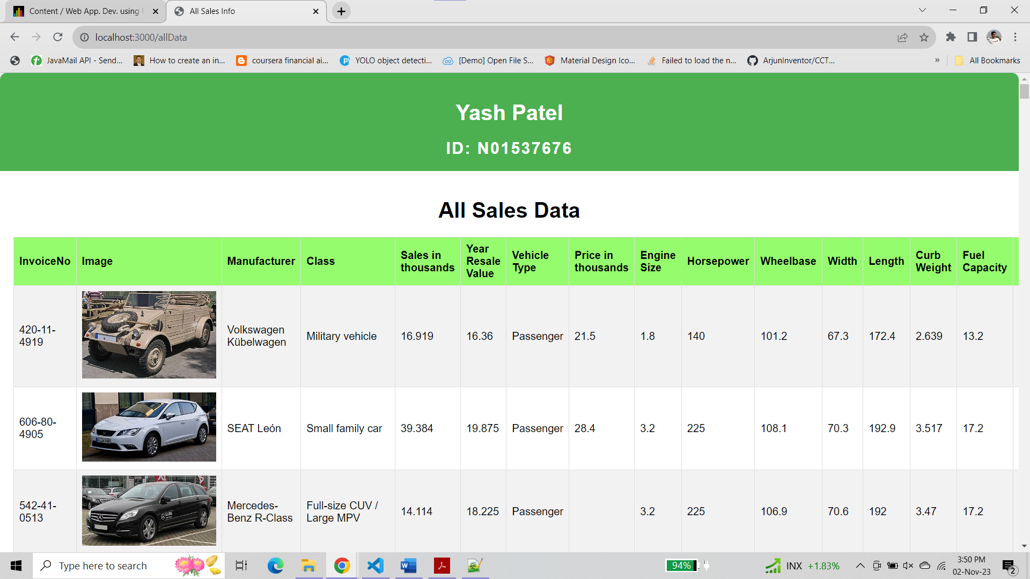

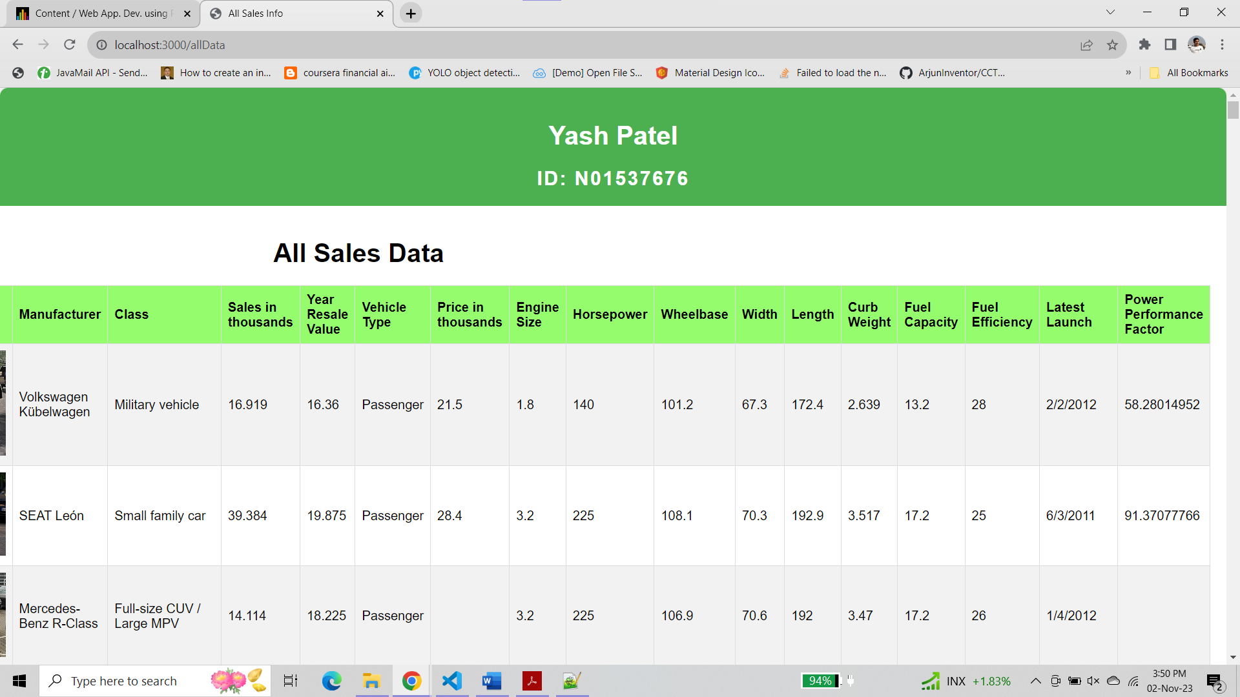

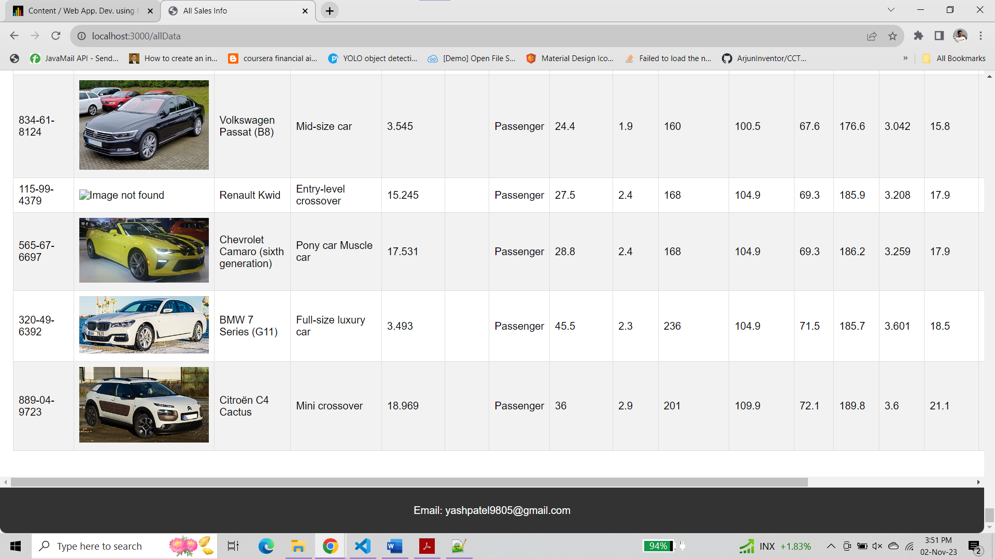

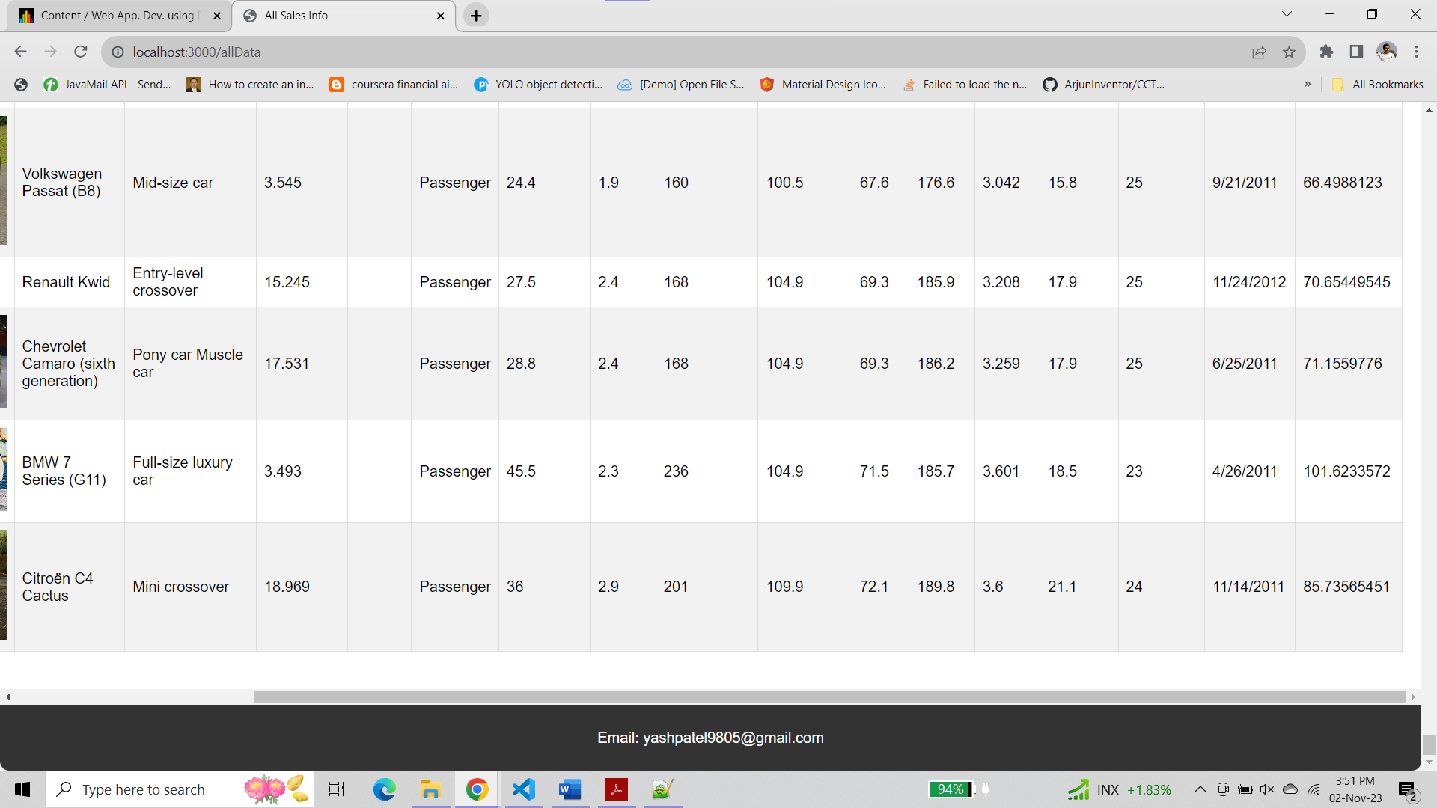

**Step 8 :-**

Modify Step 7 by removing those records which their “class” is blank

**app.js**

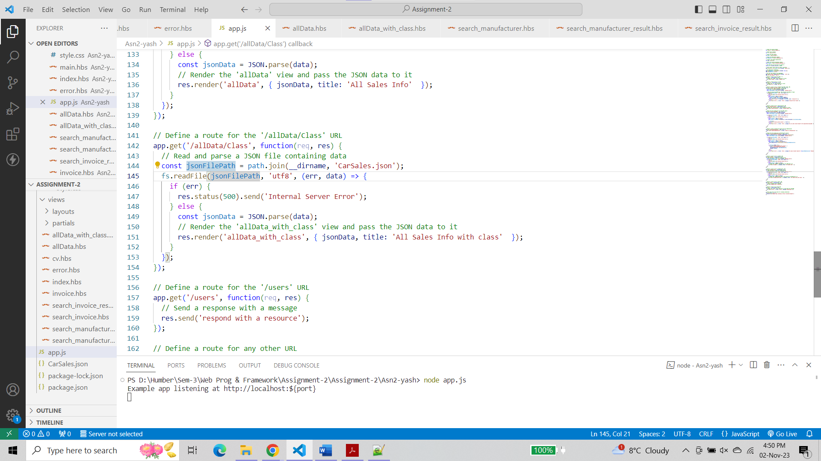

**allData_with_class.hbs**

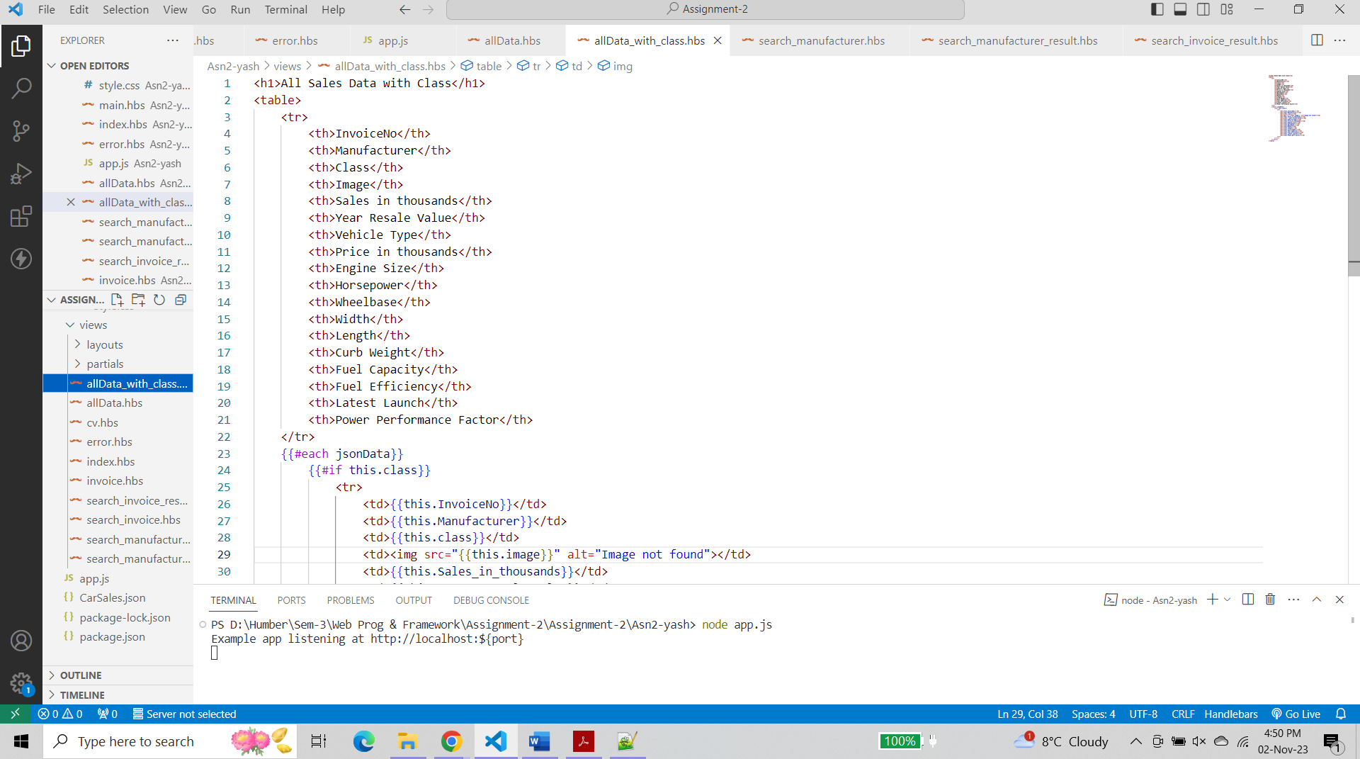

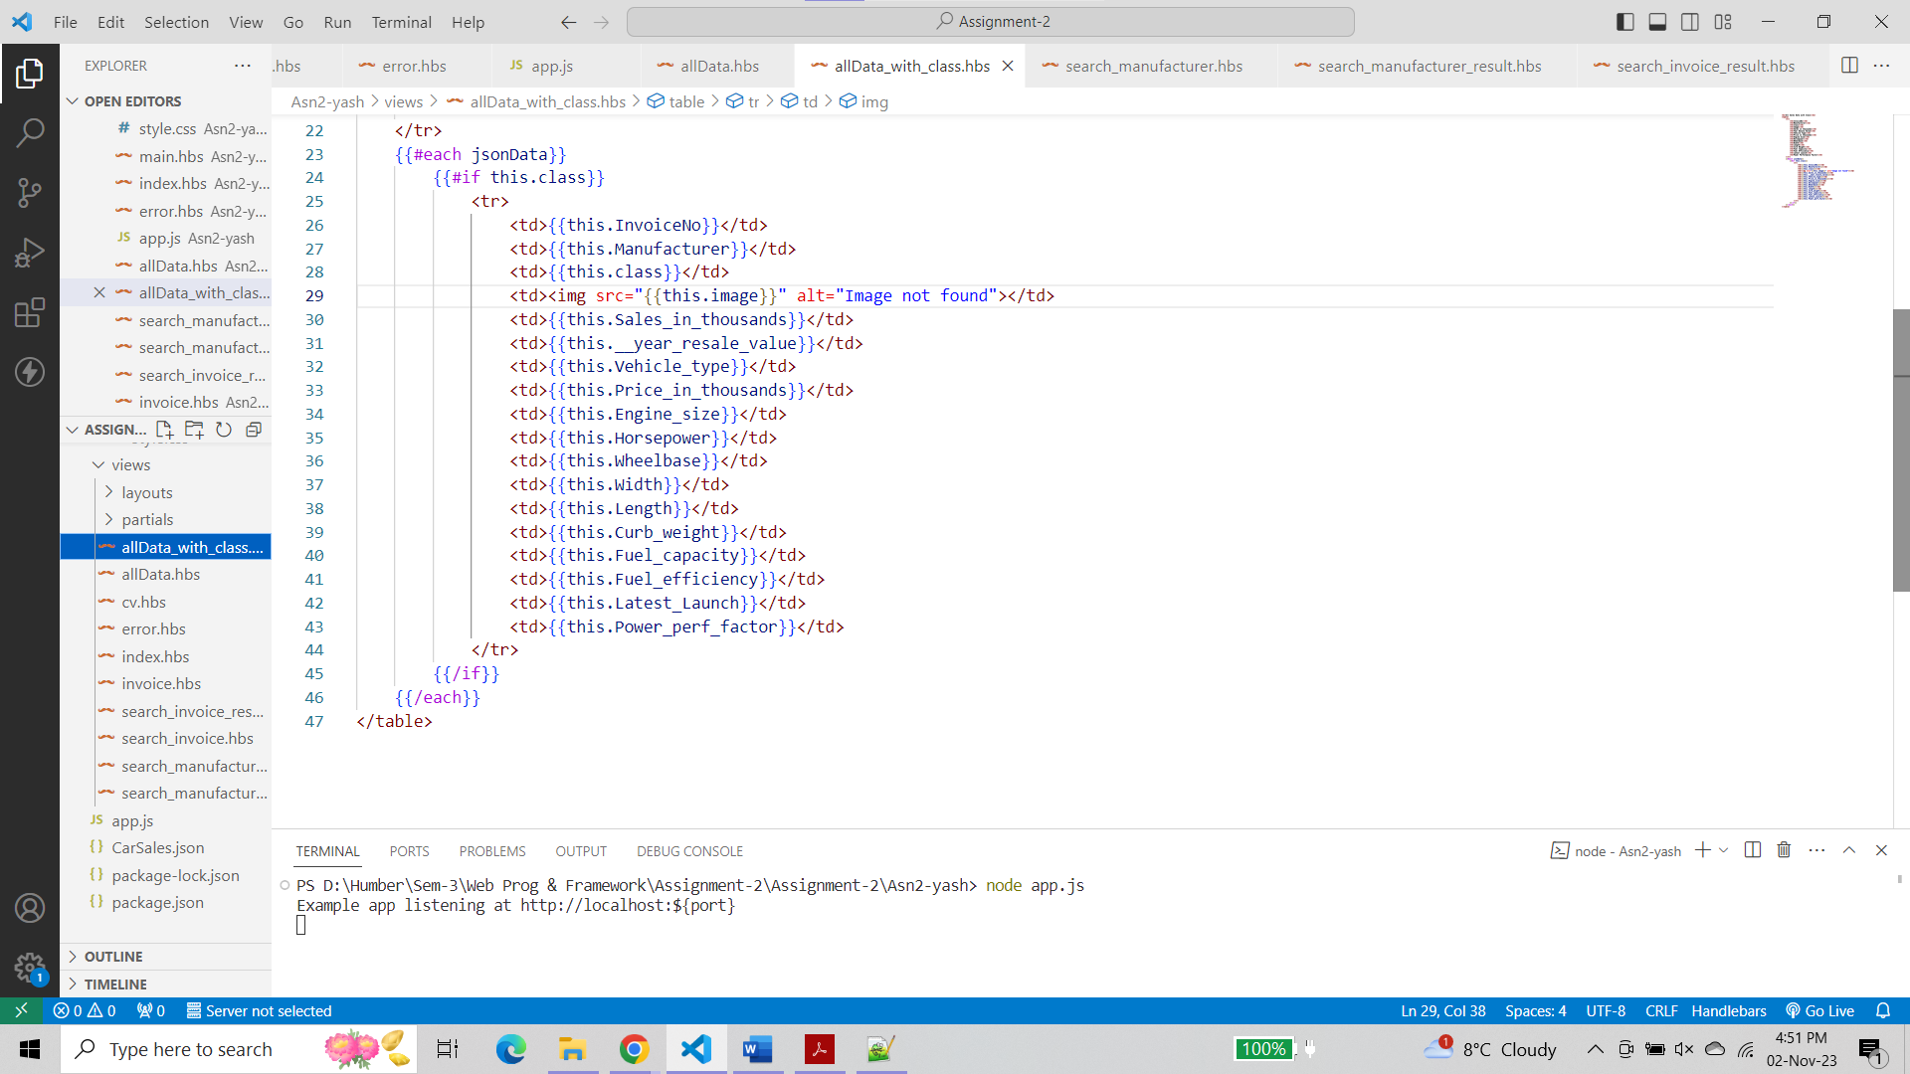

**Output**

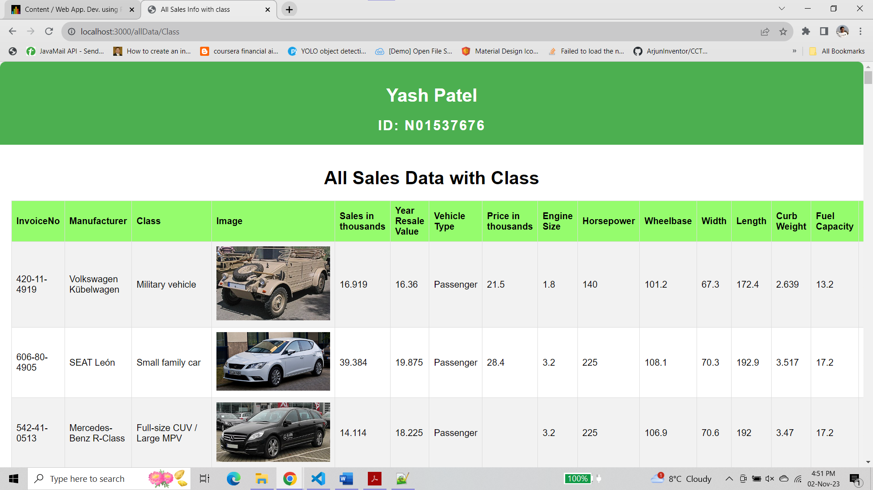

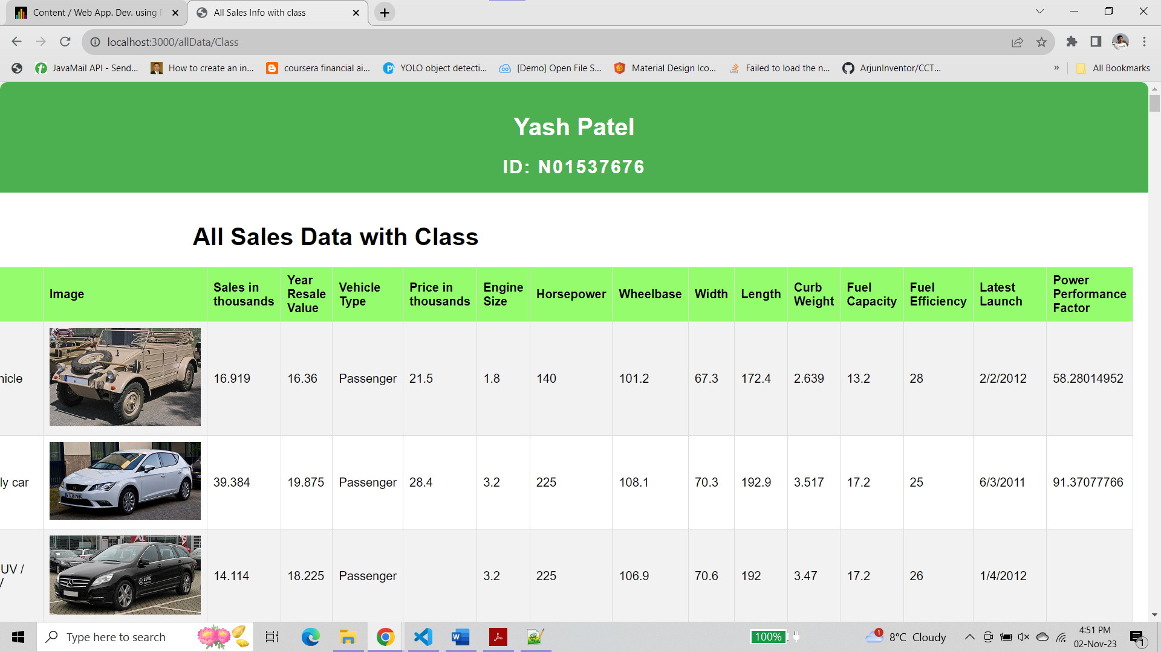

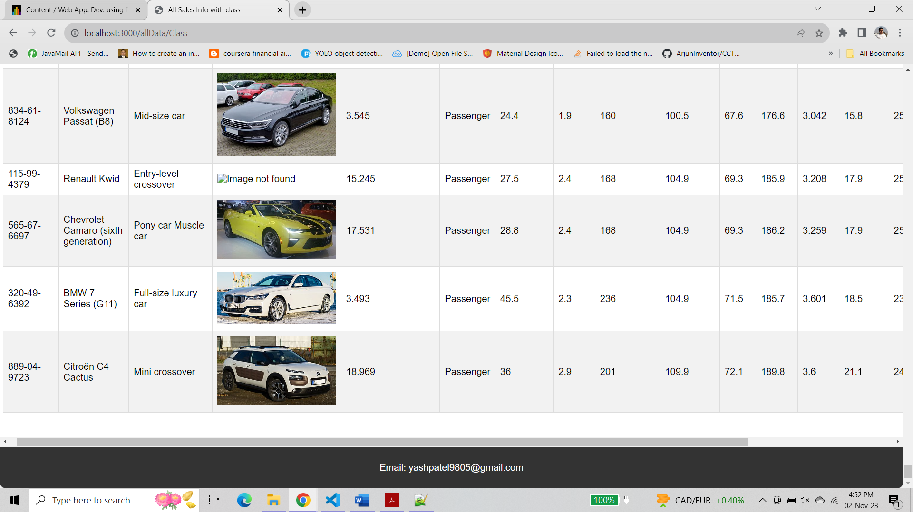

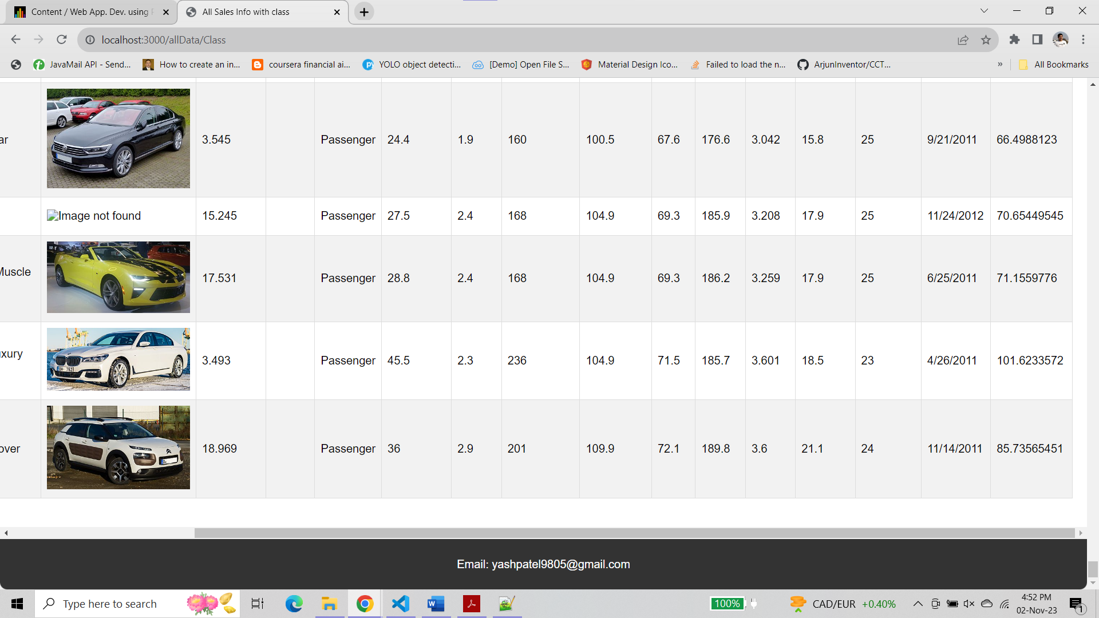

**Step 9 :-**

Design a custom helper for changing “blank” to “unknown” for records which their “class” is “blank”

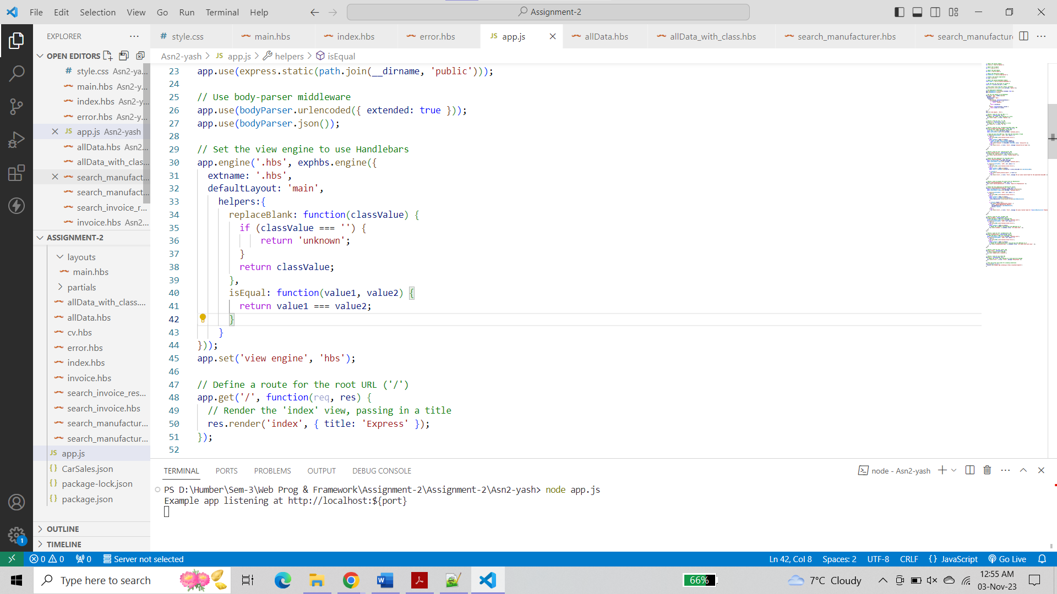

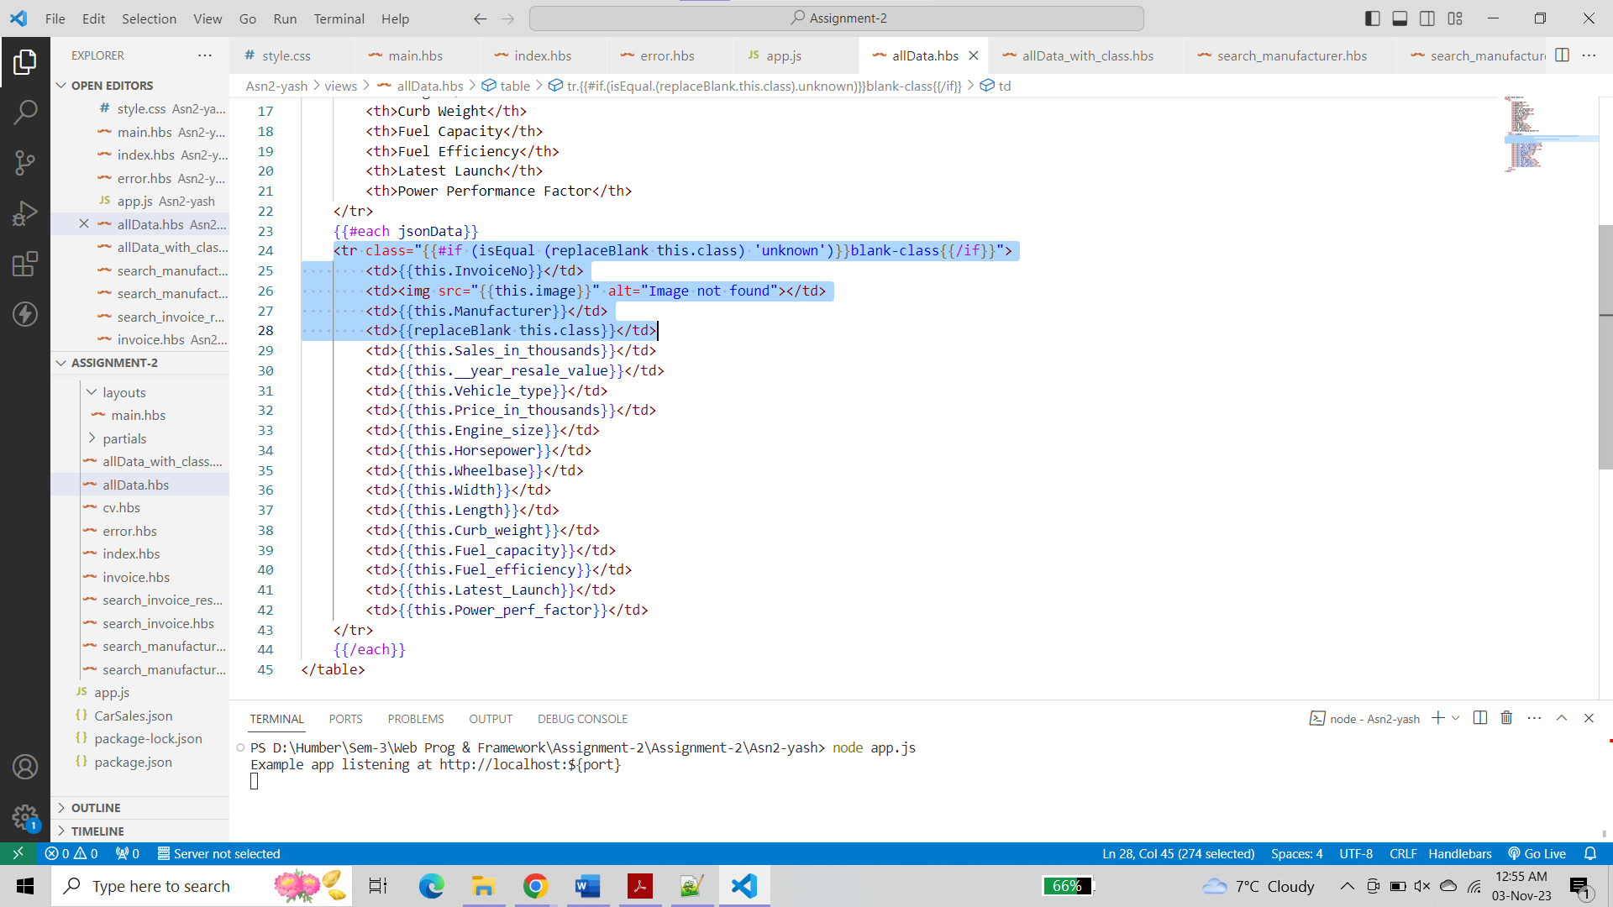

**Output**

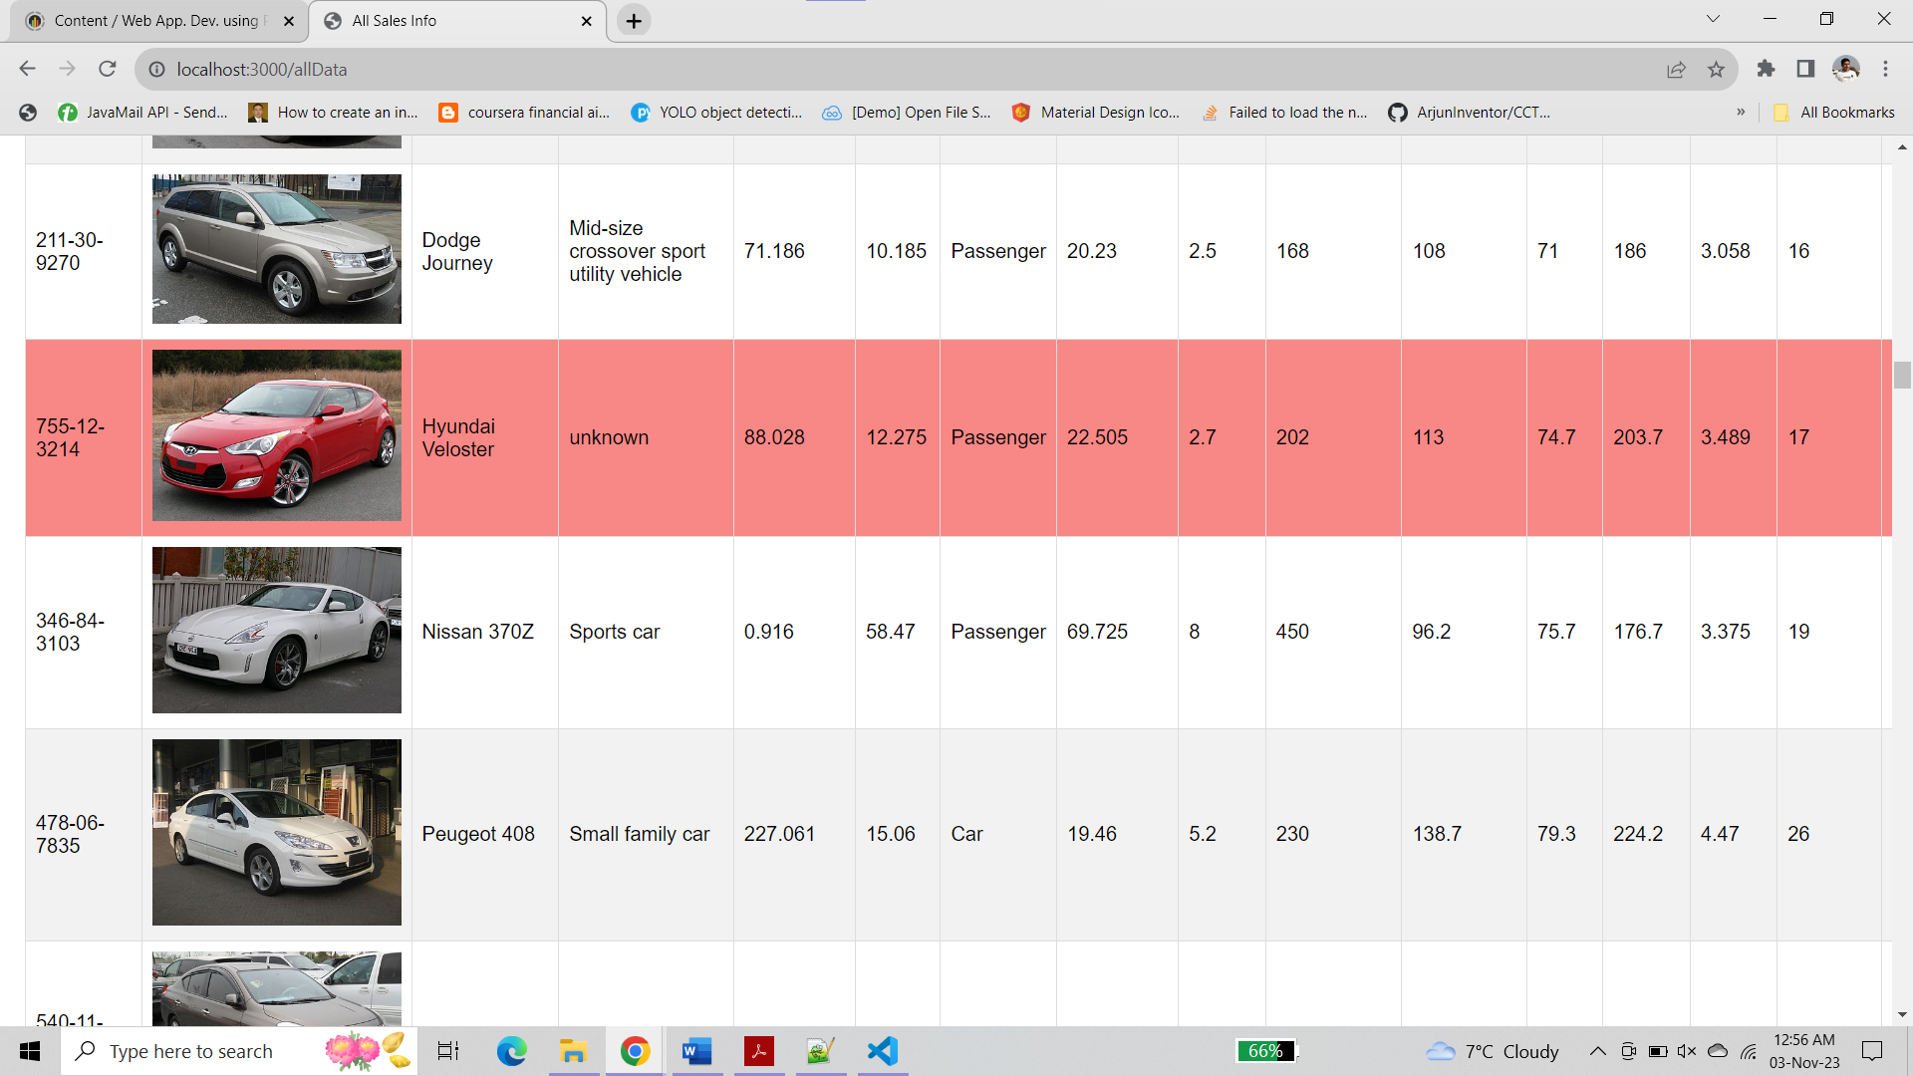

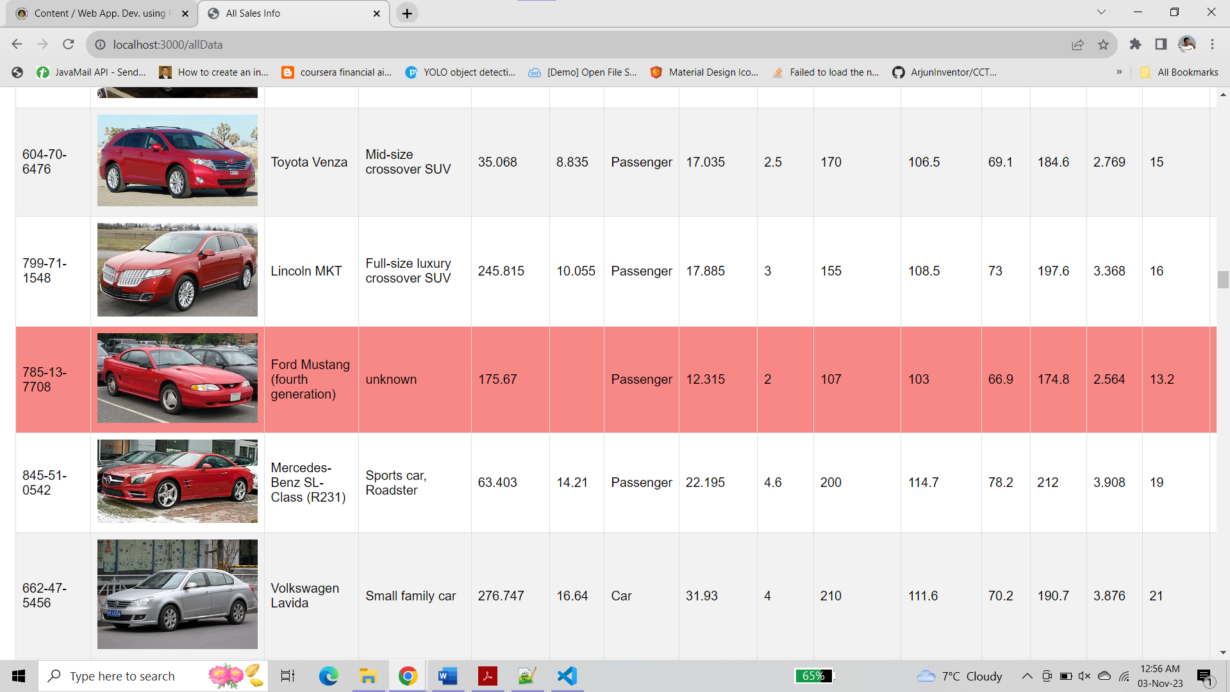

**Step 10 :-**

1. **change table row color for those records which “class” is “blank”. Any way that you can implement it using Template Engine? Explain your answer**

* I already implemented this step in the previous step-9. By defining a custom helper function, we check the value of the "class" attribute for each row. If the class is "blank," the helper returns a specific class name. This allows us to apply CSS rules to the class name in the stylesheet to change the row color accordingly.
* **Example :-**

Already implemented in Step-9

1. **In this app, do you find any use cause for utilizing “Partial” Templates? Explain your answer**

* Partial templates can be beneficial in this application for various reusable components such as headers, footers, or other shared elements across multiple pages. These partials can simplify the development process and ensure consistency in the layout and design throughout our application.
* **Example :-**

Created header.hbs and footer.hbs files inside partial folder

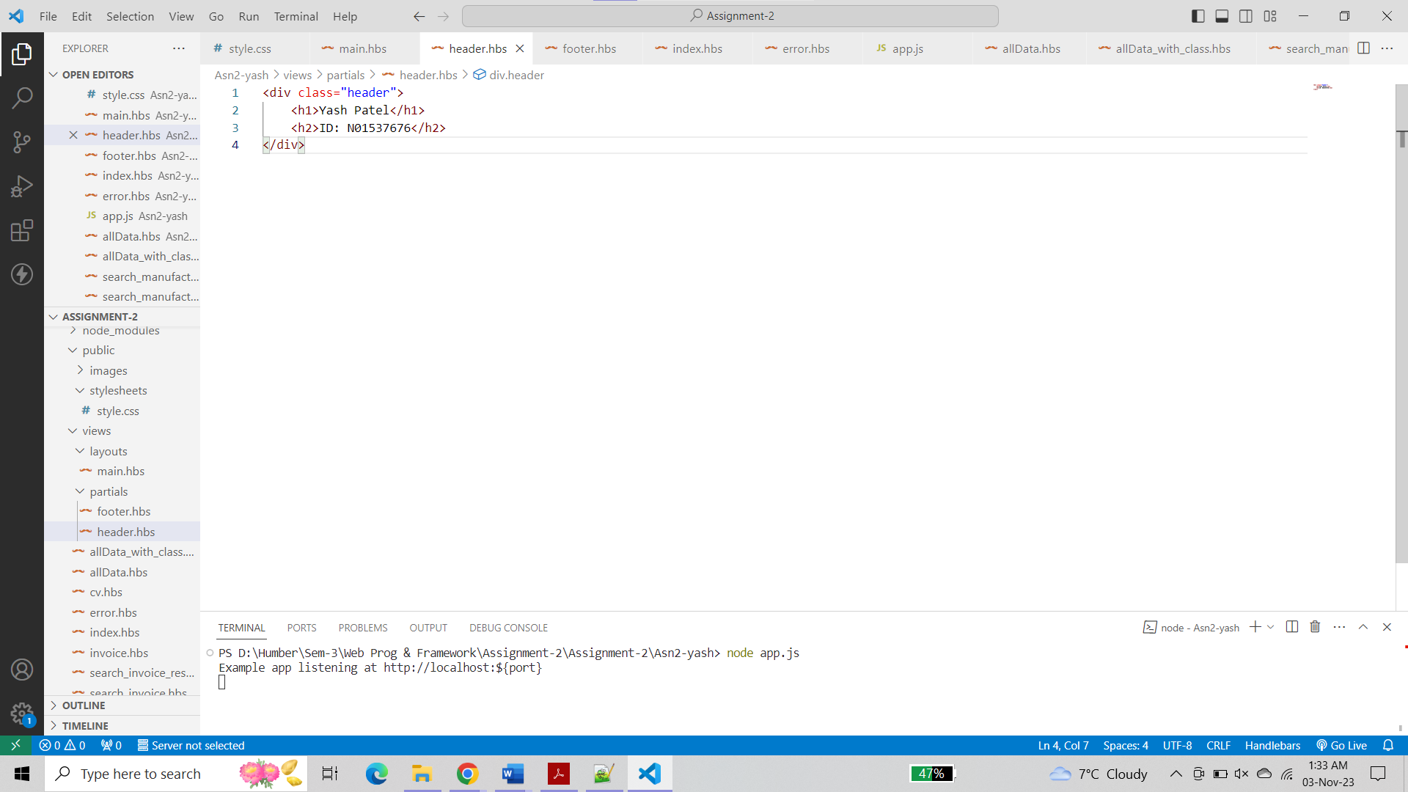

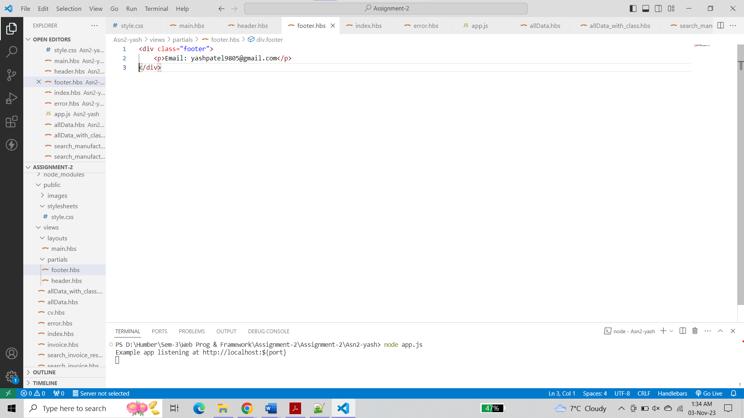

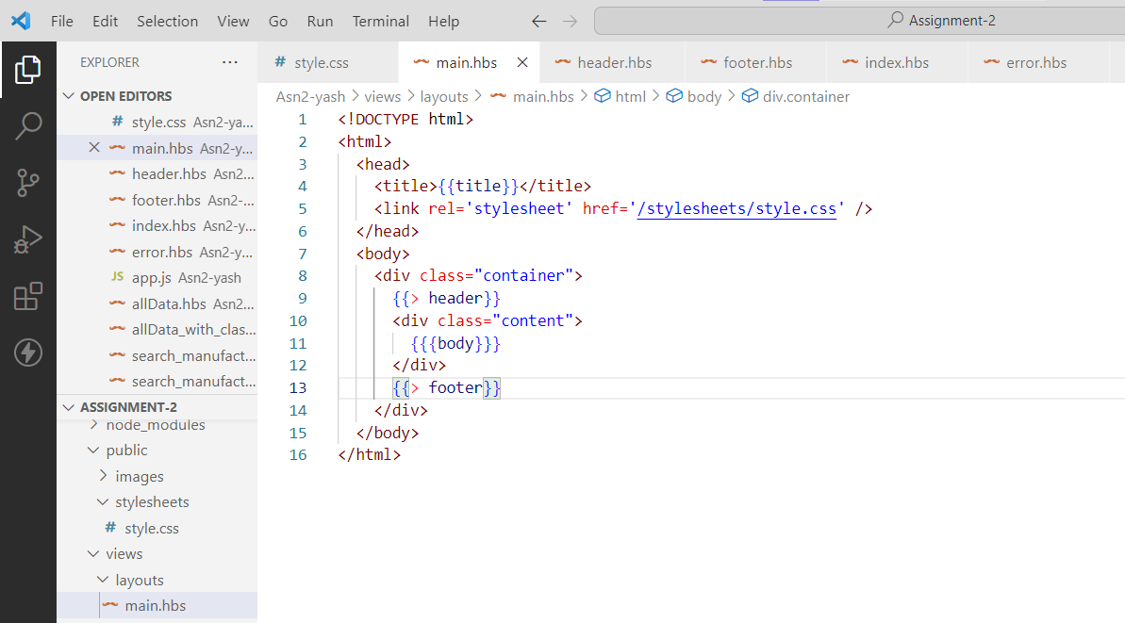

**Output :-**

You can see that my header and footer is displayed using partial

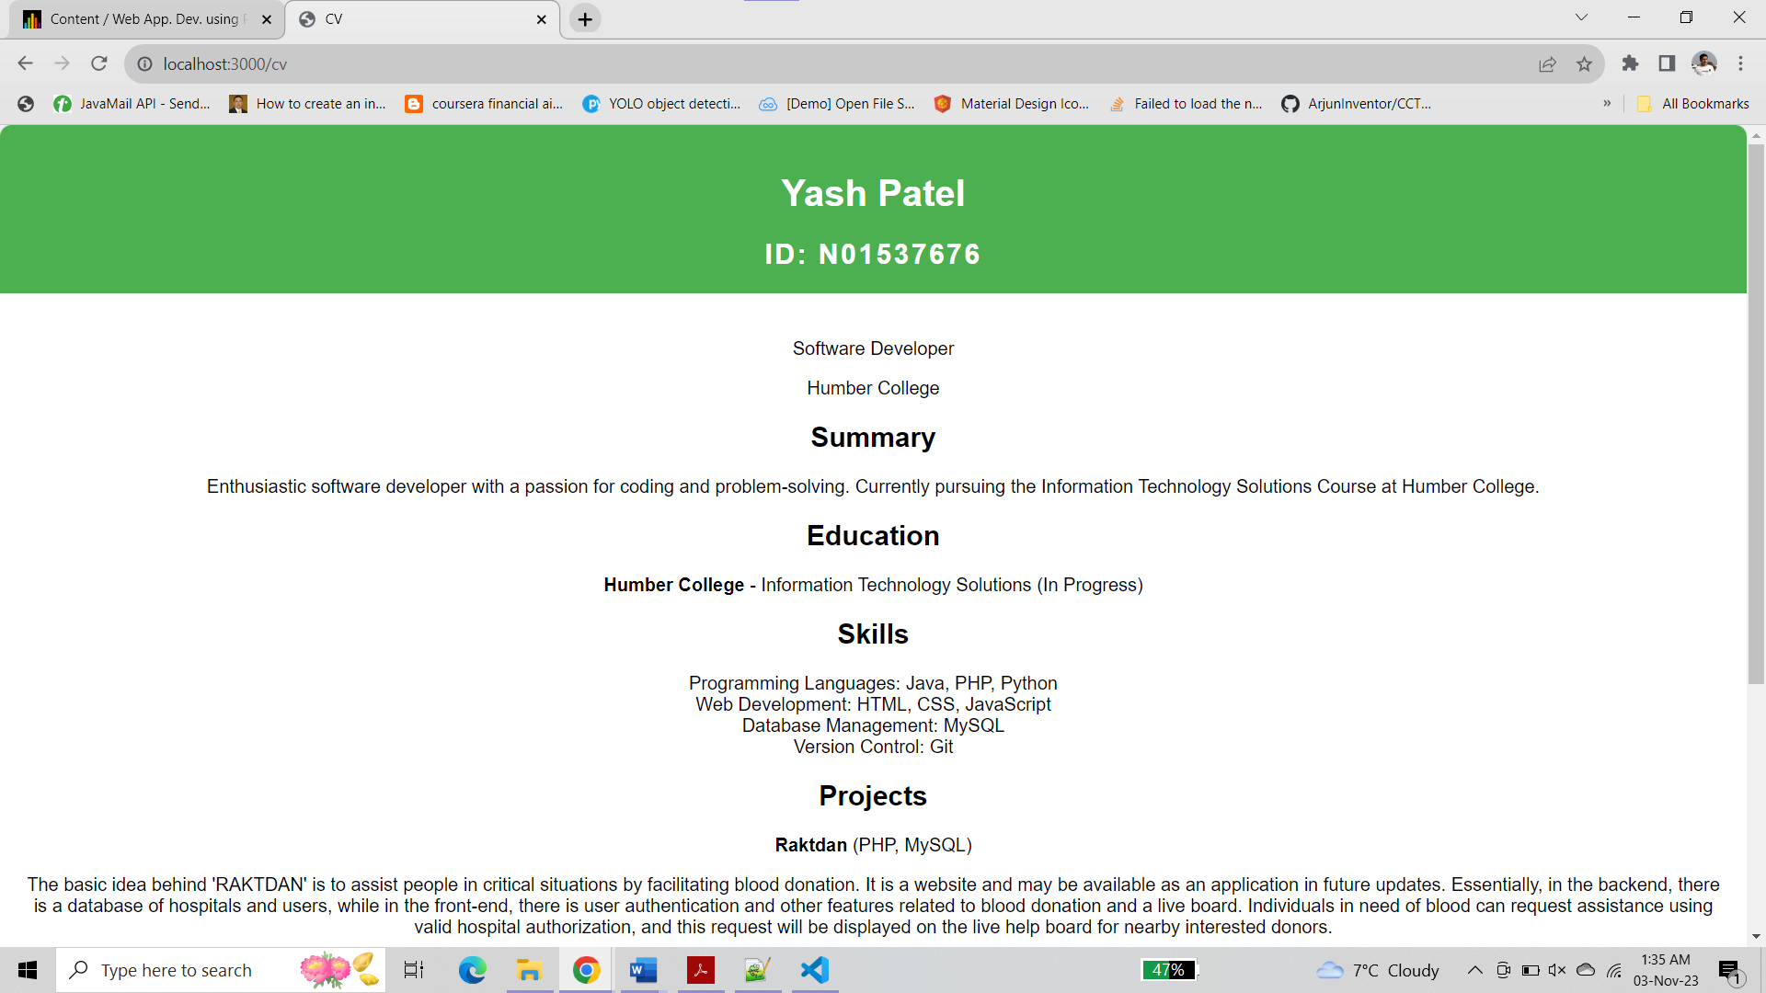

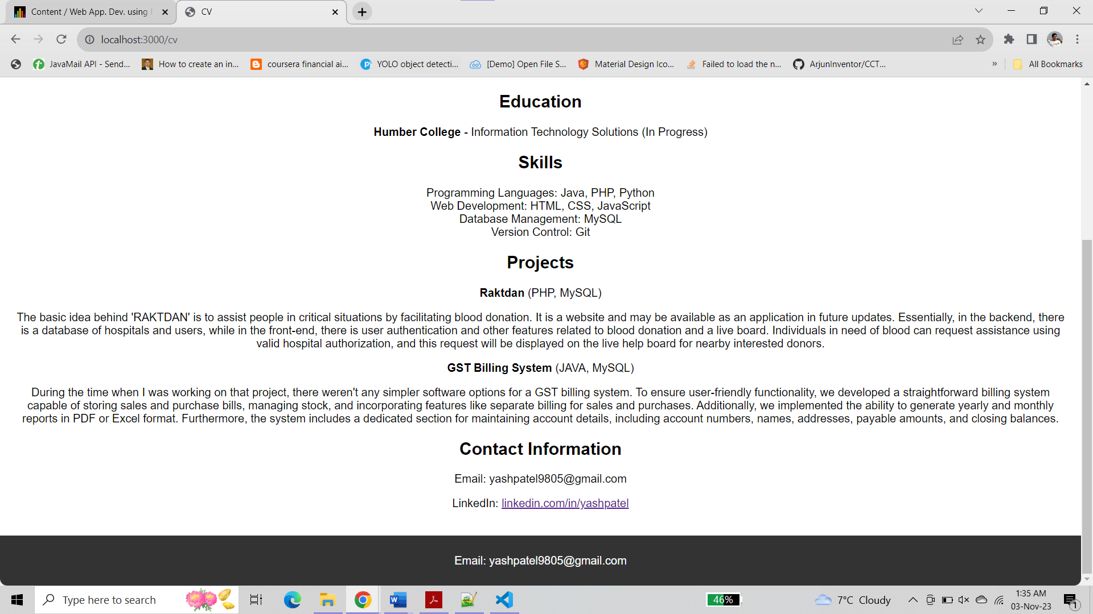

**Step 11 :-**

Deploy the application

1. Pushed the code to github

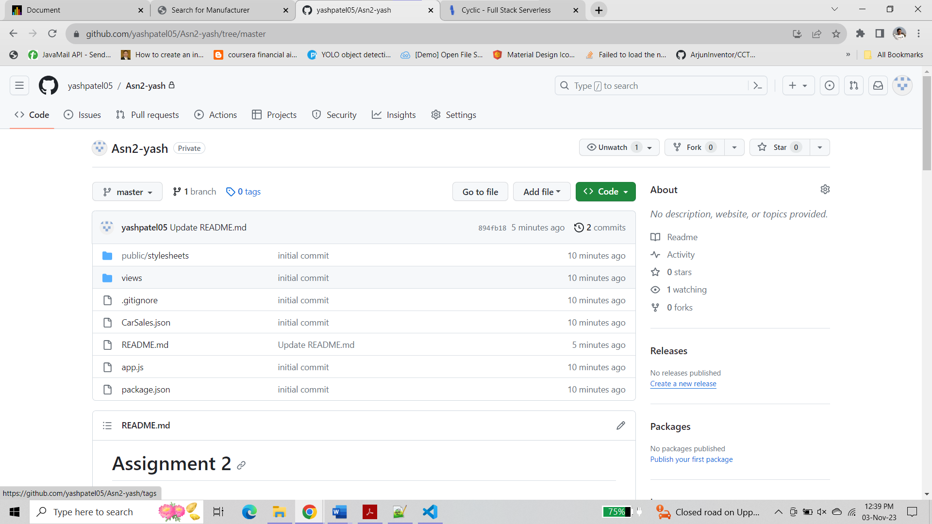

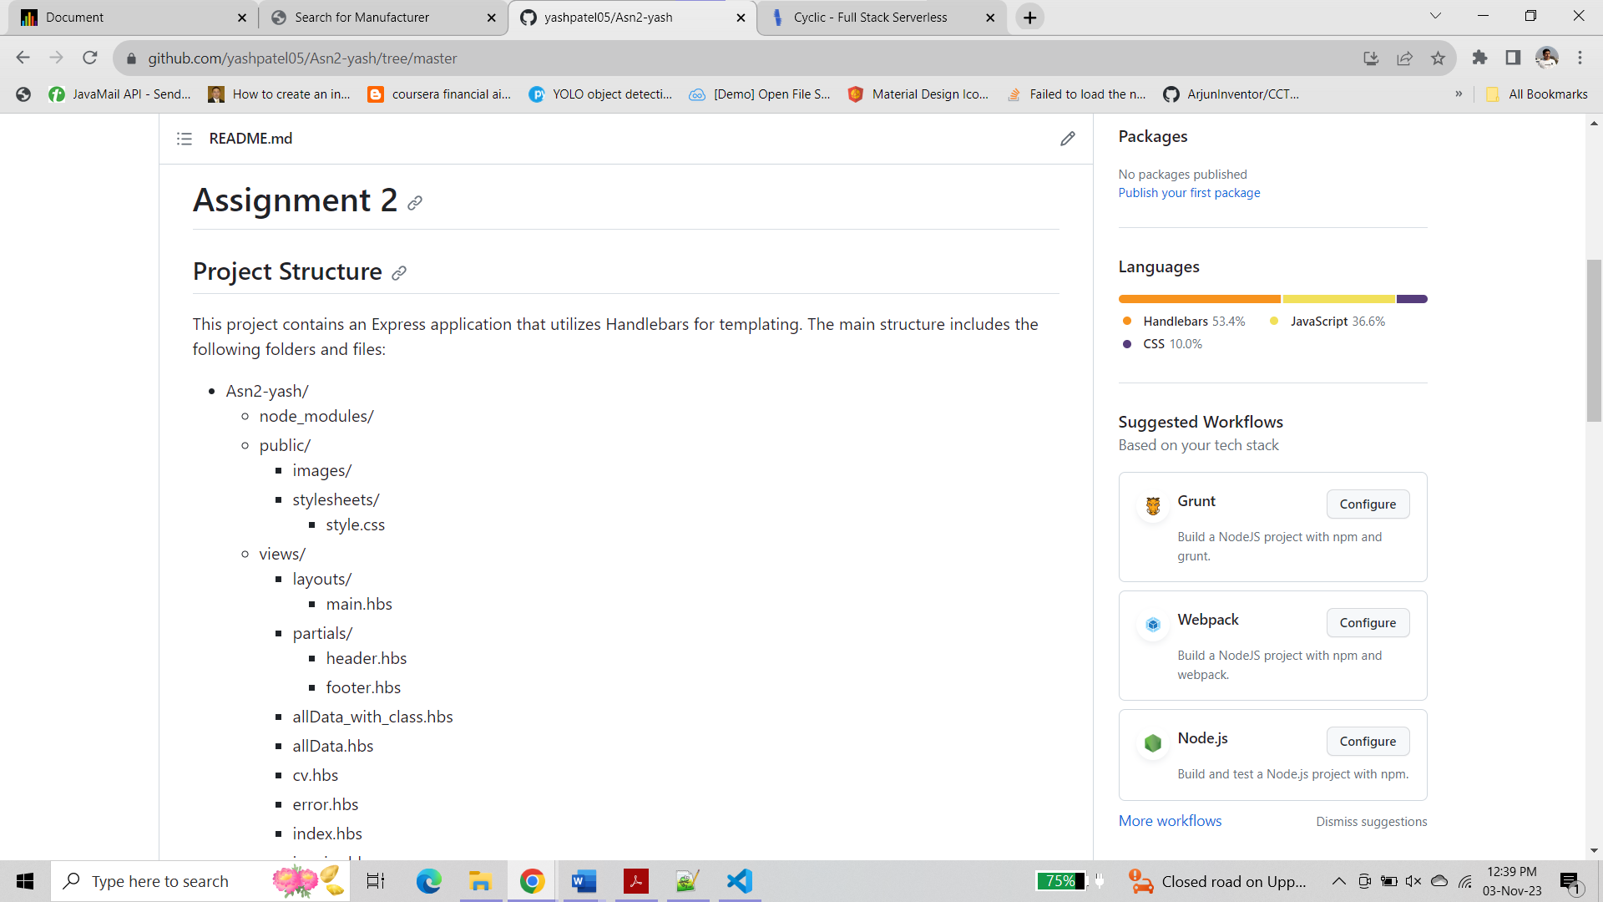

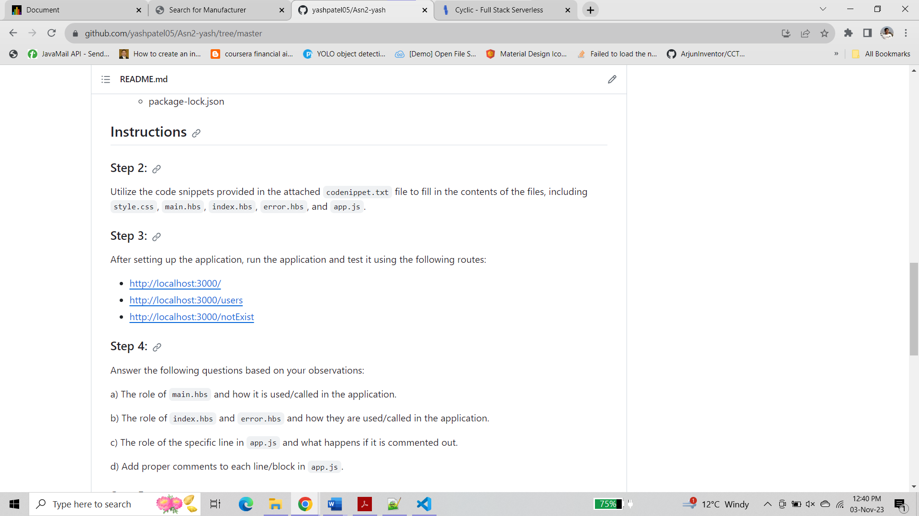

1. Deploy to the cyclic

**Link :-** <https://thankful-crab-onesies.cyclic.app/>

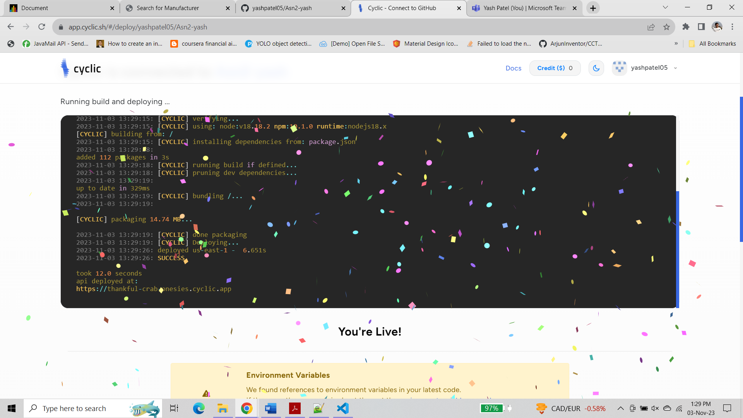

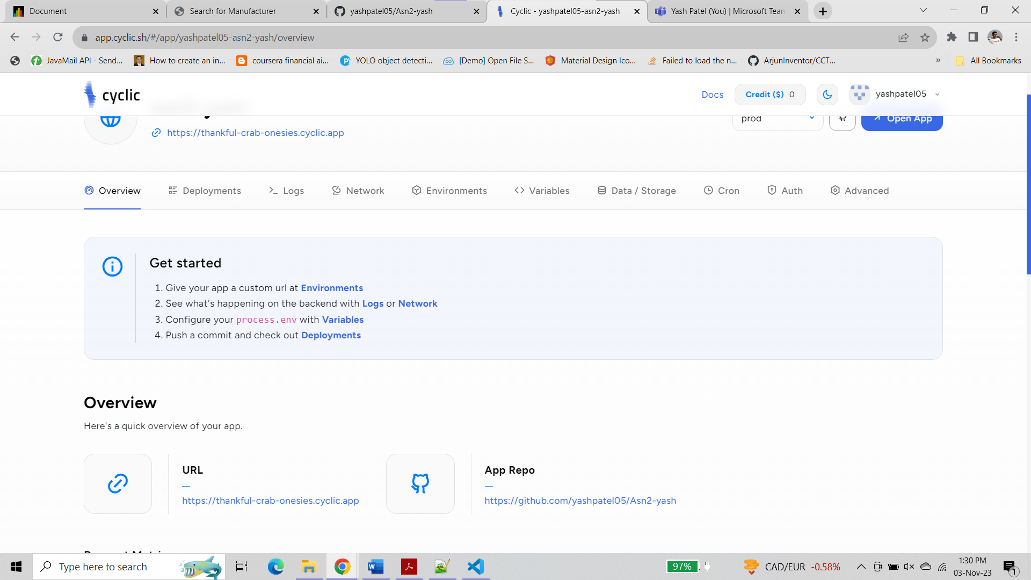

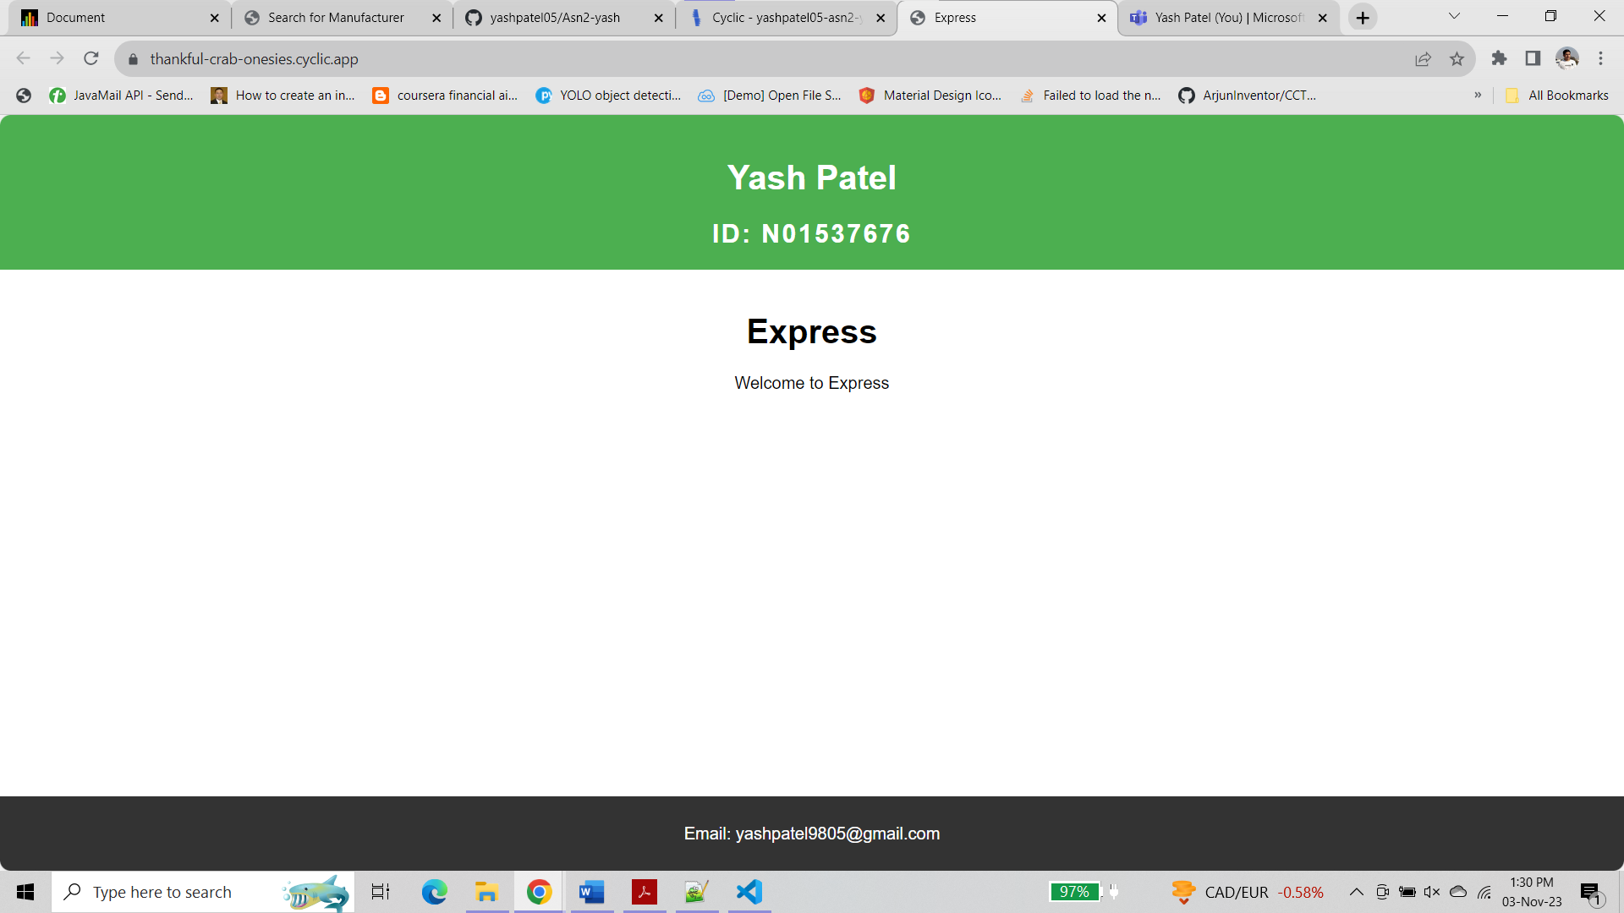

/allData/invoiceNo/1

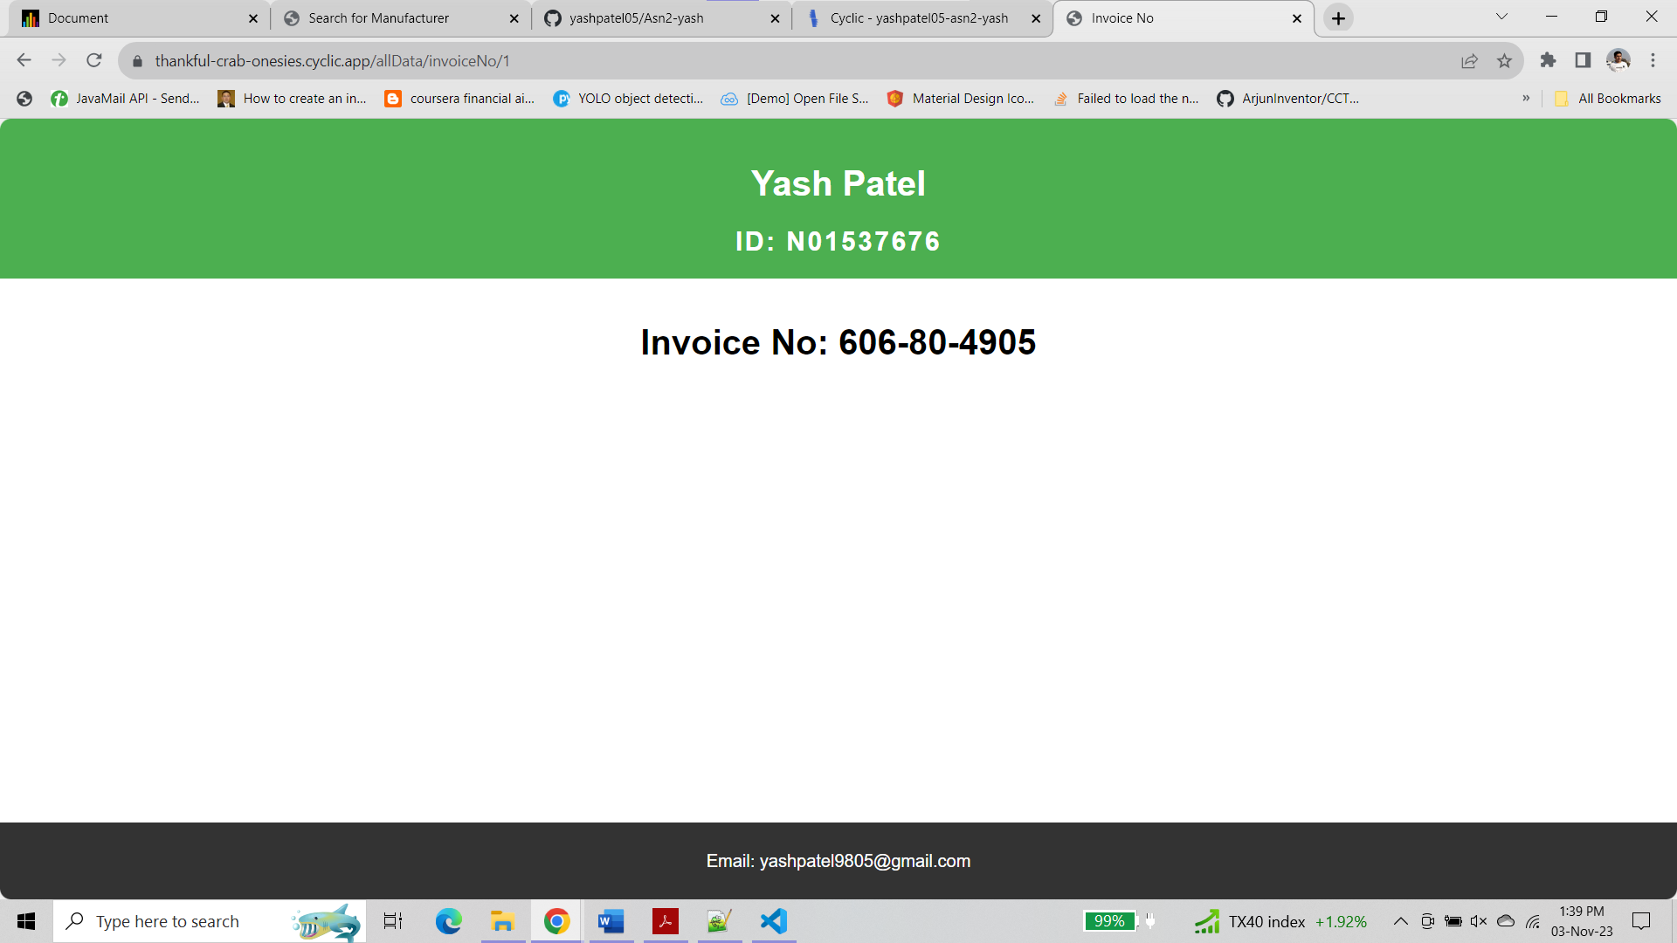

/allData/invoiceNo/a

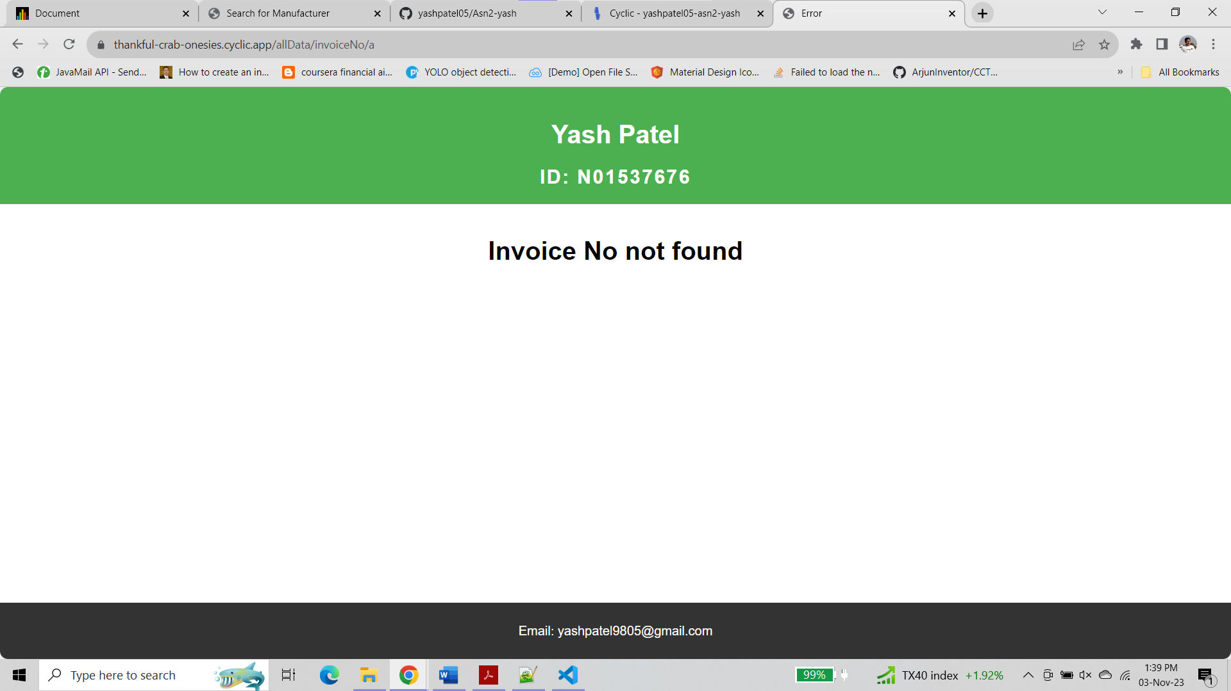

/search/invoice

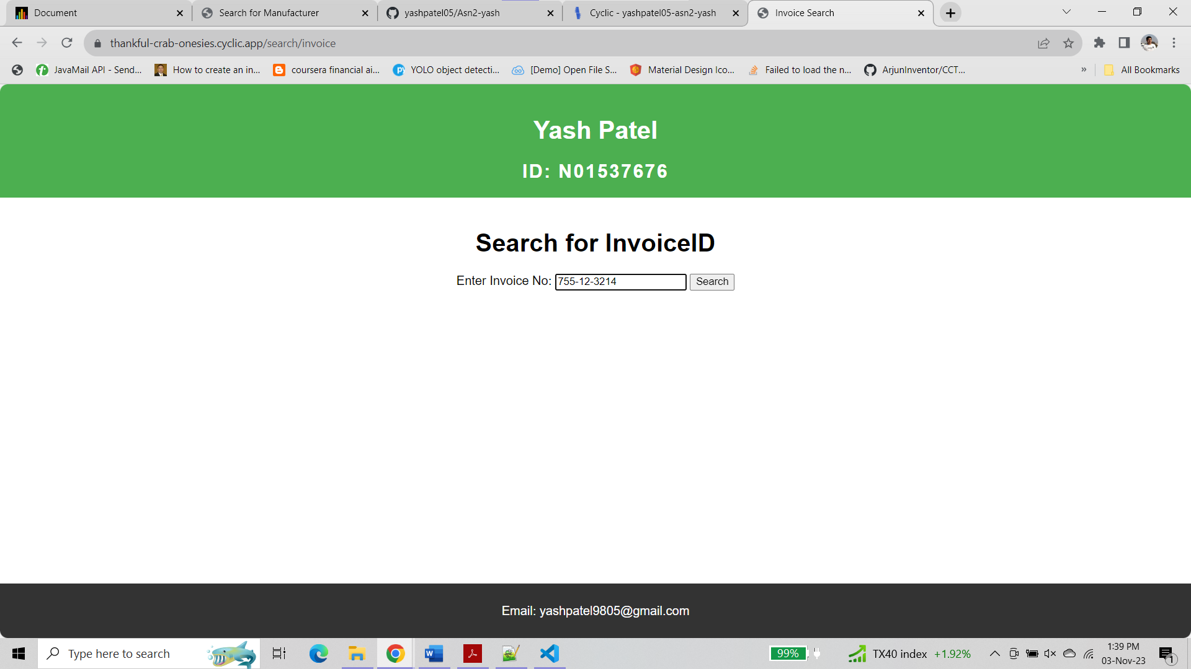

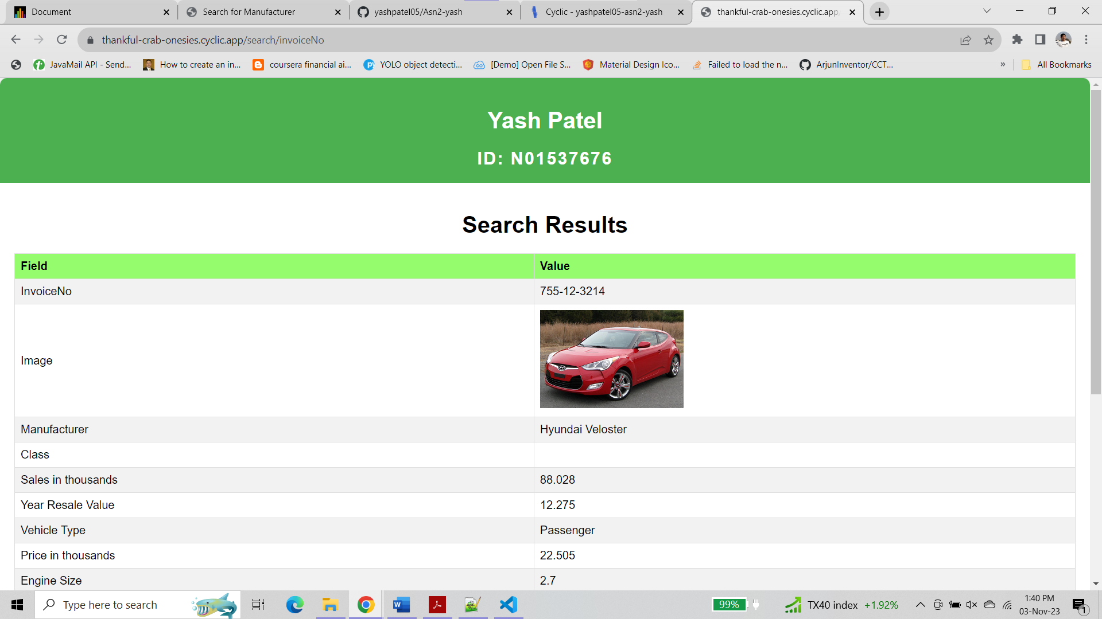

search/manufacturer

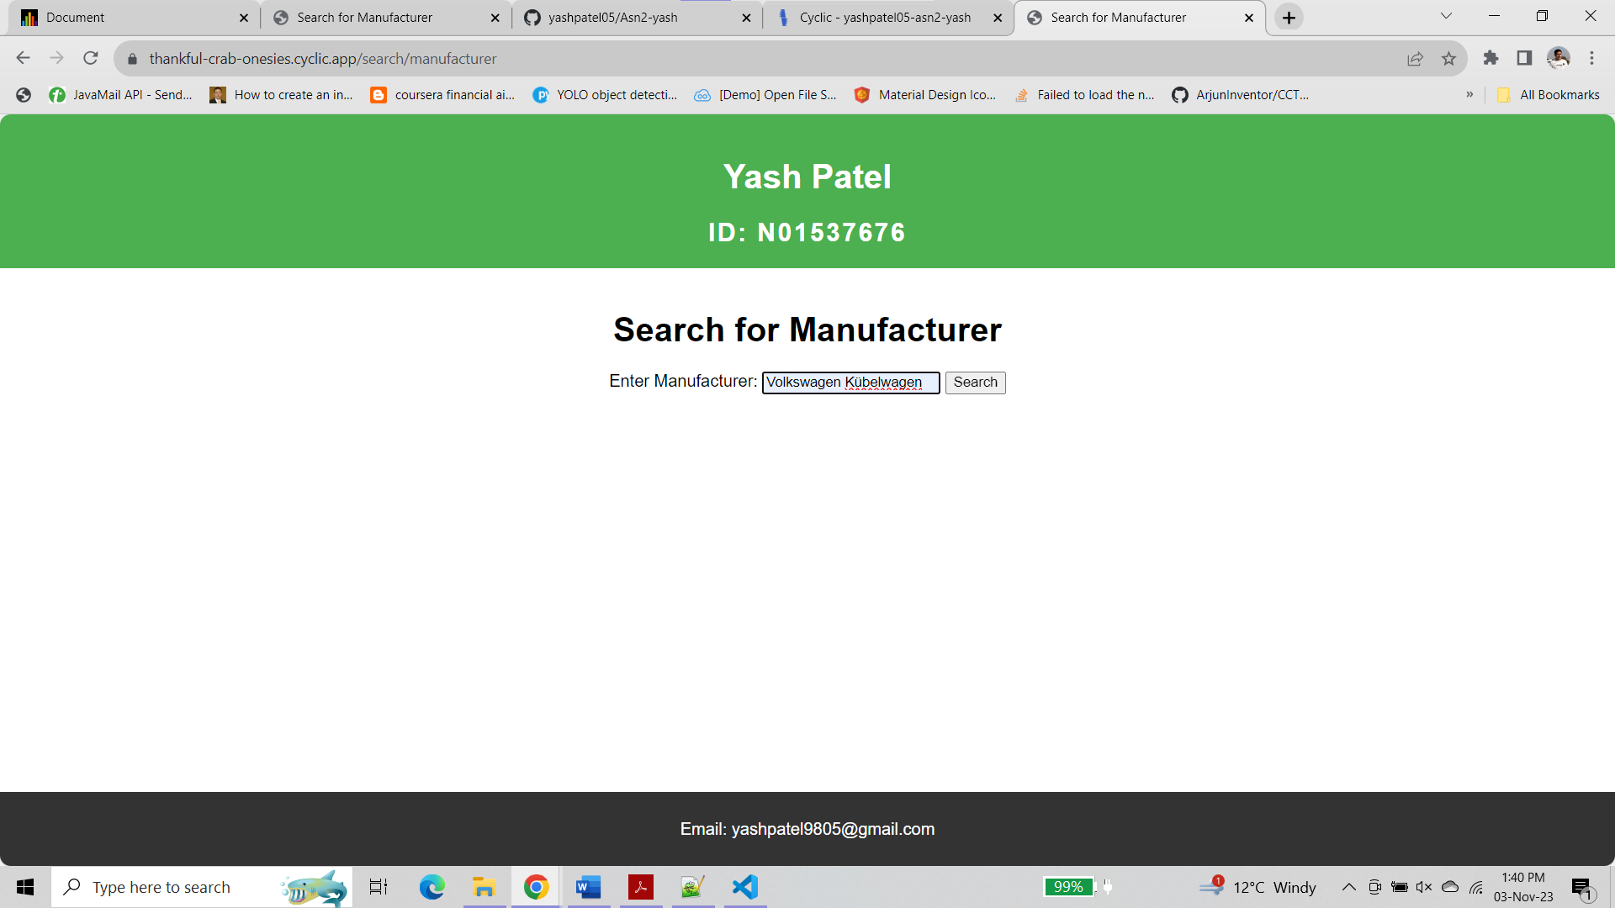

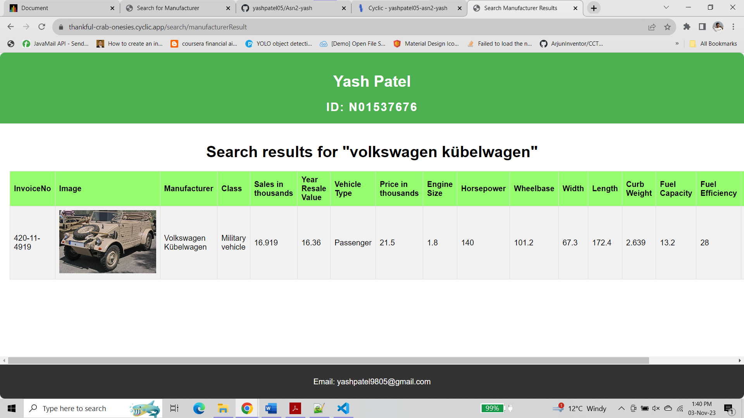

For Partial Search

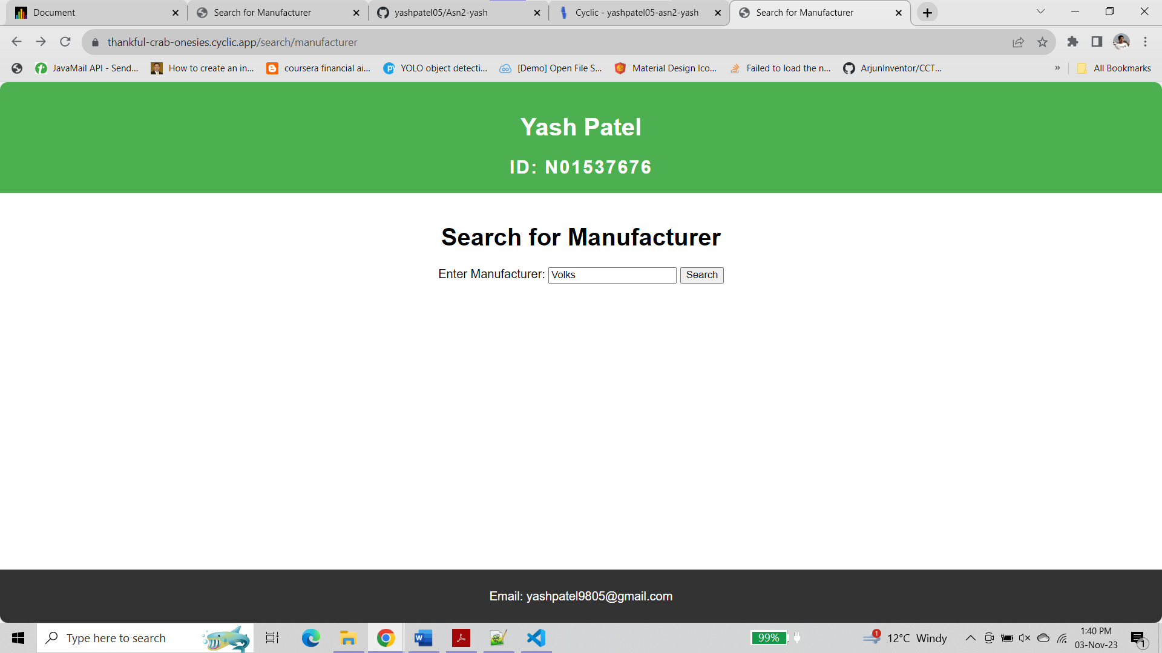

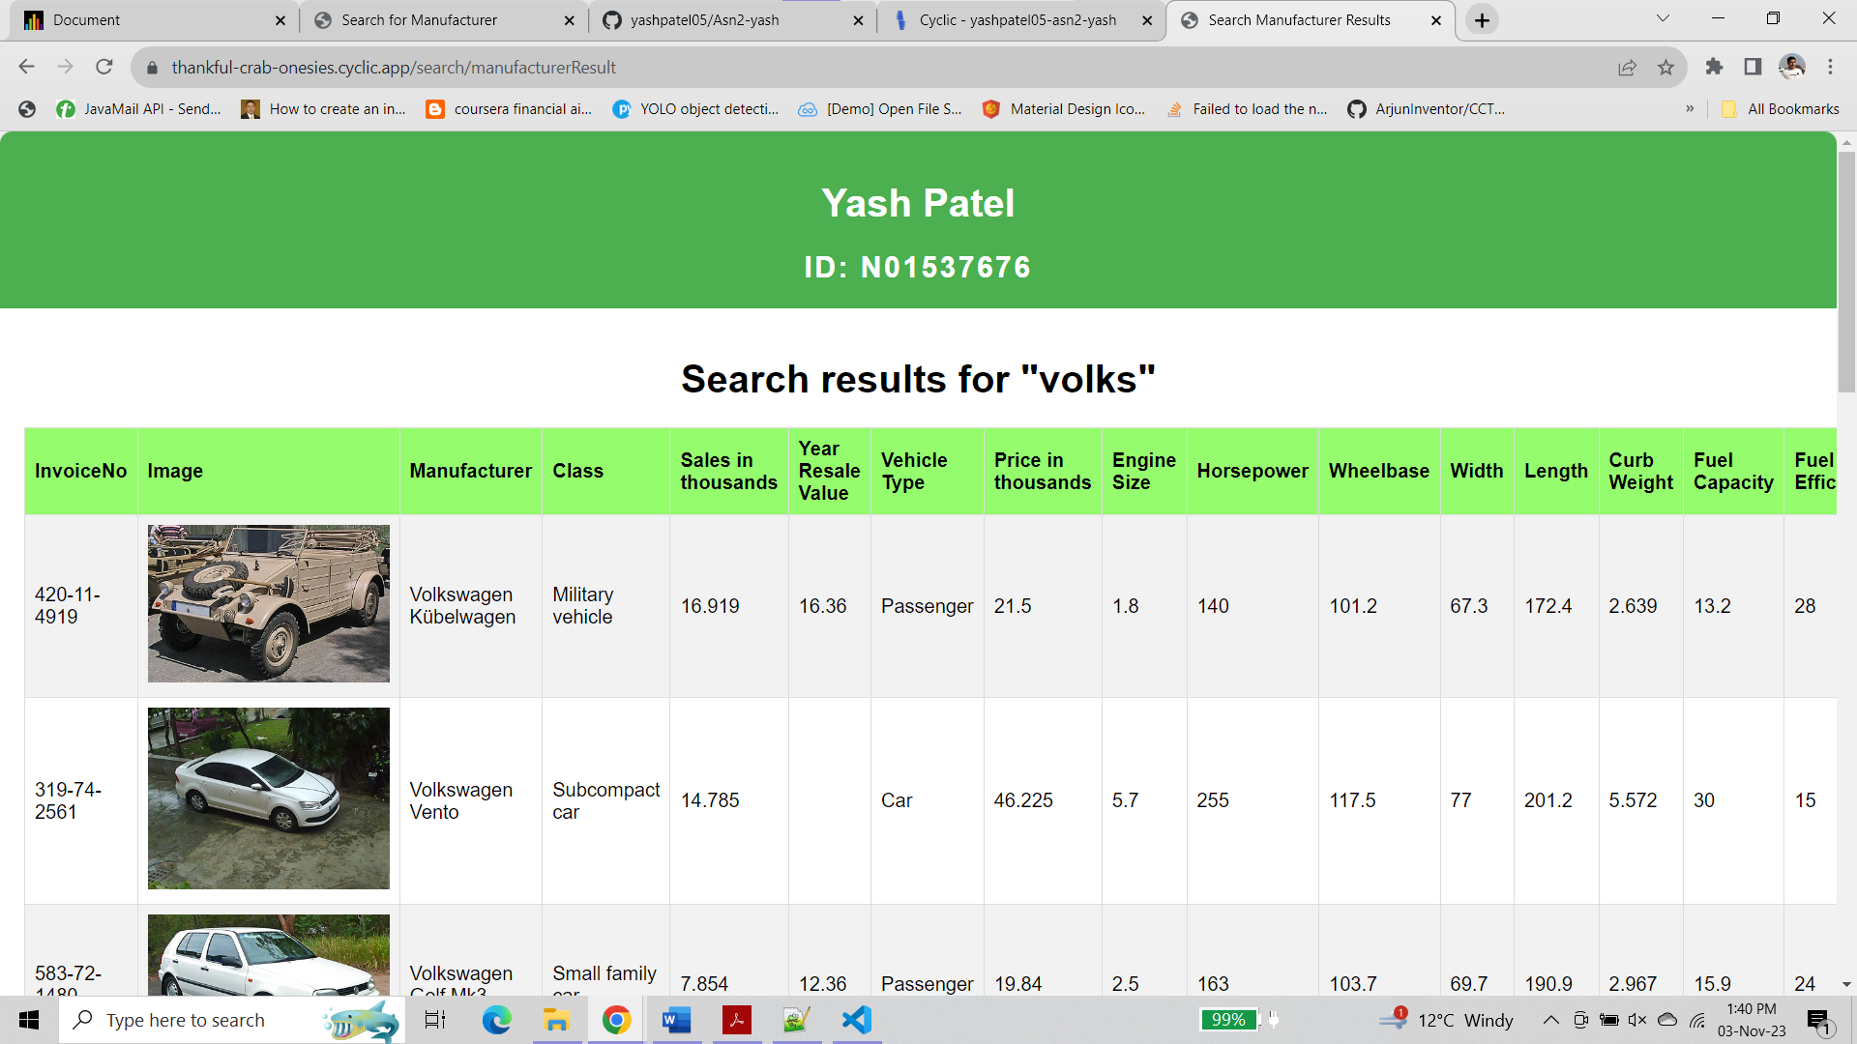

/allData

